WALTHAMSTOW SCHOOL FOR GIRLS
“Neglect not the gift that is in me”

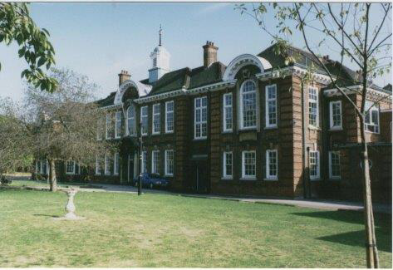

Information for applicants for the post of
Examination Invigilator
January 2019

January 2019

Dear Applicant
Thank you for requesting an application pack for the post of Casual Examinations Invigilator.
Walthamstow School for Girls is a high achieving, oversubscribed, diverse school which is regularly in the top 5% nationally for progress and the top 10% nationally for attainment and is at the centre of the vibrant local community of Waltham Forest (the first London borough of culture). We have an ambition to become ‘world class’ and a commitment to work with other professionals both locally, nationally and internationally, through our Erasmus links. We won the national High Aspiration Award for the progress made by disadvantaged students and have won SSAT Achievement and Progress awards annually since 2014. We have been awarded the SSAT Exceptional Education standard twice; in 2017, for Leadership through Moral Purpose, and, in 2018, for Systems: use of assessment, data, policies and monitoring to support teaching and learning. We were awarded Teaching School and National Support School Status in September 2017. In June 2018, following a Section 8 inspection, we were awarded an ‘outstanding’ judgement.
Our students are ambitious and hard-working; they embrace the range of opportunities offered to them both during and beyond the school day. This is highlighted not only by our exceptional examination results but also by the maturity of the girls, their sense of responsibility, community and fun. They are a delight to work with.
We offer excellent facilities to both staff and students. Our acclaimed architect designed site is an oasis of green and a pleasure to work in. It is well served by transport connections, being just ten minutes’ walk away from Walthamstow Central tube and overground station and five minutes’ walk from the popular Walthamstow ‘village’, and creative and restaurant quarter. We pride ourselves on working hard to retain our role as an important part of the local community. Examples of this commitment can be seen in our weekly Greensheets. Our staff are inclusive and friendly, with regular social and wellbeing events as well as charity fundraising.
We are committed to Safer Recruitment practices and procedures and shortlisted applicants will be questioned about their commitment to the safeguarding of young people. The successful candidate will be subject to an enhanced DBS clearance.
Thank you for taking an interest in this position. I do hope that having read more about the school you will decide to apply for the post. I look forward to receiving your application. Please note that it will not be possible to give feedback to unsuccessful applicants, other than those called for interview. Thank you for your understanding and good luck with your career in education.
Ms Meryl Davies
Headteacher, NPQH, NLE

The History of Walthamstow School for Girls
In January 1890, a circular stated that a “school for girls” was to be opened. Walthamstow was described as a pleasant suburb on the borders of Epping Forest. Hoe Street was almost a country road, with a few houses on either side and meadows in which were sheep, cattle, hawthorn and wild roses.
Miss Hewett was the first Headmistress, at the age of 27 until she retired in 1924. There were 49 girls, whose ages ranged from 7-16 years. At this time there were only five teachers, two of whom were graduates. The School’s original Staff Book gives details of the first one hundred teachers. Of them 30 remained at the school for ten years or more, 22 giving over twenty years’ service. Until 1944 all the teachers were women and not married.
The original building was in West Avenue Road and when the numbers grew the school moved to Church Hill House, where a church now stands. At this time there were also boys up to the age of 13 years at the school. It was in September 1913 that 243 girls came into the present building with the Greek Theatre being added in the 1920s. However in July 2008 the whole school moved off site for a period of four school terms to facilitate the building and refurbishment programme that has resulted in the unique blend of traditional and state of the art facilities found at the school today.
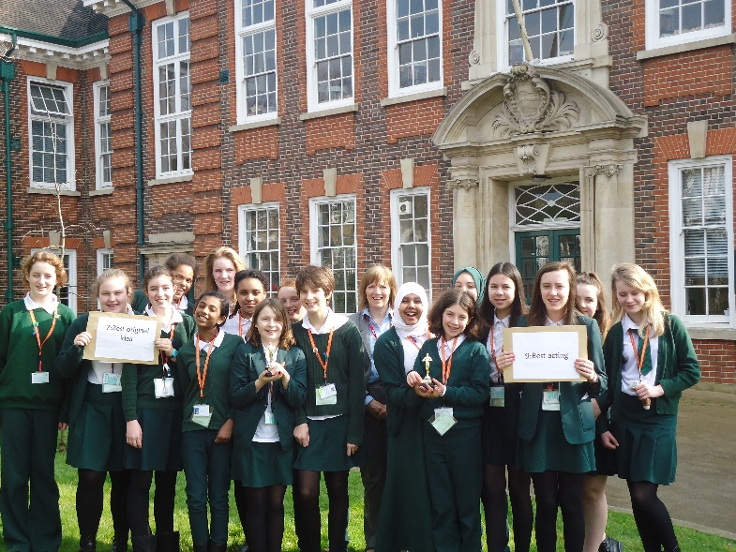
Walthamstow School for Girls is a place of high achievement. Effective teaching and learning are at the heart of our school. The school motto “Neglect not the gift that is in thee” underpins all the school’s work. Every girl is expected, encouraged and supported to achieve her very best academically and our pastoral system supports our students’ academic and social experiences.
Our role is to educate tomorrow’s women through a range of activities and opportunities to be confident, secure and happy individuals as they prepare for further education, careers and future lives.

WALTHAMSTOW SCHOOLFOR GIRLS
Job Description
JOB TITLE: Examination Invigilator
JOB PURPOSE:
To ensure all examination regulations are followed. Every student has the opportunity to access all publication examinations.

MAJOR TASKS/ACTIVITIES
- To ensure each exam room has the following:-

White board
Clock
Desks are the correct distance apart
Relevant signs are displayed inside and out
No entry signs are displayed as appropriate
Labels are placed according to the seating plan

- Check the identity of each student and that they are sitting at the correct desk.

- Student has the correct paper and level of paper.

- Ensure students have completed personal details on the front of the exam paper.

- Monitor students whilst they are in the exam room, checking for any signs of malpractice.

- Papers are collected in accordance with exam registers.

- To assist with the parcelling up of exam papers and completing Parcelforce log.

Walthamstow School for Girls
Examination Invigilator
Person Specification
1. Experience
- Relevant work experience Essential
- Experience of working within a team Essential
- Experience of working on own initiative Essential
- Experience of invigilating school examinations Essential
- Experience of working with children of relevant age Desirable
- Knowledge/experience of Education sector and/or schools Desirable
2. Special abilities / aptitudes
- Flexibility and ability to work as part of the Examinations team Essential
- Interpersonal skills – dealing with students and colleagues Essential
- Ability to work effectively under pressure Essential
- Ability to maintain integrity of confidential materials Essential
- An understanding of examination processes and/or experience
of administering examinations Essential
- Ability to communicate effectively at all levels both verbally and
in writing. Desirable
- Other job specific requirements
- Commitment to the Authority’s Equal Opportunities Policy
and acceptance of their responsibility for its practical application Essential
- Understanding of good Health and Safety practices in the work
place Essential
4. Education and Training
- Good General Standard of Education Essential
- Good numeracy/literacy skills Essential

Disqualifying Factors
Indication of sexist, racist or anti-disability attitudes or any other inconsistent with the Authority’s Equal Opportunities Policy

The diversity of all the students and accepting all religions, cultures and traditions.
It is welcoming, my daughter quickly settled into school life. It has high expectations of students but these are adapted for each individual so each is encouraged to do the best they can.

The value placed on education for young women, standards of behaviour expected, opportunities for activities which extend my daughter's understanding and interests, diverse community.

That the school provides opportunities for each girl to feel confident to strive to push beyond their current capabilities to achieve through hard endeavour and a belief that anything is possible.

What do you value most
about our school?
A sample of responses from a survey of parents (February 2016)
The sense of community; the high standards and expectations set by the school; the holistic approach to learning for the girls; the extra curriculum activities which supports learning and the fact that the staff team is a good diverse one.

High-quality learning environment and culture: comprising motivated, well-behaved pupils, strong and inspiring teachers and good resources.

The professionalism and reputation over such a long number of years.

