WALTHAMSTOW SCHOOL FOR GIRLS
“Neglect not the gift that is in me”

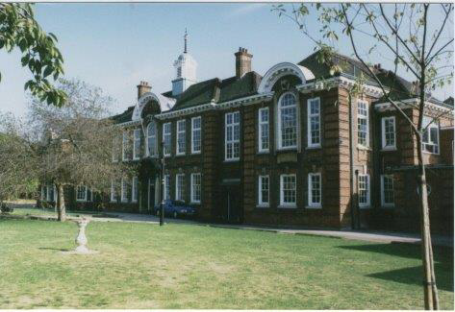

Information for applicants for the post of
Deputy Head of Faculty - Mathematics
Required for
September 2019

January 2019

Dear Applicant
Thank you for requesting an application pack for the post of Deputy Head of Faculty - Mathematics.
Walthamstow School for Girls is a high achieving, oversubscribed, diverse school which is regularly in the top 5% nationally for progress and the top 10% nationally for attainment and is at the centre of the vibrant local community of Waltham Forest (the first London borough of culture). We have an ambition to become ‘world class’ and a commitment to work with other professionals both locally, nationally and internationally, through our Erasmus links. We won the national High Aspiration Award for the progress made by disadvantaged students and have won SSAT Achievement and Progress awards annually since 2014. We have been awarded the SSAT Exceptional Education standard twice; in 2017, for Leadership through Moral Purpose, and, in 2018, for Systems: use of assessment, data, policies and monitoring to support teaching and learning. We were awarded Teaching School and National Support School Status in September 2017. In June 2018, following a Section 8 inspection, we were awarded an ‘outstanding’ judgement.
Our students are ambitious and hard-working; they embrace the range of opportunities offered to them both during and beyond the school day. This is highlighted not only by our exceptional examination results but also by the maturity of the girls, their sense of responsibility, community and fun. They are a delight to work with.
We offer excellent facilities to both staff and students. Our acclaimed architect designed site is an oasis of green and a pleasure to work in. It is well served by transport connections, being just ten minutes’ walk away from Walthamstow Central tube and overground station and five minutes’ walk from the popular Walthamstow ‘village’, and creative and restaurant quarter. We pride ourselves on working hard to retain our role as an important part of the local community. Examples of this commitment can be seen in our weekly Greensheets. Our staff are inclusive and friendly, with regular social and wellbeing events as well as charity fundraising.
We are committed to Safer Recruitment practices and procedures and shortlisted applicants will be questioned about their commitment to the safeguarding of young people. The successful candidate will be subject to an enhanced DBS clearance.
Thank you for taking an interest in this position. I do hope that having read more about the school you will decide to apply for the post. I look forward to receiving your application. Please note that it will not be possible to give feedback to unsuccessful applicants, other than those called for interview. Thank you for your understanding and good luck with your career in education.
Ms Meryl Davies
Headteacher, NPQH, NLE

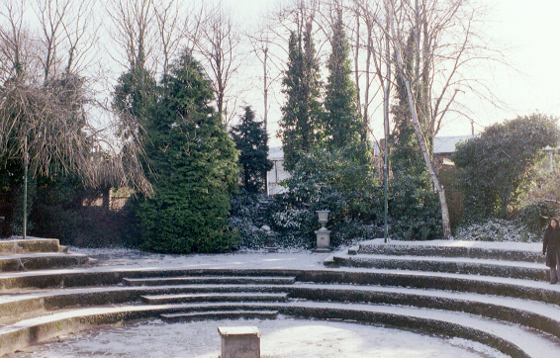

The History of Walthamstow School for Girls
In January 1890, a circular stated that a “school for girls” was to be opened. Walthamstow was described as a pleasant suburb on the borders of Epping Forest. Hoe Street was almost a country road, with a few houses on either side and meadows in which were sheep, cattle, hawthorn and wild roses.
Miss Hewett was the first Headmistress, at the age of 27 until she retired in 1924. There were 49 girls, whose ages ranged from 7-16 years. At this time there were only five teachers, two of whom were graduates. The School’s original Staff Book gives details of the first one hundred teachers. Of them 30 remained at the school for ten years or more, 22 giving over twenty years’ service. Until 1944 all the teachers were women and not married.
The original building was in West Avenue Road and when the numbers grew the school moved to Church Hill House, where a church now stands. At this time there were also boys up to the age of 13 years at the school. It was in September 1913 that 243 girls came into the present building with the Greek Theatre being added in the 1920s. However in July 2008 the whole school moved off site for a period of four school terms to facilitate the building and refurbishment programme that has resulted in the unique blend of traditional and state of the art facilities found at the school today.
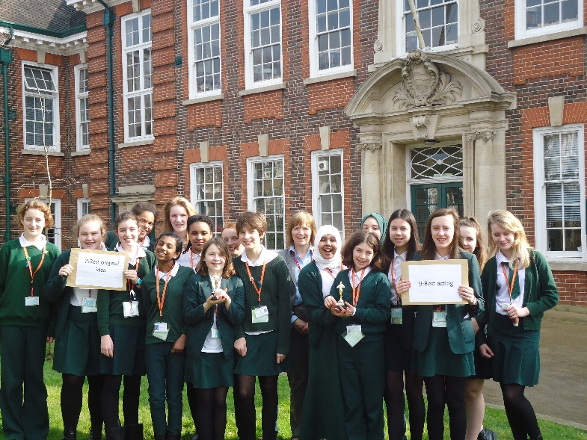
Walthamstow School for Girls is a place of high achievement. Effective teaching and learning are at the heart of our school. The school motto “Neglect not the gift that is in thee” underpins all the school’s work. Every girl is expected, encouraged and supported to achieve her very best academically and our pastoral system supports our students’ academic and social experiences.
Our role is to educate tomorrow’s women through a range of activities and opportunities to be confident, secure and happy individuals as they prepare for further education, careers and future lives.

DEPUTY HEAD OF FACULTY
JOB DESCRIPTION
(Core Faculty)

Reporting to: Head of Faculty.
Responsible for: Communicating to the Head of Faculty the interests and needs of those staff he/she line manages
Line management of: Named members of the faculty (This may include members of support staff in appropriate)
Liaising with: Head of Faculty, teaching and support staff in the faculty, relevant staff with cross school responsibilities, relevant support staff, LEA personnel, governors, parents
Contracted working time: 195 days per year – full time. Attendance at identified calendared events in school year
Salary/Grade: TLR 2b
Disclosure Level: Enhanced

Job Purpose

- To lead and manage a Key Stage
- To be accountable for student progress and attainment in that Key Stage.
- To deputise for the Head of Faculty in his/her absence (along with the
other Deputy HOF, in line with written faculty policy).
- To make appropriate cover arrangements for classes when staff are
absent (in line with written faculty policy)

Main duties
- Curriculum

  - To lead, manage and develop student attainment across KS3 or KS4.

  - To be accountable for the planning, delivery and assessment of the subject at that Key Stage including the development of syllabi, differentiated resources, Schemes of Work and assessment strategies.
  - To keep up to date with national, regional and local developments in the
subject area at that Key Stage and to actively monitor and respond to them,
disseminating this knowledge to the relevant members of staff.

2. Quality Assurance
- To support the Head of Faculty in carrying out the twice yearly Self- Evaluation Activity as a means of informing faculty practice and identifying
areas for development.
- To monitor student standards and attainment at the Key Stage against annual targets.

3. Strategic Leadership
- To lead on the implementation and evaluation of one of the three faculty development plan targets.

4. Management Information
- To use data appropriately to set targets and expectations at the Key Stage and to ensure effectively differentiated teaching of the subject.

5. Staffing
- To be Performance Manager for a small number of faculty members,
carrying out performance management reviews in line with school policy and setting challenging objectives.
- To lead, develop and enhance the teaching practice of the line managed staff.
- To participate in the recruitment and interview process for members of the
faculty.

6. Resources
- To support the HOF in overseeing and evaluating the Key Stage
budget allocation to ensure it is spent in line with faculty and SIP
priorities and best value principles.

7. Cross Faculty Responsibilities
- To be faculty rep for Challenge, ICT or SEN

8. Teaching
- To undertake an appropriate programme of teaching on a ratio of 40/50.

9. Whole School Contribution
- To contribute to the development of whole school policy.
- To represent the faculty at Head of Faculty meetings in the Head of Faculty’s absence.
- To attend Forum meetings.
- To support the school ethos, aims and policies.

Additional Duties
- To play a full part in the life of the school community, to support its distinctive aims and ethos and to encourage staff and students to follow this
example.
- To continue personal professional development.
- To engage actively in the performance review process.
- To undertake any other duty as specified by STPCB not mentioned above.

This job description is carried out in accordance with provisions of the School Teachers’ Pay and Conditions document and within the range of teachers’ duties set out in that document.
The school will endeavour to make any necessary reasonable adjustments to the job and the working environment to enable access to employment opportunity for disabled job applicants or continued employment for any employee who develops a disabling condition.
Each second in faculty may have specific duties on top of these generic ones.
This job description is current at the date shown but, in consultation with you, may be changed by the Headteacher to reflect or anticipate changes in the job commensurate with the grade and job title.
Walthamstow School for Girls is committed to Safer Recruitment practices and procedures.
This school is committed to safeguarding and promoting the welfare of children and young people and expects all staff and volunteers to share this commitment.

January 2019

DEPUTY HEAD OF FACULTY- MATHEMATICS - PERSON SPECIFICATION

The successful candidate will have:
- Qualified teaching status.
- Proven classroom expertise as a Mathematics Teacher.
- An ability to plan, deliver and evaluate sequences of work and individual lessons.
- An enthusiasm for the subject and an ability to promote a sense that Mathematics is enjoyable.
- An ability to constantly monitor students’ achievements and adapt teaching to the needs of the class.
- An ability to contribute to the development and promotion of Mathematics at KS3 and KS4.
- Understanding and knowledge of the appropriate use of a range of differentiation techniques.
- The ability to contribute to the work within the faculty, both as a leading member of the Faculty and individually.
- A commitment to the promotion of anti-sexism, anti-racism and equality of opportunity in all aspects of their work within the school.
- An ability to contribute to the development of the Mathematics curriculum in an effort to continually raise standards.
- A willingness to contribute to the extra-curricular activities within the faculty.
- A willingness to learn new skills and develop existing skills as a part of a programme of professional development, with the aim of using this development to further their career.
- Ability to collate and manage the Faculty’s assessment results in line with the Faculty assessment policy.
- A willingness to contribute to the Performance Management process as part of a wider programme of professional development.
- Personal qualities and skills that can contribute to the school’s pastoral system.
- An ability to effectively organise their workload, be energetic and have a sense of humour.
This school is committed to safeguarding and promoting the welfare of children and young people and expects all staff and volunteers to share this commitment.

Walthamstow School for Girls is committed to Equal Opportunities and to Safer Recruitment practices and procedures.

MATHEMATICS AT WALTHAMSTOW SCHOOL FOR GIRLS

Mathematics in Year 7 is taught in mixed ability groups of around 24 students, currently until the end of the first term. The students work mainly on the new Oxford Mymaths books. The classes all work on a particular topic together, with separate groups within the class working on different levels. This system allows for flexibility for individual students, as well as the possibility of whole class lessons on particular topics. A lesson which includes a starter on the same or a different topic is the norm.
The course is supplemented with a full set of written tests covering all the chapters, a bank of homework and investigational and rich tasks, computer software and various other modules of work, including one on financial capability.
Students who have not reached the required standard for maths at the end of KS2 are taught in a separate class for all of year 7, unless they reach the required standard and are moved into a mixed ability group.
After the Christmas break the rest of the students are placed in sets according to their ability. The six form groups are split into 8 mathematics sets. The top 4 groups usually have 30 students in them, with the groups decreasing in number down to the lowest groups having around 10 students.
In year 8 the groups are refined so that they are now set 1 to 8. The four lower groups currently work towards taking the Foundation level GCSE. The other four groups all take Higher. A number of group 1 students also take the FSMQ during year 11 and it is possible that in future, they also may be able to take GCSE Statistics during year 10.
During the 4 years from year 8 to 11, the students take tests that cover about one third of each book, so that comparative progress can be monitored. Other forms of continual assessment of students, including self-assessment, numeracy tests and a program of ‘mock’ style papers are also used.
The successful candidate will be expected to teach in every year group and cover the full range of ability levels.
January 2019

WALTHAMSTOW SCHOOL FOR GIRLS

The Aims of the Mathematics Department

The Mathematics Department will endeavour to ensure that students: -

- Acquire the basic skills and knowledge needed for everyday life, developing a variety of techniques to use mathematics as a tool.

- Acquire further skills and knowledge of value to her particular future within her own ability.

- Develop the ability to think logically and coherently through the experience of mathematical investigation and problem solving.

- Understand and use mathematics as a language and hence can communicate mathematically verbally, graphically and in a written fashion.

- Are able to see the role of mathematics in reproducing, simplifying and predicting the result of problems from a variety of disciplines.

- Can appreciate mathematics as an intellectual activity and develop a fascination for the aesthetic appeal of its structure, patterns and the relationships within it.

- Work in an environment of equal opportunity for all cultural backgrounds, learn how other cultures have played their role in mathematical development and understand that mathematics is equally accessible for both sexes.

- Learn mathematics through a variety of approaches including exposition, investigation, discussion, practical work and consolidation.

Teachers should encourage pupils to:-

- Enjoy their mathematics – the teachers’ enthusiasm for the subject being all important.

- Develop good working habits including the fostering of imagination creativeness and persistence.

- Work systematically, checking that results are sensible and correcting errors.

- Work independently of the teacher.

- Work co-operatively within pairs or groups discussing mathematics with each other.

- Work at a suitable level allowing them to develop confidence in their mathematical ability and to extend them but not to the point of failure.

March 2018

Staff Benefits
Outlined below are some of the additional benefits available to staff working at Walthamstow School for Girls.
Cycle 2 work scheme
This benefit offers staff the opportunity to make tax and national insurance savings whilst keeping fit at the same time.
Commitment to CPD
We actively encourage CPD to all staff. We regularly provide whole school CPD as part of the school calendar as well as supporting individual CPD requests.
Eye Tests
All staff using computer equipment should have eye and eyesight tests at regular intervals. Eyesight testing should also happen where staff experience visual difficulties, which may reasonably be considered to be caused by computer work.

Staff Wellbeing
As part of our CPD for staff we include sessions related to staff wellbeing. These include The Walthamstow School for Girls Running Club, Badminton, Box fit exercise sessions, yoga and the London Club (historical walks around London).

Workplace Options - Employee Assistance provider
A confidential counselling, help and information service is provided for all employees of LBWF and is available free of charge 24 hours a day, every day of the year. Counselling is offered on the telephone or in a face-to-face setting, in locations close to your work or your home. This service can help with a range of problems from practical everyday matters to sensitive and emotional issues. Please visit http://www.workplaceoptions.co.uk for further information.

That the school is single sex, and because of this can support the amazing young women that attend it forge their own identities and leave as independently minded, focused, well-informed citizens. The school ethos allows them to do this on their own terms.
High standards and good results through kind encouragement and interest taken in the pupils by the school. Also, developing the girls in such a way that they will be good citizens and well- rounded individuals.
That the school provides opportunities for each girl to feel confident to strive to push beyond their current capabilities to achieve through hard endeavour and a belief that anything is possible.

What do you value most
about our school?
A sample of responses from a survey of parents (February 2016)

It is welcoming, my daughter quickly settled into school life. It has high expectations of students but these are adapted for each individual so each is encouraged to do the best they can.

The professionalism and reputation over such a long number of years.

The diversity of all the students and accepting all religions, cultures and traditions.
High-quality learning environment and culture: comprising motivated, well-behaved pupils, strong and inspiring teachers and good resources.

The sense of community; the high standards and expectations set by the school; the holistic approach to learning for the girls; the extra curriculum activities which supports learning and the fact that the staff team is a good diverse one.

The value placed on education for young women, standards of behaviour expected, opportunities for activities which extend my daughter's understanding and interests, diverse community.

