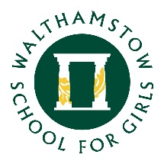
6 May 2020

Dear Parents and Carers,
I hope you are all healthy and are coping well in this unique situation.
The Year 7 Parent Teacher Consultation Evening was due to take place on Thursday 7th May. As I’m sure you understand this has been suspended as a result of the national lockdown and will no longer take place.
We do intend to feed back on your child’s progress later on in the summer term. The exact form that this feedback will take has yet to be decided.
Once we have a better idea as to when school is likely to reopen, we will be able to give you more information.
If you have any questions about this then please do get in touch.
Kind regards
Mr Morrow
Year 7 Student Progress Leader / Associate Assistant Headteacher

