21 April 2020

Dear Year 11

I hope this email finds you all safe and well.

I felt it was important to contact you as you continue to be our Year 11 students at Walthamstow School for Girls and, with the current situation, it is even more important that you keep in touch with us as we care very much about you.

We are still in the midst of very uncertain and unprecedented times. COVID-19 will always be known as the episode in our lives where we experienced the most extensive period of lockdown ever seen in peace time in our country's history. This period will be recorded in the archives (possibly books but almost definitely in the e-books and tomes online). This does not just affect us in Walthamstow, but everybody globally. In my very last assembly back at the start of March, I talked to you about remembering this moment in time... That, in 50 years' time as 65 year olds (!!), you will be able to look back at this period and recount to your children and your grandchildren how you lived through COVID-19. When I spoke to you at that time, little did I know the real consequences of COVID-19, that despite 5 years of secondary education you are part of the unique cohort unable to sit your national GCSE examinations.

These are challenging times for us all, but I want you to take the opportunity to reflect on the last five years as a successful time in your lives. I hope you will look back at school life at Walthamstow School for Girls and see your time here as amongst some of the best years you have had: the friendships you've built, the education you have had, the life experiences you have lived, the skills we have helped you to build and the opportunities you have been given should all help you to build a positive picture to hold onto and to help you envision an optimistic future ahead. I know you have it in you to make the most of this time you have: to reflect on your experiences and to start putting in place plans to build your future. And what futures you have ahead of you! You will, no doubt, have aspirations to go to colleges, sixth forms and universities, completing your ‘A' Levels/BTECs/apprenticeships or degrees and moving into the first steps of your career paths in order to live exciting and fulfilling lives. You have so much to look forward to!

Do not waste this time. Many of you have already applied to colleges and sixth forms and many continue to do so. We are here to support you through this process. There are also a number of opportunities available to students during this time: Eton college is currently offering online courses to students at no cost to you. They start on Monday so don't delay in applying! Details can be found in this link: https://etonx.com/
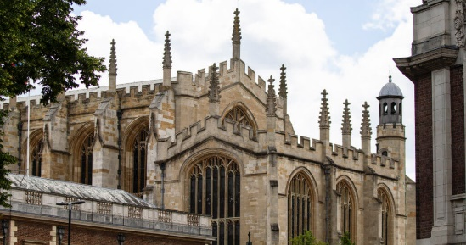 | Online Skill and Communication Courses for Teenagers | EtonX  EtonX’s online skill and communication courses allow students globally to benefit from Eton’s acclaimed expertise in developing well rounded, high-achieving students. An Eton education values real world skills alongside academic learning. Sign up today.  etonx.coof m

In addition, Ms Philippou will be sending you information about Start. You will have created a Start profile at the beginning of the year, and we feel it is an important time for you to use this effective tool to start putting in place plans for your future.

Most importantly, I will ask you to look after yourselves. Be kind to yourselves, to your siblings, your parents and carers and be there for one another. You alone know what you are going through as Year 11s, so you can be there to look out for and support each other.

Finally, an important reminder of our online forum. Our year group 'TEAM' has been set up for us all to be there for one another as a community. We are there to chat and to support one another as a year group. Visit 'TEAMS', download the app, read the posts, participate - even just to say 'Hello'. Some of you have done so already, but we do want to hear from you all. It has been heartening and uplifting to read so many of your posts and messages. Also, please check in regularly into your Tutor Group ‘TEAM’. It is a good way for you to say hello to your form group and to keep in touch with your Form Tutors who all miss you a lot!

One very last thing ... as promised, once this is all over, we will have a final year group celebration. It will be a time for us to share our stories, laugh and reminisce on your time here. I know staff at the school will want to say a final goodbye to you and you will also want to see each other at WSFG as a way to close this school chapter.
Keep in touch Year 11s and stay safe.

Mrs Jean-Baptiste
Student Progress Leader Year 11

