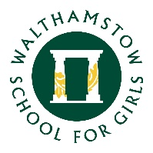
6 October 2020

Dear Parent/Carers of Year 11 students

I have had a few enquires about ways to help students apply for colleges and 6th forms, so here are a few pointers.

We have asked all colleges and 6th forms which our students have previously attended, to supply us with (virtual) open day information. This will be coming in over the next few weeks and months. The school website and Teams is being updated daily with this information.

Students will be given guidance on how to complete applications, and who to refer them to in school, during their PSHE lessons later in the term. We are unable to offer specific advice on course or colleges as this would be subjective.

We have suggested the girls use the National Careers Service website https://nationalcareers.service.gov.uk/ to look at careers they may be interested in, to find out the requirements for these careers whether this is through A levels, BTECs, university degrees or apprenticeships.

Once they know what is needed, students should look at college/6th form websites, attend (virtual) open days and read the college/6th form prospectus, which should be available online. Many websites will have information about virtual question/answer sessions, or students can e-mail the college or school with their questions.

I hope this helps.

Kind regards

Mrs Careless-Pye
Student Progress Leader Year 11

