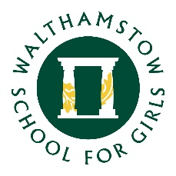

27 April 2022

Dear parent/carer

The school has undertaken a significant review of curriculum at both KS3 and KS4 over the last term which has resulted in us planning for significant changes to the Science provision at KS3 and KS4.

The letter linked below details these changes and how we plan to support students and families over the coming weeks with regard to this.

As detailed in the letter, we plan to offer an information evening to support families and have included an opportunity to submit questions for this information evening. Your questions can be submitted on this link.

Yours faithfully

Nick O'Brien
Deputy Headteacher/Director North East London Teaching School Hub (NELTSH)
Triple Science Option Letter

