WALTHAMSTOW SCHOOL FOR GIRLS
“Neglect not the gift that is in me”

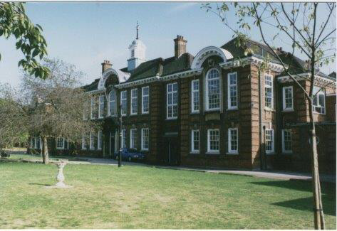

Information for applicants for the post of
Temporary Waltham Forest Green Teaching School Alliance Administrator / DHT PA
November 2017

November 2017

Dear Applicant
Thank you for requesting an application pack for the post of Waltham Forest Green Teaching School Alliance Administrator / DHT PA.
Walthamstow School for Girls is a high achieving, oversubscribed multi-cultural school which is regularly in the top 5% nationally for progress and the top 10% nationally for attainment. We have an ambition to become ‘world class’ and a commitment to work with other professionals both locally and nationally. In 2015 we won the national High Aspiration Award for the progress made by disadvantaged students and have won SSAT Achievement and Progress awards annually since 2014. Our students are ambitious and hard-working, they embrace the opportunities offered to them and this is highlighted by our exceptional examination results. They are a delight to work with.
We offer excellent facilities to both staff and students. Our acclaimed architect designed site is a pleasure to work in and is well served by transport connections, being just ten minutes’ walk away from Walthamstow Central tube and overground station and five minutes’ walk from the popular Walthamstow ‘village’, and creative and restaurant quarter. We pride ourselves on working hard to retain our role as an important part of the local community. Examples of this commitment can be seen in our weekly Greensheets. Our staff are inclusive and friendly, with social and wellbeing events organised on a regular basis. Other incentives for staff include membership of a child care voucher and cycle to work scheme.
The school is committed to safeguarding and promoting the welfare of children. We are committed to Safer Recruitment practices and procedures and shortlisted applicants will be questioned about their commitment to the safeguarding of young people. The successful candidate will be subject to an enhanced DBS clearance.
Thank you for taking an interest in this position. I do hope that having read more about the school you will decide to apply for the post. I look forward to receiving your application. Please note that it will not be possible to give feedback to unsuccessful applicants, other than those called for interview. Thank you for your understanding.

Ms Meryl Davies
Headteacher

The History of Walthamstow School for Girls
In January 1890, a circular stated that a “school for girls” was to be opened. Walthamstow was described as a pleasant suburb on the borders of Epping Forest. Hoe Street was almost a country road, with a few houses on either side and meadows in which were sheep, cattle, hawthorn and wild roses.
Miss Hewett was the first Headmistress, at the age of 27 until she retired in 1924. There were 49 girls, whose ages ranged from 7-16 years. At this time there were only five teachers, two of whom were graduates. The School’s original Staff Book gives details of the first one hundred teachers. Of them 30 remained at the school for ten years or more, 22 giving over twenty years’ service. Until 1944 all the teachers were women and not married.
The original building was in West Avenue Road and when the numbers grew the school moved to Church Hill House, where a church now stands. At this time there were also boys up to the age of 13 years at the school. It was in September 1913 that 243 girls came into the present building with the Greek Theatre being added in the 1920s. However in July 2008 the whole school moved off site for a period of four school terms to facilitate the building and refurbishment programme that has resulted in the unique blend of traditional and state of the art facilities found at the school today.
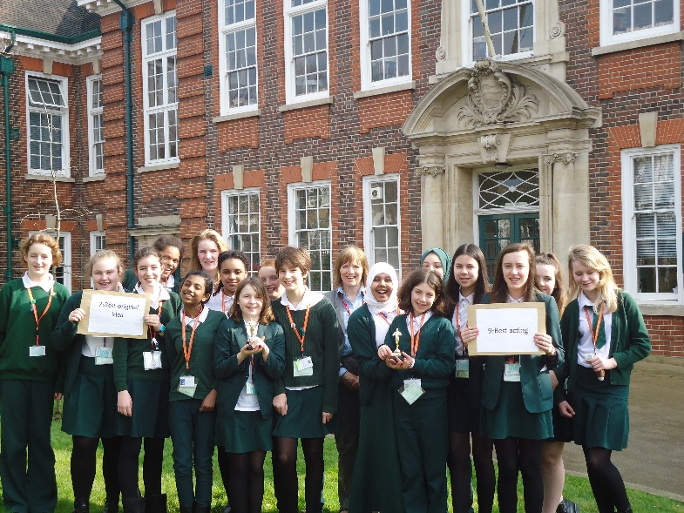
Walthamstow School for Girls is a place of high achievement. Effective teaching and learning are at the heart of our school. The school motto “Neglect not the gift that is in thee” underpins all the school’s work. Every girl is expected, encouraged and supported to achieve her very best academically and our pastoral system supports our students’ academic and social experiences.
Our role is to educate tomorrow’s women through a range of activities and opportunities to be confident, secure and happy individuals as they prepare for further education, careers and future lives.

WALTHAMSTOW SCHOOL FOR GIRLS
Job Description

JOB TITLE: Temporary Waltham Forest Green Teaching School Alliance Administrator / DHT PA
(Fixed-term contract for 2 years)
GRADE: Scale 4 / 5 (depending on experience)
HOURS: 25 Hours per week / 48 weeks per year
REPORTING TO: Deputy Headteacher

PURPOSE
- To be responsible for all the administration relating to the Waltham Forest Green Teaching School Alliance (WFGTSA)
- To provide day to day administrative support to the Deputy Headteachers

MAIN RESPONSIBILITIES
Teaching Alliance Administration
- To act as the main contact for all administrative support to the Waltham Forest Green Teaching School Alliance.

- To be the main contact for all Teaching School Alliance queries; from external queries and alliance members.

- To assist in the development of a full programme of available courses for the year, as directed by the Headteacher and Deputy Headteachers.

- To be responsible for ensuring that the WSGTSA programmes and publicised and promoted as direct by the Headteacher and Deputy Headteachers.

- To liaise closely with other partner schools across the alliance to ensure that any diary clashes with other school events are minimised.

- To prepare agendas for WFGTSA meetings and to ensure all attendees receive the relevant correspondence.

- To be responsible for liaising with schools hosting courses to ensure that the training sessions are run smoothly.

- To work with the Finance team to ensure invoices are issued accordingly.

- To be responsible for keeping accurate records regarding courses provided and payments received. Chasing outstanding invoices as necessary.

- To collate feedback from participants on the WFGTSA courses and activities and produce reports to evaluating the training provided.

- To liaise with the Communications Officer to ensure that the website has up to date and accurate information regarding the WFGTSA and is fully compliant with regulatory requirements.

- In liaison with the Headteacher and Deputy Headteacher complete all the necessary forms and documentation for NCTL.

- Attend any relevant Teaching School Alliance meetings and liaise with the Teaching School Alliance Team on a regular basis.

Administrative Support for the Deputy Headteachers
- To provide administrative and organisational support to the Deputy Headteachers.

- To undertake the typing and the complex IT based tasks required to produce correspondence and confidential reports.

- To meet and greet the Deputy Headteachers’ visitors, ensuring they are welcomed in a polite, friendly and efficient manner.

- To assist the Deputy Headteachers produce key school publications including; SIP, SEF, and School Policy documents, ensuring they are in the correct format and available within the set deadlines.

- To arrange hospitality requests for any events/meetings involving the Deputy Headteachers.

- To book and organise conferences on behalf of the Deputy Headteachers.

Other Administrative Duties
- To support the main school office, including the reception of visitors and answering the telephone.

- To provide other administrative support as directed by the line manager.

- Be aware of and comply with policies and procedures relating to Safeguarding, Equal Opportunities, Behaviour for Learning, Health and Safety, Data Protection and confidentiality and security, reporting all concerns to an appropriate person.

- There is an expectation to attend all key school events out of hours as detailed in the school calendar e.g. Open Evenings, all Faculty and Staff meetings and the relevant twilight inset sessions.

- Contribute to the overall ethos/work/aims of the school.

- To be flexible and work according to needs, which may involve assisting other areas which are commensurate with the grading of the post.

November 2017

This school is committed to safeguarding and promoting the welfare of children and young people and expects all staff and volunteers to share this commitment.

Walthamstow School for Girls
Person Specification
Temporary Waltham Forest Green Teaching School Alliance Administrator / DHT PA

Experience
- Experience of delivering efficient and effective secretarial support for senior management staff. | Essential
- Experience of working on own initiative with minimum supervision and meeting tight deadlines. | Essential
- Experience of the use of a wide range of computer software (e.g. word processing, spreadsheets, databases). | Essential
- Knowledge / experience of Education sector and/or schools.  - Experience / knowledge of managing social media sites | Desirable  Desirable
- Special abilities / aptitudes
- Flexibility and ability to work as part of and to contribute to the school administrative team. | Essential
- Interpersonal skills - dealing with parents, students, colleagues and outside agencies. | Essential
- Ability to deal sensitively and in confidence with a wide range of issues relating to working practices. | Essential
- Ability to communicate effectively at all levels both verbally and in writing and to produce high quality correspondence and reports. | Essential
- Ability to work effectively under pressure and to manage own workload and conflicting priorities. | Essential
- Ability to type quickly and accurately | Essential
- Ability to work methodically, ensuring attention to detail. | Essential
- Numeracy skills. | Essential
- Other job specific requirements
- Commitment to the Authority’s Equal Opportunities Policy and acceptance of their responsibility for its practical application.  - First Aid qualification | Essential  Desirable
- Education and Training
- Good General Standard of Education. | Essential

Disqualifying Factors
Indication of sexist, racist or anti-disability attitudes or any other inconsistent with the Authority’s Equal Opportunities Policy.
November 2017

This school is committed to safeguarding and promoting the welfare of children and young people and expects all staff and volunteers to share this commitment.

- cation and Training

That the school provides opportunities for each girl to feel confident to strive to push beyond their current capabilities to achieve through hard endeavour and a belief that anything is possible.

What do you value most
about our school?
A sample of responses from a survey of parents (February 2016)

It is welcoming, my daughter quickly settled into school life. It has high expectations of students but these are adapted for each individual so each is encouraged to do the best they can.

The diversity of all the students and accepting all religions, cultures and traditions.
The sense of community; the high standards and expectations set by the school; the holistic approach to learning for the girls; the extra curriculum activities which supports learning and the fact that the staff team is a good diverse one.

The value placed on education for young women, standards of behaviour expected, opportunities for activities which extend my daughter's understanding and interests, diverse community.

High-quality learning environment and culture: comprising motivated, well-behaved pupils, strong and inspiring teachers and good resources.

The professionalism and reputation over such a long number of years.

