WALTHAMSTOW SCHOOL FOR GIRLS
“Neglect not the gift that is in me”

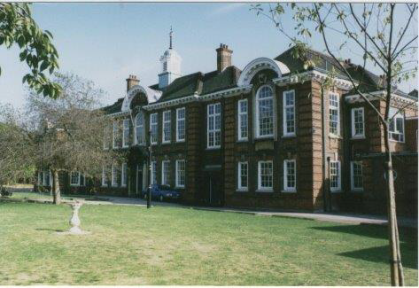

Information for applicants for the post of
Temporary Teacher of English
March 2018

March 2018

Dear Applicant
Thank you for requesting an application pack for the post of Temporary Teacher of English.
Walthamstow School for Girls is a high achieving, oversubscribed, diverse school which is regularly in the top 5% nationally for progress and the top 10% nationally for attainment and is at the centre of the vibrant local community of Waltham Forest (the first London borough of culture). We have an ambition to become ‘world class’ and a commitment to work with other professionals both locally, nationally and internationally, through our Erasmus links. Three years ago we won the national High Aspiration Award for the progress made by disadvantaged students and have won SSAT Achievement and Progress awards annually since 2014. We have been awarded the SSAT Exceptional Education standard twice; in 2017, for Leadership through Moral Purpose, and, in 2018, for Systems: use of assessment, data, policies and monitoring to support teaching and learning. We were awarded Teaching School and National Support School Status in September 2017.
Our students are ambitious and hard-working; they embrace the range of opportunities offered to them both during and beyond the school day. This is highlighted not only by our exceptional examination results but also by the maturity of the girls, their sense of responsibility, community and fun. They are a delight to work with.
We offer excellent facilities to both staff and students. Our acclaimed architect designed site is an oasis of green and a pleasure to work in. It is well served by transport connections, being just ten minutes’ walk away from Walthamstow Central tube and overground station and five minutes’ walk from the popular Walthamstow ‘village’, and creative and restaurant quarter. We pride ourselves on working hard to retain our role as an important part of the local community. Examples of this commitment can be seen in our weekly Greensheets. Our staff are inclusive and friendly, with regular social and wellbeing events as well as charity fundraising.
We are committed to Safer Recruitment practices and procedures and shortlisted applicants will be questioned about their commitment to the safeguarding of young people. The successful candidate will be subject to an enhanced DBS clearance.
Thank you for taking an interest in this position. I do hope that having read more about the school you will decide to apply for the post. I look forward to receiving your application. Please note that it will not be possible to give feedback to unsuccessful applicants, other than those called for interview. Thank you for your understanding and good luck with your career in education.
Ms Meryl Davies
Headteacher, NPQH, NLE

The History of Walthamstow School for Girls
In January 1890, a circular stated that a “school for girls” was to be opened. Walthamstow was described as a pleasant suburb on the borders of Epping Forest. Hoe Street was almost a country road, with a few houses on either side and meadows in which were sheep, cattle, hawthorn and wild roses.
Miss Hewett was the first Headmistress, at the age of 27 until she retired in 1924. There were 49 girls, whose ages ranged from 7-16 years. At this time there were only five teachers, two of whom were graduates. The School’s original Staff Book gives details of the first one hundred teachers. Of them 30 remained at the school for ten years or more, 22 giving over twenty years’ service. Until 1944 all the teachers were women and not married.
The original building was in West Avenue Road and when the numbers grew the school moved to Church Hill House, where a church now stands. At this time there were also boys up to the age of 13 years at the school. It was in September 1913 that 243 girls came into the present building with the Greek Theatre being added in the 1920s. However in July 2008 the whole school moved off site for a period of four school terms to facilitate the building and refurbishment programme that has resulted in the unique blend of traditional and state of the art facilities found at the school today.
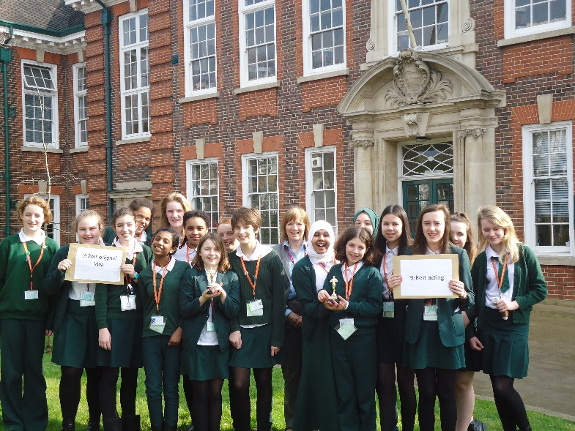
Walthamstow School for Girls is a place of high achievement. Effective teaching and learning are at the heart of our school. The school motto “Neglect not the gift that is in thee” underpins all the school’s work. Every girl is expected, encouraged and supported to achieve her very best academically and our pastoral system supports our students’ academic and social experiences.
Our role is to educate tomorrow’s women through a range of activities and opportunities to be confident, secure and happy individuals as they prepare for further education, careers and future lives.

WALTHAMSTOW SCHOOL FOR GIRLS
Classroom Teacher
JOB DESCRIPTION
1.1 Post Title: TEACHER
1.2 Post Purpose: Under the reasonable direction of the Headteacher, carry out the professional duties of a school teacher as set out in the current school Teachers’ Pay and Conditions Document (STPCD).
To implement and deliver an appropriately broad, balanced, relevant and differentiated curriculum for students and to support a designated curriculum area as appropriate.
To monitor and support the overall progress and development of students as a teacher/Form Tutor.
To facilitate and encourage a learning experience which provides students with the opportunity to achieve their individual potential.
To contribute to raising standards of student attainment.
To share and support the school’s responsibility to provide and monitor opportunities for personal and academic growth.
1.3 Reporting to: Head of Faculty
1.4 Responsible for: The provision of a full learning experience and support for students.
Safeguarding and promoting the welfare of all students.
1.5 Liaising with: Teachers and support staff, LEA representatives, external agencies and parents.
1.6 Working time: Full time as specified within the STPCD.
1.7 Salary/Grade Classroom Teachers’ Pay Scale
1.8 Disclosure Level: Enhanced

2. TEACHING
2.1 To teach students according to their individual educational needs, including the setting and marking of work according to the school’s policies.
2.2 To assess, record and report on the attendance, progress, development and attainment of students and to keep such records as are required.
2.3 To provide, or contribute to, oral and written assessments, reports and references relating to individual students and groups of students.
2.4 To ensure that ICT, Literacy, Numeracy and school subject specialism(s) are reflected in the teaching/learning experience of students.
2.5 To undertake a designated programme of teaching on a ratio of 40/50 periods.
2.6 To ensure a high quality of learning experience for students which meets internal and external quality standards.
2.7 To prepare and update subject materials.
2.8 To use a variety of delivery methods which will stimulate learning appropriate to student needs and demands of the syllabus.
2.9 To maintain discipline in accordance with the school’s procedures, and to encourage and model good practice with regard to punctuality, behaviour, standards of work and homework.
2.10 To undertake assessment of students as requested by external examination bodies, departmental and school procedures.
2.11 To mark, grade and give written/verbal and diagnostic feedback as required.

3. OPERATIONAL/STRATEGIC PLANNING
3.1 To assist in the development of appropriate syllabi, resources, schemes of work, marking policies and teaching strategies in the Faculty.
3.2 To contribute to the Faculty’s development plan and its implementation.
3.3 To plan and prepare courses and lessons
3.4 To contribute to the whole school’s planning activities.

4. CURRICULUM PROVISION & DEVELOPMENT
4.1 To assist the Head of Faculty in ensuring that the curriculum area provides a range of teaching which complements the school’s strategic objectives and continues to be relevant to the needs of students, examining and awarding bodies and the school’s Aims.

5 STAFFING
5.1 To take part in the school’s staff development programme by participating in arrangements for further training and professional development.
5.2 To continue personal development in the relevant areas including subject knowledge and teaching periods.
5.3 To engage actively in the Performance Management Review process.
5.4 To ensure the effective/efficient deployment of classroom support.
5.5 To work as a member of a designated team and to contribute positively to effective working relations within the school.
6. QUALITY ASSURANCE
6.1 To help implement school quality procedures and to adhere to those.
6.2 To contribute to the process of monitoring and evaluation of the curriculum area in line with agreed school procedures, including evaluation against quality standards and performance criteria. To seek/implement modification and improvement where required.
6.3 To review from time to time methods of teaching and programmes of work.
6.4 To take part, as may be required, in the review, development and management of activities relating to the curriculum, organisation and pastoral functions of the school.
7. MANAGEMENT INFORMATION
7.1 To maintain appropriate records and to provide relevant accurate and up to-date information for MIS, registers, etc.
7.2 To complete the relevant documentation to assist in the tracking of students.
7.3 To track student progress and use information to inform teaching and learning.
8. COMMUNICATIONS & LIAISON
8.1 To communicate effectively with the parents of students as appropriate.
8.2 Where appropriate, to communicate and co-operate with persons or bodies outside the school.
8.3 To follow agreed policies for communications in the school.
8.4 To take part in liaison activities such as parents’ evenings, review days and liaison events with partner schools.
8.5 To contribute to the development of effective subject links with external agencies.

9 MANAGEMENT OF RESOURCES
9.1 To assist the Head of Faculty in identifying resource needs and to contribute to the efficient/effective use of physical resources.
9.2 To co-operate with other staff to ensure a sharing and effective usage of resources to the benefit of the School, Faculty and the students.
10 PASTORAL SYSTEM
10.1 To be a Form Tutor to an assigned group of students.
10.2 To promote the general progress and well-being of individual students and of the Form Tutor Group as a whole.
10.3 To liaise with a Curriculum Leader to ensure the implementation of the school’s Pastoral System.
10.4 To register students, accompany them to assemblies, encourage their full attendance at all lessons and their participation in other aspects of school life.
10.5 To evaluate and monitor the progress of students and keep up-to-date student records as may be required.
10.6 To contribute to the preparation of action plans and progress files and other reports.
10.7 To alert the appropriate staff to problems experienced by students and to make recommendations as to how these may be resolved.
10.8 To communicate as appropriate, with the parents of students and with persons or bodies outside the school concerned with the welfare of individual students, after consultation with the appropriate staff.
10.9 To apply the Behaviour Management systems so that effective learning can take place.
  - To deliver a tutorial programme of activities relevant to the tutor group as
advised by line manager.
  - To attend annual reviews for assigned students who are on the SEN register.

11 SCHOOL ETHOS
11.1 To play a full part in the life of the school community, to support is distinctive aims and ethos and to encourage staff and students to follow this example.
11.2 To promote actively the school’s policies.
11.3 To comply with the school’s Health and Safety policy and undertake risk assessments as appropriate.

Whilst every effort has been made to explain the main duties and responsibilities of the post, each individual task undertaken may not be identified.
The school will endeavour to make any necessary reasonable adjustments to the job and the working environment to enable access to employment opportunities for disabled job applicants or continued employment for any employee who develops a disabling condition.
This job description is current at the date below but will be reviewed on an annual basis and, following consultation with you, may be changed to reflect or anticipate changes in the job requirements which are commensurate with the job title and grade.
November 2017
This school is committed to safeguarding and promoting the welfare of children and young people and expects all staff and volunteers to share this commitment.

PERSON SPECIFICATION

The successful candidate will have:
- A degree in English or a related subject.
- Qualified teaching status.
- Proven classroom expertise.
- Experience of, or willingness to teach English GCSE
- An ability to plan, deliver and evaluate sequences of work and individual lessons.
- A passion for the subject and an ability to promote a sense that English is enjoyable.
- An ability to constantly monitor students’ achievements and adapt teaching to the needs of the class.
- Understanding and knowledge of the appropriate use of a range of differentiation techniques.
- The ability to contribute to the work within the faculty, both as a member of a team and individually.
- A commitment to the promotion of anti-sexism, anti-racism and equality of opportunity in all aspects of their work within the school.
- A willingness to contribute to the extra-curricular activities within the faculty and support ongoing projects.
- A willingness to learn new skills and develop existing skills as a part of a program of professional development, with the aim of using this development to further their career.
- Personal qualities and skills that can contribute to the school’s pastoral system.
- An ability to effectively organise their workload, be energetic and have a sense of humour.
This school is committed to safeguarding and promoting the welfare of children and young people and expects all staff and volunteers to share this commitment.

November 2017

The English Faculty

The English Faculty is a dynamic and exciting one currently consisting of seven enthusiastic and committed English specialists and further English specialists from outside the faculty. The Faculty is a well-established team with a reputation for innovative curriculum development and effective and creative teaching and learning styles. The Faculty’s work is often modelled as good practice for other faculty areas. The Faculty adds value significantly in excess of national expectations across both Key Stages.

Classes are taught in mixed ability groups in both Key Stages where all lessons are thoroughly differentiated to cater for all our students’ needs. In-class support is provided by members of the Learning Support Department who also tailor make resources, collaborate with English teachers and regularly team teach. Classes in Key Stage 3 are taught in groups of 30; Key Stage 4 classes are between 22 and 26.

At Walthamstow School for Girls, English is an extremely popular area of the curriculum and emphasis is placed on development of the students’ skills and confidence in reading, writing, speaking and listening as well as the development of independent learners. The Faculty is well equipped with audio visual resources and Faculty laptop trolleys and makes extensive use of the school’s other ICT facilities.

The Faculty electronically stores resources centrally for all to use and colleagues regularly contribute to this forum. All six rooms have interactive whiteboards. The Faculty is well stocked and texts are regularly updated.

The Faculty has shared schemes of work in place for both Key Stages which cover the requirements
of the National Curriculum, and ensure students’ steady progression of key skills and the WJEC GCSE syllabus. These consist of carefully devised sequences which respect students’ diversity, stimulate their interests and introduce them to challenges. The Faculty regularly updates and modifies common schemes of work to ensure students are developing the appropriate skills for lifelong learning and are continually being offered the appropriate level of challenge. The department works closely with the Librarian to promote reading, and the school also successfully run the Accelerated Reading Programmme. We regularly facilitate writing competitions and a number of our students have had work published in poetry anthologies.

At Key Stage 4 all students follow the WJEC English and English Literature GCSE courses. The Faculty has a strong tradition of good GCSE results and many students study further in English at post 16 level. In 2016 84% of students achieved A* to C in Language and 91% achieved A* to C in Literature. Progress of students is in the top 2% nationally.

Ongoing curriculum development and research is at the core of the English Faculty’s work. We have made significant and exciting progress in many areas including; reading, media, ICT, multicultural literature, and bi-lingual support materials.

The Faculty provides a range of quality extra curriculum events which support and reaffirm the schools’ ethos and engender a sense of the school as a community of readers and writers. These range from annual poetry and short story competitions, visiting poets, International Women’s Day celebrations and working with Shakespeare’s Globe Theatre.

We have an excellent team spirit, learn from each other and see ourselves as a committed team. We are keen to learn and experiment with new teaching and learning pedagogy and always rise to the challenge.

November 2017

Staff Benefits

Outlined below are some of the additional benefits available to staff working at Walthamstow School for Girls.
Cycle 2 work scheme
This benefit offers staff the opportunity to make tax and national insurance savings whilst keeping fit at the same time.
Commitment to CPD
We actively encourage CPD to all staff. We regularly provide whole school CPD as part of the school calendar as well as supporting individual CPD requests.
Eye Tests
All staff using computer equipment should have eye and eyesight tests at regular intervals. Eyesight testing should also happen where staff experience visual difficulties, which may reasonably be considered to be caused by computer work.

Staff Wellbeing
As part of our CPD for staff we include sessions related to staff wellbeing. These include The Walthamstow School for Girls Running Club, Badminton, Box fit exercise sessions, yoga and the London Club (historical walks around London).

Workplace Options - Employee Assistance provider
A confidential counselling, help and information service is provided for all employees of LBWF and is available free of charge 24 hours a day, every day of the year. Counselling is offered on the telephone or in a face-to-face setting, in locations close to your work or your home. This service can help with a range of problems from practical everyday matters to sensitive and emotional issues. Please visit http://www.workplaceoptions.co.uk for further information.

That the school provides opportunities for each girl to feel confident to strive to push beyond their current capabilities to achieve through hard endeavour and a belief that anything is possible.

What do you value most
about our school?
A sample of responses from a survey of parents (February 2016)

It is welcoming, my daughter quickly settled into school life. It has high expectations of students but these are adapted for each individual so each is encouraged to do the best they can.

The sense of community; the high standards and expectations set by the school; the holistic approach to learning for the girls; the extra curriculum activities which supports learning and the fact that the staff team is a good diverse one.

The professionalism and reputation over such a long number of years.

High-quality learning environment and culture: comprising motivated, well-behaved pupils, strong and inspiring teachers and good resources.

The diversity of all the students and accepting all religions, cultures and traditions.
The value placed on education for young women, standards of behaviour expected, opportunities for activities which extend my daughter's understanding and interests, diverse community.

