WALTHAMSTOW SCHOOL FOR GIRLS
“Neglect not the gift that is in me”

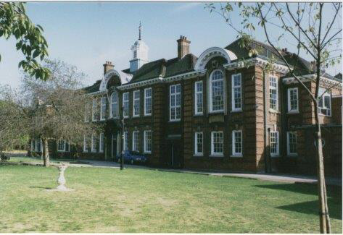

Information for applicants for the post of
Teacher of History
January 2018

September 2017

Dear Applicant

Thank you for requesting an application pack for the post of Teacher of History at Walthamstow School for Girls.
Walthamstow School for Girls is a high achieving, oversubscribed multi-cultural school which is regularly in the top 5% nationally for progress and the top 10% nationally for attainment. We have an ambition to become ‘world class’ and a commitment to work with other professionals both locally and nationally. In 2015 we won the national High Aspiration Award for the progress made by disadvantaged students and have won SSAT Achievement and Progress awards annually since 2014. Our students are ambitious and hard-working, they embrace the opportunities offered to them and this is highlighted by our exceptional examination results. They are a delight to work with.
We offer excellent facilities to both staff and students. Our acclaimed architect designed site is a pleasure to work in and is well served by transport connections, being just ten minutes’ walk away from Walthamstow Central tube and overground station and five minutes’ walk from the popular Walthamstow ‘village’, and creative and restaurant quarter. We pride ourselves on working hard to retain our role as an important part of the local community. Examples of this commitment can be seen in our weekly Greensheets. Our staff are inclusive and friendly, with social and wellbeing events organised on a regular basis. Other incentives for staff include membership of a child care voucher and cycle to work scheme.
The school is committed to safeguarding and promoting the welfare of children. We are committed to Safer Recruitment practices and procedures and shortlisted applicants will be questioned about their commitment to the safeguarding of young people. The successful candidate will be subject to an enhanced DBS clearance.
Thank you for taking an interest in this position. I do hope that having read more about the school you will decide to apply for the post. I look forward to receiving your application. Please note that it will not be possible to give feedback to unsuccessful applicants, other than those called for interview. Thank you for your understanding.

Ms Meryl Davies
Headteacher

The History of Walthamstow School for Girls
In January 1890, a circular stated that a “school for girls” was to be opened. Walthamstow was described as a pleasant suburb on the borders of Epping Forest. Hoe Street was almost a country road, with a few houses on either side and meadows in which were sheep, cattle, hawthorn and wild roses.
Miss Hewett was the first Headmistress, at the age of 27 until she retired in 1924. There were 49 girls, whose ages ranged from 7-16 years. At this time there were only five teachers, two of whom were graduates. The School’s original Staff Book gives details of the first one hundred teachers. Of them 30 remained at the school for ten years or more, 22 giving over twenty years’ service. Until 1944 all the teachers were women and not married.
The original building was in West Avenue Road and when the numbers grew the school moved to Church Hill House, where a church now stands. At this time there were also boys up to the age of 13 years at the school. It was in September 1913 that 243 girls came into the present building with the Greek Theatre being added in the 1920s. However in July 2008 the whole school moved off site for a period of four school terms to facilitate the building and refurbishment programme that has resulted in the unique blend of traditional and state of the art facilities found at the school today.
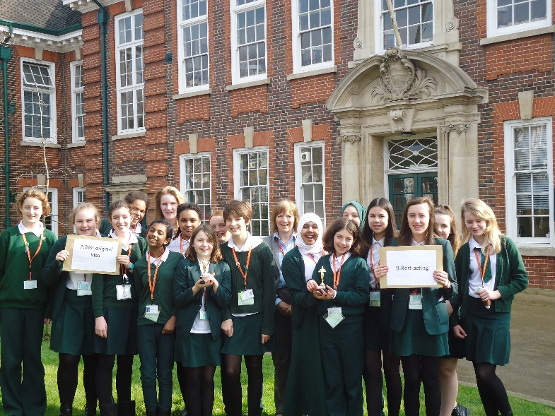
Walthamstow School for Girls is a place of high achievement. Effective teaching and learning are at the heart of our school. The school motto “Neglect not the gift that is in thee” underpins all the school’s work. Every girl is expected, encouraged and supported to achieve her very best academically and our pastoral system supports our students’ academic and social experiences.
Our role is to educate tomorrow’s women through a range of activities and opportunities to be confident, secure and happy individuals as they prepare for further education, careers and future lives.

WALTHAMSTOW SCHOOL FOR GIRLS
CLASSROOM TEACHER
JOB DESCRIPTION
1.1 Post Title: TEACHER
1.2 Post Purpose: Under the reasonable direction of the Headteacher, carry out the professional duties of a school teacher as set out in the current school Teachers’ Pay and Conditions Document (STPCD).
To implement and deliver an appropriately broad, balanced, relevant and differentiated curriculum for students and to support a designated curriculum area as appropriate.
To monitor and support the overall progress and development of students as a teacher/Form Tutor.
To facilitate and encourage a learning experience which provides students with the opportunity to achieve their individual potential.
To contribute to raising standards of student attainment.
To share and support the school’s responsibility to provide and monitor opportunities for personal and academic growth.
1.3 Reporting to: Head of Faculty
1.4 Responsible for: The provision of a full learning experience and support for students.
Safeguarding and promoting the welfare of all students.
1.5 Liaising with: Teachers and support staff, LEA representatives, external agencies and parents.
1.6 Working time: Full time as specified within the STPCD.
1.7 Salary/Grade Classroom Teachers’ Pay Scale
1.8 Disclosure Level: Enhanced

2. TEACHING
2.1 To teach students according to their individual educational needs, including the setting and marking of work according to the school’s policies.
2.2 To assess, record and report on the attendance, progress, development and attainment of students and to keep such records as are required.
2.3 To provide, or contribute to, oral and written assessments, reports and references relating to individual students and groups of students.
2.4 To ensure that ICT, Literacy, Numeracy and school subject specialism(s) are reflected in the teaching/learning experience of students.
2.5 To undertake a designated programme of teaching on a ratio of 40/50 periods.
2.6 To ensure a high quality of learning experience for students which meets internal and external quality standards.
2.7 To prepare and update subject materials.
2.8 To use a variety of delivery methods which will stimulate learning appropriate to student needs and demands of the syllabus.
2.9 To maintain discipline in accordance with the school’s procedures, and to encourage and model good practice with regard to punctuality, behaviour, standards of work and homework.
2.10 To undertake assessment of students as requested by external examination bodies, departmental and school procedures.
2.11 To mark, grade and give written/verbal and diagnostic feedback as required.

3. OPERATIONAL/STRATEGIC PLANNING
3.1 To assist in the development of appropriate syllabi, resources, schemes of work, marking policies and teaching strategies in the Faculty.
3.2 To contribute to the Faculty’s development plan and its implementation.
3.3 To plan and prepare courses and lessons.
3.4 To contribute to the whole school’s planning activities.

4. CURRICULUM PROVISION & DEVELOPMENT
4.1 To assist the Head of Faculty in ensuring that the curriculum area provides a range of teaching which complements the school’s strategic objectives and continues to be relevant to the needs of students, examining and awarding bodies and the school’s Aims.

5 STAFFING
5.1 To take part in the school’s staff development programme by participating in arrangements for further training and professional development.
5.2 To continue personal development in the relevant areas including subject knowledge and teaching periods.
5.3 To engage actively in the Performance Management Review process.
5.4 To ensure the effective/efficient deployment of classroom support.
5.5 To work as a member of a designated team and to contribute positively to effective working relations within the school.

6. QUALITY ASSURANCE
6.1 To help implement school quality procedures and to adhere to those.
6.2 To contribute to the process of monitoring and evaluation of the curriculum area in line with agreed school procedures, including evaluation against quality standards and performance criteria. To seek/implement modification and improvement where required.
6.3 To review from time to time methods of teaching and programmes of work.
6.4 To take part, as may be required, in the review, development and management of activities relating to the curriculum, organisation and pastoral functions of the school.

7. MANAGEMENT INFORMATION
7.1 To maintain appropriate records and to provide relevant accurate and up-to-date information for MIS, registers, etc.
7.2 To complete the relevant documentation to assist in the tracking of students.
7.3 To track student progress and use information to inform teaching and learning.

8. COMMUNICATIONS & LIAISON
8.1 To communicate effectively with the parents of students as appropriate.
8.2 Where appropriate, to communicate and co-operate with persons or bodies outside the school.
8.3 To follow agreed policies for communications in the school.
8.4 To take part in liaison activities such as parents’ evenings, review days and liaison events with partner schools.
8.5 To contribute to the development of effective subject links with external agencies.

9 MANAGEMENT OF RESOURCES
9.1 To assist the Head of Faculty in identifying resource needs and to contribute to the efficient/effective use of physical resources.
9.2 To co-operate with other staff to ensure a sharing and effective usage of resources to the benefit of the School, Faculty and the students.

10 PASTORAL SYSTEM
10.1 To be a Form Tutor to an assigned group of students.
10.2 To promote the general progress and well-being of individual students and of the Form Tutor Group as a whole.
10.3 To liaise with a Curriculum Leader to ensure the implementation of the school’s Pastoral System.
10.4 To register students, accompany them to assemblies, encourage their full attendance at all lessons and their participation in other aspects of school life.
10.5 To evaluate and monitor the progress of students and keep up-to-date student records as may be required.
10.6 To contribute to the preparation of action plans and progress files and other reports.
10.7 To alert the appropriate staff to problems experienced by students and to make recommendations as to how these may be resolved.
10.8 To communicate as appropriate, with the parents of students and with persons or bodies outside the school concerned with the welfare of individual students, after consultation with the appropriate staff.
10.9 To apply the Behaviour Management systems so that effective learning can take place.
  - To deliver a tutorial programme of activities relevant to the tutor group as
advised by line manager.
  - To attend annual reviews for assigned students who are on the SEN register.

11 SCHOOL ETHOS
11.1 To play a full part in the life of the school community, to support is distinctive aims and ethos and to encourage staff and students to follow this example.
11.2 To promote actively the school’s policies.
11.3 To comply with the school’s Health and Safety policy and undertake risk assessments as appropriate.

Whilst every effort has been made to explain the main duties and responsibilities of the post, each individual task undertaken may not be identified.
The school will endeavour to make any necessary reasonable adjustments to the job and the working environment to enable access to employment opportunities for disabled job applicants or continued employment for any employee who develops a disabling condition.
This job description is current at the date below but will be reviewed on an annual basis and, following consultation with you, may be changed to reflect or anticipate changes in the job requirements which are commensurate with the job title and grade.

This school is committed to safeguarding and promoting the welfare of children and young people and expects all staff and volunteers to share this commitment.

Teacher of Humanities

Person Specification

The successful candidate will have:
- A degree in a Humanities related subject.
- Qualified teaching status.
- Proven classroom expertise in teaching Humanities.
- An ability to plan, deliver and evaluate sequences of work and individual lessons.
- An enthusiasm for the subjects, in particular History, and an ability to promote a sense that Humanities is enjoyable.
- An ability to constantly monitor students’ achievements and adapt teaching to the needs of the class.
- Understanding and knowledge of the appropriate use of a range of differentiation techniques.
- The ability to contribute to the work within the faculty, both as a member of a team and individually.
- A commitment to the promotion of anti-sexism, anti-racism and equality of opportunity in all aspects of their work within the school.
- A willingness to contribute to the extra-curricular activities within the faculty and support ongoing projects.
- A willingness to learn new skills and develop existing skills as a part of a program of professional development, with the aim of using this development to further their career.
- Personal qualities and skills that can contribute to the school’s pastoral system.
- An ability to effectively organise their workload, be energetic and have a sense of humour.

This school is committed to safeguarding and promoting the welfare of children and young people and expects all staff and volunteers to share this commitment.

July 2017

Humanities Faculty

Mission Statement
The Humanities Faculty aims to foster an understanding of human attitudes and values, past and present, as well as an understanding of how society is organised, develops and changes. We endeavour to equip students with knowledge and skills so that they can become informed citizens of the future.

Approaches to learning
The faculty's approach stresses the importance of a core entitlement curriculum in humanities. We believe in working closely as a team; consequently team approaches to curriculum planning and delivery lie at the heart of our work. Teaching methods are flexible and pair-work and group-work play a significant role in enhancing student understanding. ICT based lessons, role-plays and simulations are seamlessly integrated into the schemes of work. We have developed a range of visits at both Key Stages, enhanced by the use of the local area to support a variety of learning activities.

Curriculum
In Years 7-9 we teach Humanities, a modular programme of lessons based on the National Curriculum for Geography and History. We also follow the locally agreed syllabus for Religious Education at Key Stage 3. There is a strong commitment to mixed-ability teaching and we support student learning and progress by working closely with the Learning Language and Development Faculty and the LSAs who support our lessons. In Year 10 pupils can opt for GCSE Geography and History and these options have been very popular over the past few years. From September 2016 the faculty has offered Religious Education as a timetabled GCSE option for the first time. Previously, all students completed the EdExcel short course in RE and were able to study the full course in their own time. We were the first faculty to develop a vocational studies course and at present we offer students a BTEC in Travel and Tourism.

Resources
The Humanities Faculty has seven specialist teachers working in five specialist teaching rooms, with each classroom having an interactive white board and five PCs for student use. One of the rooms has twenty PCs, which has helped to reinforce the teaching of the BTEC and to embed ICT activities in all three Humanities subjects. There is a good range of textbooks, DVDs and artefacts at both Key Stages.

Structure of the Faculty
The Head of Humanities is the Head of History. There are two Deputy Heads of Faculty: the Head of Geography and the Head of RE. The faculty also offers BTEC Travel and Tourism.

Feb 2017

That the school provides opportunities for each girl to feel confident to strive to push beyond their current capabilities to achieve through hard endeavour and a belief that anything is possible.

What do you value most
about our school?
A sample of responses from a survey of parents (February 2016)
It is welcoming, my daughter quickly settled into school life. It has high expectations of students but these are adapted for each individual so each is encouraged to do the best they can.

High-quality learning environment and culture: comprising motivated, well-behaved pupils, strong and inspiring teachers and good resources.

The diversity of all the students and accepting all religions, cultures and traditions.
The sense of community; the high standards and expectations set by the school; the holistic approach to learning for the girls; the extra curriculum activities which supports learning and the fact that the staff team is a good diverse one.

The value placed on education for young women, standards of behaviour expected, opportunities for activities which extend my daughter's understanding and interests, diverse community.

The professionalism and reputation over such a long number of years.

