WALTHAMSTOW SCHOOL FOR GIRLS
“Neglect not the gift that is in me”

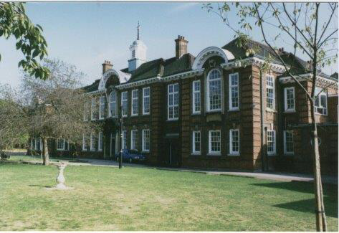

Information for applicants for the post of
Head of Faculty- Humanities
February 2018

February 2018

Dear Applicant

Thank you for requesting an application pack for the post of Head of Faculty - Humanities at Walthamstow School for Girls.
Walthamstow School for Girls is a high achieving, oversubscribed multi-cultural school which is regularly in the top 5% nationally for progress and the top 10% nationally for attainment. We have an ambition to become ‘world class’ and a commitment to work with other professionals both locally and nationally. In 2015 we won the national High Aspiration Award for the progress made by disadvantaged students and have won SSAT Achievement and Progress awards annually since 2014. Our students are ambitious and hard-working, they embrace the opportunities offered to them and this is highlighted by our exceptional examination results. They are a delight to work with.
We offer excellent facilities to both staff and students. Our acclaimed architect designed site is a pleasure to work in and is well served by transport connections, being just ten minutes’ walk away from Walthamstow Central tube and overground station and five minutes’ walk from the popular Walthamstow ‘village’, and creative and restaurant quarter. We pride ourselves on working hard to retain our role as an important part of the local community. Examples of this commitment can be seen in our weekly Greensheets. Our staff are inclusive and friendly, with social and wellbeing events organised on a regular basis. Other incentives for staff include membership of a child care voucher and cycle to work scheme.
The school is committed to safeguarding and promoting the welfare of children. We are committed to Safer Recruitment practices and procedures and shortlisted applicants will be questioned about their commitment to the safeguarding of young people. The successful candidate will be subject to an enhanced DBS clearance.
Thank you for taking an interest in this position. I do hope that having read more about the school you will decide to apply for the post. I look forward to receiving your application. Please note that it will not be possible to give feedback to unsuccessful applicants, other than those called for interview. Thank you for your understanding.

Ms Meryl Davies
Headteacher

The History of Walthamstow School for Girls
In January 1890, a circular stated that a “school for girls” was to be opened. Walthamstow was described as a pleasant suburb on the borders of Epping Forest. Hoe Street was almost a country road, with a few houses on either side and meadows in which were sheep, cattle, hawthorn and wild roses.
Miss Hewett was the first Headmistress, at the age of 27 until she retired in 1924. There were 49 girls, whose ages ranged from 7-16 years. At this time there were only five teachers, two of whom were graduates. The School’s original Staff Book gives details of the first one hundred teachers. Of them 30 remained at the school for ten years or more, 22 giving over twenty years’ service. Until 1944 all the teachers were women and not married.
The original building was in West Avenue Road and when the numbers grew the school moved to Church Hill House, where a church now stands. At this time there were also boys up to the age of 13 years at the school. It was in September 1913 that 243 girls came into the present building with the Greek Theatre being added in the 1920s. However in July 2008 the whole school moved off site for a period of four school terms to facilitate the building and refurbishment programme that has resulted in the unique blend of traditional and state of the art facilities found at the school today.
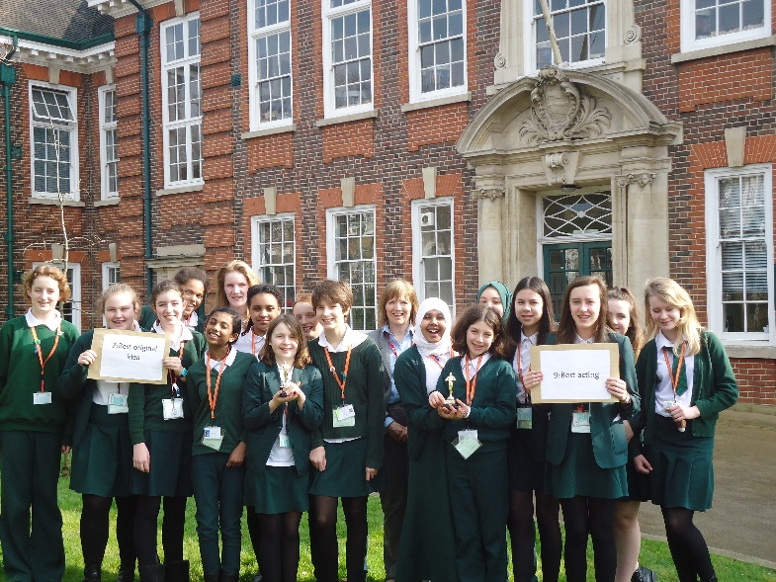
Walthamstow School for Girls is a place of high achievement. Effective teaching and learning are at the heart of our school. The school motto “Neglect not the gift that is in thee” underpins all the school’s work. Every girl is expected, encouraged and supported to achieve her very best academically and our pastoral system supports our students’ academic and social experiences.
Our role is to educate tomorrow’s women through a range of activities and opportunities to be confident, secure and happy individuals as they prepare for further education, careers and future lives.

HEAD OF FACULTY
(non core)

JOB DESCRIPTION

Reporting to: Leadership Team member line manager
Responsible for: Teaching staff and support staff within the faculty
Line management of: Deputy HOFs and other named members of the faculty
Liaising with: LT, other HOFs, SPLs, Teaching and Learning Leader, Student Support Services, relevant staff with cross-school responsibilities, relevant support staff, LEA personnel, governors, parents
Contracted working time: 195 days per year – full time. Attendance at identified calendared events in school year
Salary/Grade: TLR 1b
Disclosure Level: Enhanced

Job Purpose
- To lead and manage the faculty.
- To be accountable for student progress and attainment within the faculty.
- To monitor student achievement levels and ensure that strategies are in
place to maximise standards of attainment.
- To develop and enhance the teaching practice of the other members of the
faculty.

Main duties
- Curriculum
- To ensure the provision of an appropriately broad, balanced, relevant and differentiated curriculum to meet the needs of all students studying in the faculty.
- To assume direct responsibility for one subject within the faculty (non-core HOFs), including the development of syllabi, resources, SoW and assessment strategies.
- To lead curriculum development for the faculty.
- To keep up to date with national developments in the subject area and teaching practice and methodology.
- To actively monitor and respond to curriculum developments and initiatives at national, regional and local levels and to disseminate this knowledge to faculty members.
- To ensure that statutory requirements are met.

2. Monitoring and Evaluation
- To assume responsibility for Monitoring and Evaluation of school policies and procedures within the faculty, and the teaching and assessment of members of the faculty.
- To lead Self Evaluation activities and carry out the activities as a means of improving faculty practice and identifying areas for development.

3. Strategic Leadership
- To lead faculty colleagues in formulating aims, objectives and strategic plans
for the faculty which have coherence and relevance to the needs of students and to the aims, objectives and strategic plans of the school.
- To assume responsibility for writing, overseeing and evaluating the faculty improvement plan on an annual cycle.
- To lead on the implementation and evaluation of one of the three school improvement plan (SIP) themes.
- To plan the development of staff expertise to achieve faculty improvement plan objectives.
- To monitor and evaluate the contribution and impact of faculty members to school improvement.

4. Quality Assurance
- To ensure that all school policies are implemented by all faculty members.
- To carry out lesson observation and feedback in line with the school’s Self
Evaluation Policy.
- To ensure high expectations and consistent excellent practice throughout
the faculty.
- To ensure consistently high standards of student behaviour in the faculty by role modelling, supporting colleagues, intervening and following up any incidents or issues.
- To implement and evaluate the impact of improvement activities on the quality of teaching and learning in the faculty.
- To identify appropriate attainment targets, monitor student standards and support the achievement of annual targets, in liaison with Deputy HOFs where they are subject leaders.
- To actively monitor, analyse and evaluate student progress and attainment, formatively and summatively.
- To ensure the implementation of all school evaluation systems in line with the School’s Self Evaluation Policy.

5. Resources
- To effectively manage and deploy teaching and support staff.
- To effectively manage the faculty’s budget in order to progress SIP priorities, maximise attainment and meet the school’s aims of providing value for money.
- To bid for resources as part of the SIP process.
- To effectively manage physical resources, stock and faculty accommodation in order to maximise student attainment levels and ensure an ambience conducive to learning.
- To ensure that risk assessments and H & S checks are carried out in line with school policy.

6. Staffing
- To be performance manager for the post holders in the faculty, carrying out performance management reviews in line with school policy and setting challenging and objectives.
- To support other team leaders in the faculty in discharging their performance management duties and to monitor the effectiveness of performance management arrangements in the faculty.
- To ensure that the career and professional development needs of all members of the faculty are addressed.
- To oversee the arrangements made by the Deputy HOFs for covering the lessons of absent staff in the faculty.
- To support, guide and motivate faculty members.
- To participate in the recruitment and interview process for members of the Faculty.
- To ensure effective induction of new staff in line with school procedures.
- To promote teamwork and to motivate staff to ensure effective learning relations.
- To be responsible for the day to day management of staff within the faculty and to act as a positive role model.
- To provide advice to colleagues in the faculty on threshold, UPS, references, promotion, behaviour management, etc.
- To delegate appropriately to postholders in the faculty cross curricular responsibilities for Challenge, SEN & ICT.
- To organise faculty meetings and arrange chairing and minuting.
- To support and challenge faculty members, including in circumstances where they are underperforming.

7. Management Information
- To make use of analysis and evaluate performance data provided.
- To identify and take appropriate action on issues arising from referrals, data and reports.
- To produce reports on examination performance, supported by Deputy
HOFs where they are subject leaders.
- To ensure that all faculty members use data appropriately to set targets, expectations and to differentiate their teaching.

8. Communication
- To coordinate and oversee marking in line with school policy.
- To quality control reports on students, supported by Deputy HOFswhere they are subject leaders.
- To oversee feedback from the faculty to parents.
- To prepare reports on the work of the faculty eg. for governors.
- To make contributions relating to the work of the faculty to school publications, LEA reports etc.
- To keep faculty members informed of whole school matters and developments.
- To provide the Headteacher with relevant pupil performance information.
- To promote the work of the faculty.
- To liaise with partner schools, primary schools, HE, industry, exam boards, awarding bodies and other relevant external agencies.

9. Students
- To be responsible for effective and efficient timetable arrangements and
organisation of teaching groups.
- To be responsible for student behaviour, wellbeing and development within the faculty.
- To support the SPL whose year group the HOF is attached to.

10. Whole School Contribution
- To contribute to the development of whole school policy as a member of the
school forum and HoFs.
- To represent the faculty at the above meetings.
- To support the school ethos, aims and policies.

Additional Duties
- To play a full part in the life of the school community, to support its distinctive aims and ethos and to encourage staff and students to follow this example.
- To continue personal professional development.
- To undertake any other duty as specified by STPCB not mentioned above.

This job description is carried out in accordance with provisions of the School Teachers’ Pay and Conditions document and within the range of teachers’ duties set out in that document.
The school will endeavour to make any necessary reasonable adjustments to the job and the working environment to enable access to employment opportunity for disabled job applicants or continued employment for any employee who develops a disabling condition.
This job description is current at the date shown but, in consultation with you, may be changed by the Headteacher to reflect or anticipate changes in the job commensurate with the grade and job title.
Each Head of Faculty may have specific duties on top of these generic ones.
This school is committed to safeguarding and promoting the welfare of children and young people and expects all staff and volunteers to share this commitment.

February 2018

HEAD OF FACULTY
PERSON SPECIFICATION
Qualifications and Experience
- A degree and appropriate teaching qualification.

- Proven experience as an outstanding classroom practitioner teaching the full ability range 11-16.

- Successful management experience.

- Evidence of recent relevant professional development activities.

- Considerable experience of curriculum development.

Knowledge and Understanding
- An in-depth understanding of the nature of the English curriculum and its relationship to the curriculum as a whole.

- Secure knowledge of the statutory requirements for English and assessment, recording and reporting requirements in the subject.

- Good knowledge and understanding of the characteristics of high quality teaching in English and the main strategies for improving and sustaining high standards of teaching, learning and achievement for all students.

- A full appreciation of the contribution the subject can make to furthering the school’s aims and to its central priority of further raising achievement.

- A full knowledge and understanding of the contribution the subject can make to the school’s Equal Opportunities Policy and practice.

- Knowledge and understanding of how evidence from a variety of sources can be used to inform expectations, targets and teaching approaches in the faculty.

- Knowledge and understanding of the current use and future potential of information technology to aid teaching and learning of the subject and to assist with subject management.

Skills and Personal Qualities
- Ability to set high standards and provide a professional role model for staff in the teaching and learning of the subject.

- Ability to set clear aims, direction and purpose for the subject and to lead a team to achieve identified aims.

- First class communication skills (written and oral) for working with a variety of audiences.

- Energy and enthusiasm for all aspects of the post.

- Creative approach to curriculum development and school development.

- Strong commitment to maintaining and improving still further the quality of teaching and learning and standards achieved in the faculty.

- Ability to evaluate the quality of classroom experience.

- Ability to support, guide and motivate others.

- Ability to provide strong leadership and to work as a member of a team and to understand when these roles are appropriate.

- Ability to work under pressure, to meet challenging deadlines and to be adaptable.

- Good organisation and proven administrative abilities.

- Ability to devolve responsibilities and delegate tasks, as appropriate.

- Ability to identify professional development needs and encourage continuing professional development, plan and organise INSET.

- Ability to develop successful relationships with students and to employ a variety of strategies for behaviour management.

This school is committed to safeguarding and promoting the welfare of children and young people and expects all staff and volunteers to share this commitment.

February 2018

Walthamstow School for Girls: Humanities Faculty

Mission Statement
The Humanities Faculty aims to foster an understanding of human attitudes and values, past and present, as well as an understanding of how society is organised, develops and changes. We endeavour to equip students with knowledge and skills so that they can become informed citizens of the future.

Approaches to learning
The faculty's approach stresses the importance of a core entitlement curriculum in humanities. We believe in working closely as a team; consequently team approaches to curriculum planning and delivery lie at the heart of our work. Teaching methods are flexible and pair-work and group-work play a significant role in enhancing student understanding. ICT based lessons, role-plays and simulations are seamlessly integrated into the schemes of work. We have developed a range of visits at both Key Stages, enhanced by the use of the local area to support a variety of learning activities.

Curriculum
In Years 7-9 we teach Humanities, a modular programme of lessons based on the National Curriculum for Geography and History. We also follow the locally agreed syllabus for Religious Education at Key Stage 3. There is a strong commitment to mixed-ability teaching and we support student learning and progress by working closely with the Learning Language and Development Faculty and the LSAs who support our lessons. In Year 10 pupils can opt for GCSE Geography and History and these options have been very popular over the past few years. From September 2016 the faculty has offered Religious Education as a timetabled GCSE option for the first time. Previously, all students completed the EdExcel short course in RE and were able to study the full course in their own time. We were the first faculty to develop a vocational studies course and at present we offer students a BTEC in Travel and Tourism.

Resources
The Humanities Faculty has seven specialist teachers working in five specialist teaching rooms, with each classroom having an interactive white board and five PCs for student use. One of the rooms has twenty PCs, which has helped to reinforce the teaching of the BTEC and to embed ICT activities in all three Humanities subjects. There is a good range of textbooks, DVDs and artefacts at both Key Stages.

Structure of the Faculty
The Head of Humanities is the Head of History. There are two Deputy Heads of Faculty: the Head of Geography and the Head of RE. The faculty also offers BTEC Travel and Tourism.

Feb 2017

[
That the school is single sex, and because of this can support the amazing young women that attend it forge their own identities and leave as independently minded, focused, well-informed citizens. The school ethos allows them to do this on their own terms.
High standards and good results through kind encouragement and interest taken in the pupils by the school. Also, developing the girls in such a way that they will be good citizens and well- rounded individuals.
That the school provides opportunities for each girl to feel confident to strive to push beyond their current capabilities to achieve through hard endeavour and a belief that anything is possible.

What do you value most
about our school?
A sample of responses from a survey of parents (February 2016)

The diversity of all the students and accepting all religions, cultures and traditions.
High-quality learning environment and culture: comprising motivated, well-behaved pupils, strong and inspiring teachers and good resources.

The sense of community; the high standards and expectations set by the school; the holistic approach to learning for the girls; the extra curriculum activities which supports learning and the fact that the staff team is a good diverse one.

The value placed on education for young women, standards of behaviour expected, opportunities for activities which extend my daughter's understanding and interests, diverse community.

The professionalism and reputation over such a long number of years.

It is welcoming, my daughter quickly settled into school life. It has high expectations of students but these are adapted for each individual so each is encouraged to do the best they can.

