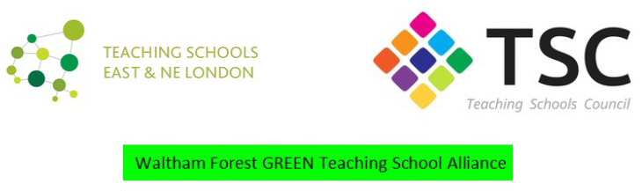

Waltham Forest GREEN Teaching School Alliance Steering Group Meeting

Venue: Walthamstow School for Girls, Church Hill, Walthamstow

Date: Thursday 13th December 2018

Time: 4.00pm – 5.00pm

Present: Debbie Chapman-Andrews - Willowfield (DCA), S Jones – Kelmscott (SJO), Jo Kaltak – Frederick
Bremer (JK), Louise Cowburn – Holy Family (LC), Rhianne Pawley – Lammas (RP), Tim Morris – Highams Park (TM), Annabel Rook – George Mitchell (AR), Julie Stewart – Connaught (JS), Astrid Davis – Chingford FS (AD), Jonathan Gunzi – WSFG (JGI), Meryl Davies – WSFG (MDA)

Apologies: Nick Taylor – Buxton (NT), Sarah Jaggs – Rushcroft (SJA)

MINUTES
- Welcome

- Minutes and Matter Arising

- ITT
DCA gave the following updates:

- UCAS applications are up, and the quality of early applicants has also improved. Three applicants were put through to the next round of interviews.
- The recruitment fair went very well and our unique offer generated a lot of interest.
- ITT professional studies are very popular and well attended

ACTION: for recruitment purposes this steering group would like the email addresses of our trainees.

- Apprenticeships: there are still mixed messages with HE providers. UEL currently has 12 apprenticeships, whilst the IOE is still not engaging. MDA explained how the LA levy should enable schools to fund apprenticeships.
ACTION: Investigate Middlesex as a possible partner
Investigate possibilities for support staff
- NQT residential: DCA asked final names to be given to her asap.

- CPD Feedback on PTI Courses, Coaching Courses and CPD Outline of TSST and L4F Courses.

    - PTI Courses Feedback: for one day courses and residential courses was distributed and discussed. It was agreed to continue to offer these courses
ACTION: send out the next set of courses earlier one ( additional note 06.01: this is the link to the new courses ( https://www.ptieducation.org/events/?event=CPD Subject Day )

    - Coaching: excellent feedback on the quality of training. It was noted many coaches would like to be coaches first as part of their training.
ACTION: share this information with Sally Kennedy (JGI)

    - L4F: one date needs to be changed on the flyer which was distributed
ACTION: members to email JGI with names before the end of term.

    - TSST: JGI outlined the course
ACTION: members to email JGI with names before the end of term.

    - SSAT Legacy: MDA explained the benefits of the SSAT legacy course for relatively new teachers. Each SSAT school gets one free place.

- S2S Support: SLE and NLE work
      - SLE: JGI went through SLE meeting outcomes
ACTION: send SLE minutes and contact details out with minutes
      - NLE: MDA explained the nature of her current NLE work. A significant part of the work involves support in recruitment and retention and will have some link with the CPD we offer.

- Examiner bursaries
JGI explained the difficulty in allocating bursaries as the number of examiners is much higher than expected.
ACTION: Send the current list out with minutes
Invite all examiners for a big event in the summer term (JGI)
- AOB
Outstanding admin action:
  - Creating profiles for SLEs
  - KPEs

Additional attachments to be sent out: PTI feedback spreadsheets (JGI), email addresses of ITT trainees (from Debbie), SLE minutes and contact details (JGI), examiner list (MDA), link to PTI courses (see above).

