WALTHAMSTOW SCHOOL FOR GIRLS
“Neglect not the gift that is in me”

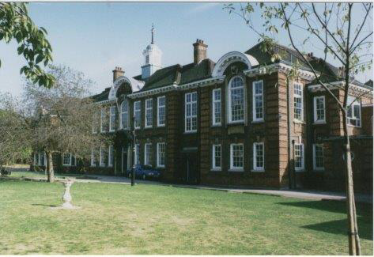

Information for applicants for the post of
Administrative Assistant Apprentice
April 2019

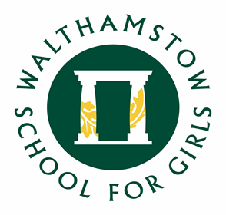

March 2019

Dear Applicant
Thank you for requesting an application pack for the post of Administrative Assistant Apprentice.
Walthamstow School for Girls is a high achieving, oversubscribed, diverse school which is regularly in the top 5% nationally for progress and the top 10% nationally for attainment and is at the centre of the vibrant local community of Waltham Forest (the first London borough of culture). We have an ambition to become ‘world class’ and a commitment to work with other professionals both locally, nationally and internationally, through our Erasmus links. We won the national High Aspiration Award for the progress made by disadvantaged students and have won SSAT Achievement and Progress awards annually since 2014. We have been awarded the SSAT Exceptional Education standard twice; in 2017, for Leadership through Moral Purpose, and, in 2018, for Systems: use of assessment, data, policies and monitoring to support teaching and learning. We were awarded Teaching School and National Support School Status in September 2017. In June 2018, following a Section 8 inspection, we were awarded an ‘outstanding’ judgement.
Our students are ambitious and hard-working; they embrace the range of opportunities offered to them both during and beyond the school day. This is highlighted not only by our exceptional examination results but also by the maturity of the girls, their sense of responsibility, community and fun. They are a delight to work with.
We offer excellent facilities to both staff and students. Our acclaimed architect designed site is an oasis of green and a pleasure to work in. It is well served by transport connections, being just ten minutes’ walk away from Walthamstow Central tube and overground station and five minutes’ walk from the popular Walthamstow ‘village’, and creative and restaurant quarter. We pride ourselves on working hard to retain our role as an important part of the local community. Examples of this commitment can be seen in our weekly Greensheets. Our staff are inclusive and friendly, with regular social and wellbeing events as well as charity fundraising.
We are committed to Safer Recruitment practices and procedures and shortlisted applicants will be questioned about their commitment to the safeguarding of young people. The successful candidate will be subject to an enhanced DBS clearance.
Thank you for taking an interest in this position. I do hope that having read more about the school you will decide to apply for the post. I look forward to receiving your application. Please note that it will not be possible to give feedback to unsuccessful applicants, other than those called for interview. Thank you for your understanding and good luck with your career in education.
Ms Meryl Davies
Headteacher, NPQH, NLE

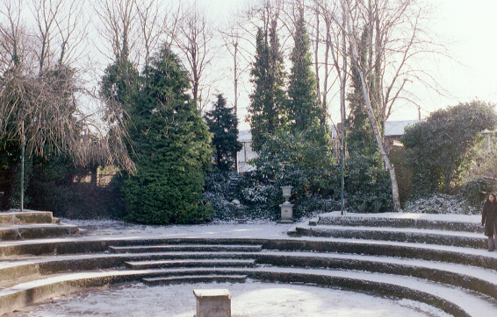

The History of Walthamstow School for Girls
In January 1890, a circular stated that a “school for girls” was to be opened. Walthamstow was described as a pleasant suburb on the borders of Epping Forest. Hoe Street was almost a country road, with a few houses on either side and meadows in which were sheep, cattle, hawthorn and wild roses.
Miss Hewett was the first Headmistress, at the age of 27 until she retired in 1924. There were 49 girls, whose ages ranged from 7-16 years. At this time there were only five teachers, two of whom were graduates. The School’s original Staff Book gives details of the first one hundred teachers. Of them 30 remained at the school for ten years or more, 22 giving over twenty years’ service. Until 1944 all the teachers were women and not married.
The original building was in West Avenue Road and when the numbers grew the school moved to Church Hill House, where a church now stands. At this time there were also boys up to the age of 13 years at the school. It was in September 1913 that 243 girls came into the present building with the Greek Theatre being added in the 1920s. However in July 2008 the whole school moved off site for a period of four school terms to facilitate the building and refurbishment programme that has resulted in the unique blend of traditional and state of the art facilities found at the school today.
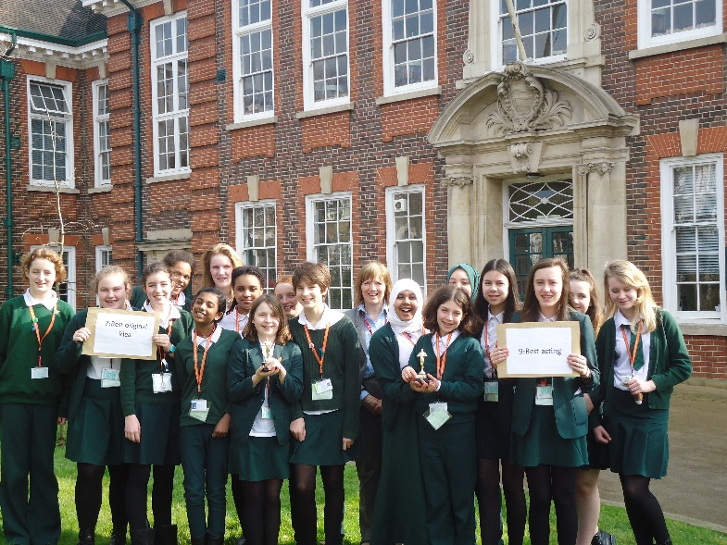
Walthamstow School for Girls is a place of high achievement. Effective teaching and learning are at the heart of our school. The school motto “Neglect not the gift that is in thee” underpins all the school’s work. Every girl is expected, encouraged and supported to achieve her very best academically and our pastoral system supports our students’ academic and social experiences.
Our role is to educate tomorrow’s women through a range of activities and opportunities to be confident, secure and happy individuals as they prepare for further education, careers and future lives.

Staff Benefits
Outlined below are some of the additional benefits available to staff working at Walthamstow School for Girls.
Cycle 2 work scheme
This benefit offers staff the opportunity to make tax and national insurance savings whilst keeping fit at the same time.
Commitment to CPD
We actively encourage CPD to all staff. We regularly provide whole school CPD as part of the school calendar as well as supporting individual CPD requests.
Eye Tests
All staff using computer equipment should have eye and eyesight tests at regular intervals. Eyesight testing should also happen where staff experience visual difficulties, which may reasonably be considered to be caused by computer work.

Staff Wellbeing
As part of our CPD for staff we include sessions related to staff wellbeing. These include The Walthamstow School for Girls Running Club, Badminton, Box fit exercise sessions, yoga and the London Club (historical walks around London).

Workplace Options - Employee Assistance provider
A confidential counselling, help and information service is provided for all employees of LBWF and is available free of charge 24 hours a day, every day of the year. Counselling is offered on the telephone or in a face-to-face setting, in locations close to your work or your home. This service can help with a range of problems from practical everyday matters to sensitive and emotional issues. Please visit http://www.workplaceoptions.co.uk for further information.

The diversity of all the students and accepting all religions, cultures and traditions.
It is welcoming, my daughter quickly settled into school life. It has high expectations of students but these are adapted for each individual so each is encouraged to do the best they can.

The value placed on education for young women, standards of behaviour expected, opportunities for activities which extend my daughter's understanding and interests, diverse community.

That the school provides opportunities for each girl to feel confident to strive to push beyond their current capabilities to achieve through hard endeavour and a belief that anything is possible.

What do you value most
about our school?
A sample of responses from a survey of parents (February 2016)
The sense of community; the high standards and expectations set by the school; the holistic approach to learning for the girls; the extra curriculum activities which supports learning and the fact that the staff team is a good diverse one.

High-quality learning environment and culture: comprising motivated, well-behaved pupils, strong and inspiring teachers and good resources.

The professionalism and reputation over such a long number of years.

