15 June 2020

Dear students, parents and carers,

I hope you and your family are well and safe. Now that some households can form ''support bubbles'' with one other household, some of you will be able to see more family members and hug them! You can already meet outside in groups of up to six people from different households and see your friends in the park. Some non-essential shops will begin to reopen and hopefully we will start to see more activities in our streets specially to support our local businesses. I know you are very keen to have life returning to normal as quickly as possible but please remember to stay safe.

Welcome to week 8 of online learning.

It has been wonderful to see how our community has come together last week to support each other but particularly our black community. It has been heartwarming to see the positive messages of solidarity and hope. Here are 2 examples of beautiful support posters designed by Mya 8H and Lolita 8G for their French assignments. It means “If you are neutral in times of injustice, you have chosen the side of the oppressor” and “We may have different religions, speak different languages, have different skin colours, but we all belong to the same race, the human race”:
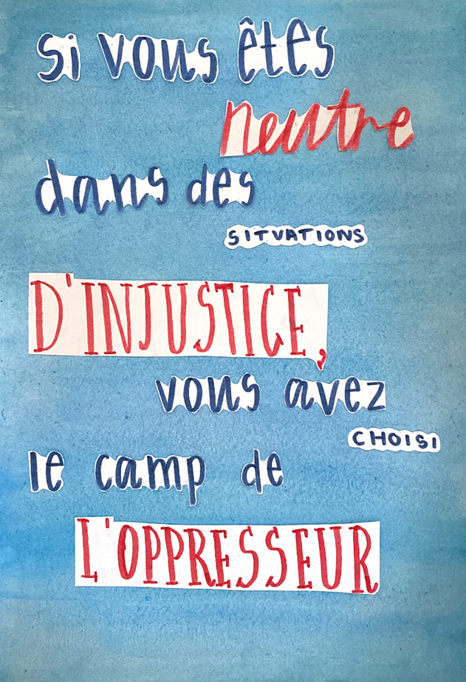
Moving forward as a community, we want to put in place a platform where all our black and ethnic minority students can speak freely and openly and be part of the deeper change taking place in our school.

Remember to keep up to date with what’s going on in the news and to read our school Greensheet and The Day

Please continue to stay calm and to look after your mental wellbeing. Remember if you have any general school issues or you are having problems with Teams, please contact us at info@wsfg.waltham.sch.uk

For the next 3 weeks in school, Year 10 students will be offered some face to face time in English, Maths and Science. We still have to be very careful in respecting all the health and social distancing rules to ensure everybody is safer and minimise all chance of infection. There will be one-way systems, hand washing/sanitising stations, fewer desks in each classroom and staggered start times. This is the first step in what will be a long process in getting school (and indeed society) back to where it was before the Coronavirus outbreak. It will take time for that to happen, at times it will be challenging and frustrating, but the important thing is that we do it right.

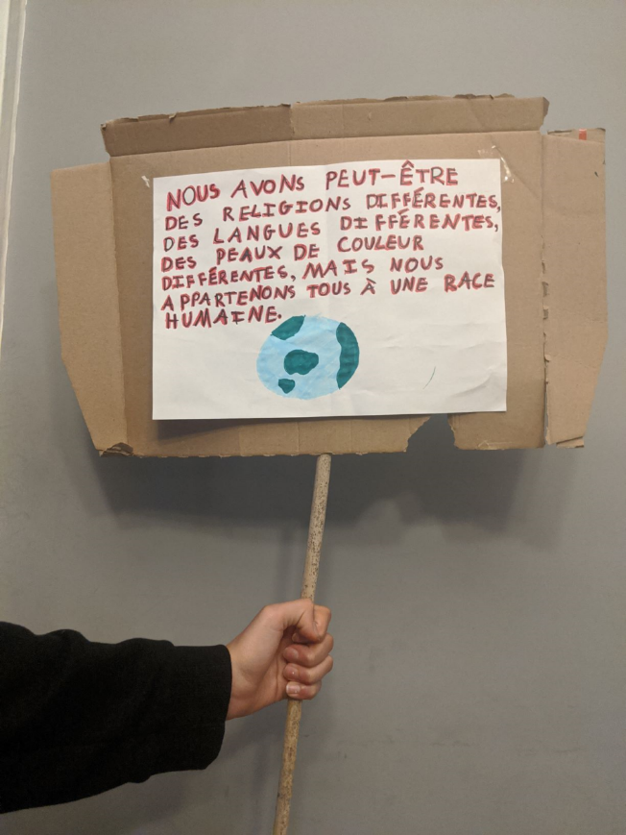
In the near future, Year 8s will also return to school but until then please be patient, keep learning from home as the work will continue to be set on Monday to be completed by Friday. Please ensure you follow the timetable I suggested to help you with organisation and submit your work straightaway once you have completed it. I am so proud of all the effort and hard work you are doing!

On top of your schoolwork, you should all be reading and completing your quizzes for Accelerated Reader. Please make sure you don’t neglect your reading. It is such a wonderful way to relax, escape and learn! Well done again to Deya in 8S for becoming a word millionaire, I’m so proud!

Well done again for engaging so brilliantly with Tutor Time! It is a pleasure to read your creative ideas when you discuss Thunks and also to see how encouraging and supportive you are of each other.

Remember to set your alarms for 1.30 p.m. on Wednesdays and Fridays so you are registering on time this week.

Kind regards

Ms Desbenoit
Student Progress Leader Year 8 / Diversity Coordinator

