School Uniform and Equipment

Our uniform is available from …

Speedstitch Unit 32, Walthamstow Business Centre, Clifford Road, Walthamstow London E17 4SX. (0208 531 4800)
www.speedstitch.co.uk / enquiries@speedstitch.co.uk

Victoria 2, 246 Hoe Street, Walthamstow, Tel – 020 8520 2176 http://www.victoria2schoolwear.co.uk/
Fashion Fair, 184 – 186 High Street, Walthamstow Tel – 020 8503 7048

A visual guide to what is acceptable and not acceptable for WSFG school uniform and equipment.

Trousers and Skirts

Dark, bottle green pleated knee length skirt or trousers in the acceptable school styles below:
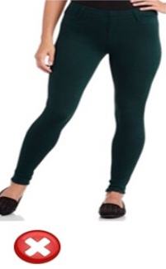
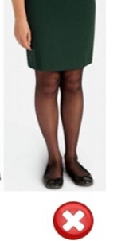
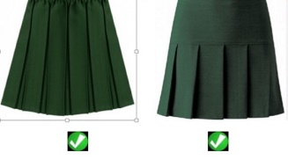
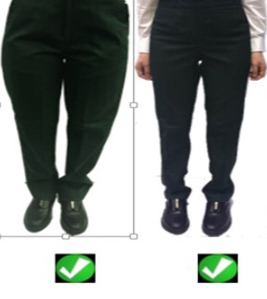
Strictly no jeans style trousers, tight trousers or leggings are permitted.

Dark, bottle green religious dress in plain, cotton fabric.

Shirts:

Plain white blouse with shirt collar to be worn by all. Shirts can be long sleeved or short sleeved. Plain white vest top can be worn under the school shirt if necessary
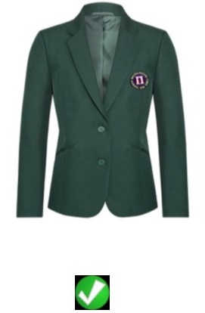
Jumpers/Cardigans:

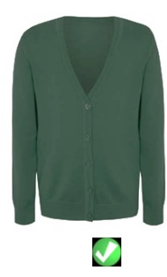
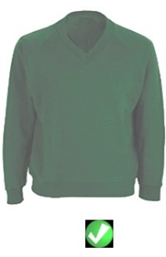
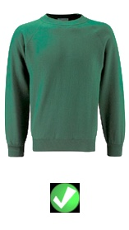
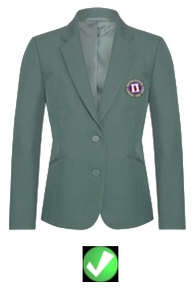
Dark, bottle green sweater, cardigan or sweatshirt without any logo.
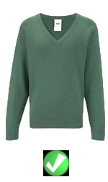

Head Coverings

Hijabs must be plain white or dark bottle green with no fringe and must be worn pinned securely. Under-scarves must be white or dark bottle green.
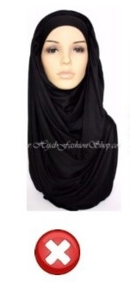
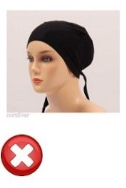
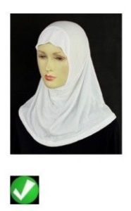
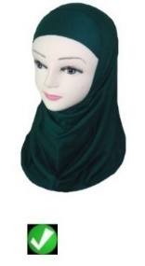
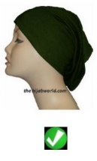
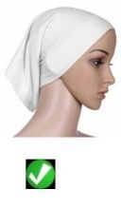

Coats and Blazers

School blazer with WSFG logo (see below) is compulsory for all years. This must be worn at all times.
Plain, BLACK coat or jacket that is suitably waterproof. This is compulsory for all students.
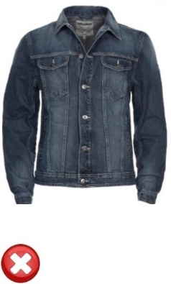
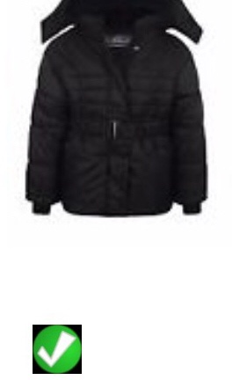
Denim, leather or faux leather jackets and hoodies are not permitted to be worn to or from school, or in school.
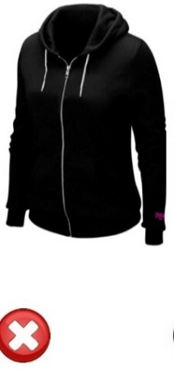
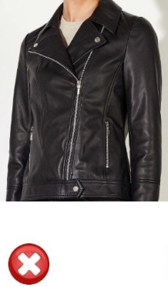

School Shoes:

Plain black low-heeled sensible shoes or boots.
Trainers and higher heels are not permitted.
Footwear must have black laces and not have pattern, colour or large branded logos.

Tights and Socks

Plain black, white or bottle green knee socks, ankle socks or tights are to be worn at all times.
Over the knee socks and leggings are not permitted.
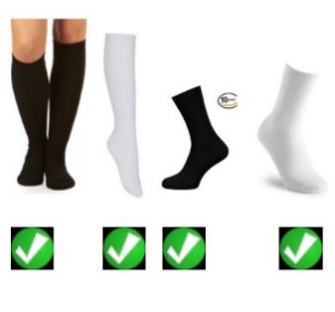
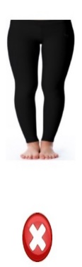
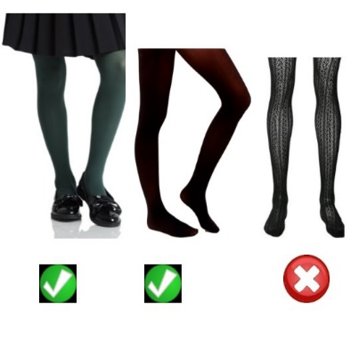

Make up

Make-up, if worn, must be minimal and discreet.
False eyelashes, eye lash extensions, acrylic or other types of nail extensions are not permitted.
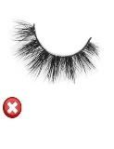
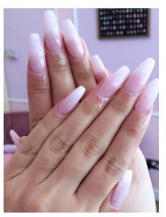

Jewellery

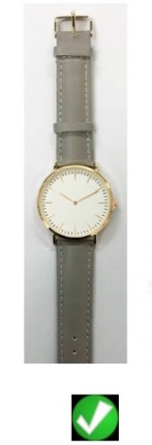
Students are permitted to wear one small stud in each ear (which should be no bigger than the size of a pea) and a wristwatch only.
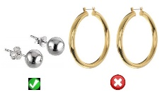

Facial piercings and visible body piercings (including tongue piercings) are not permitted.
Any other jewellery items will be confiscated and will only be returned to parents / carers at the end of each half term.

Hair accessories

Hair must be of a natural colour and hair of a non-natural colour is not permitted.
All hair accessories must be small, discreet and plain.
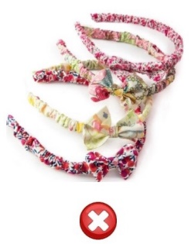
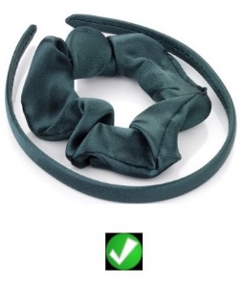
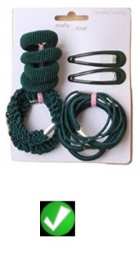

Bags

Students need a bag that will fit A4 sized books

