When you click on assignments for a subject, you can see two headings: ‘assigned’ and ‘completed’.
Under “assigned” will be all assignments not yet completed (and it will highlight due date in red if the deadline has passed.
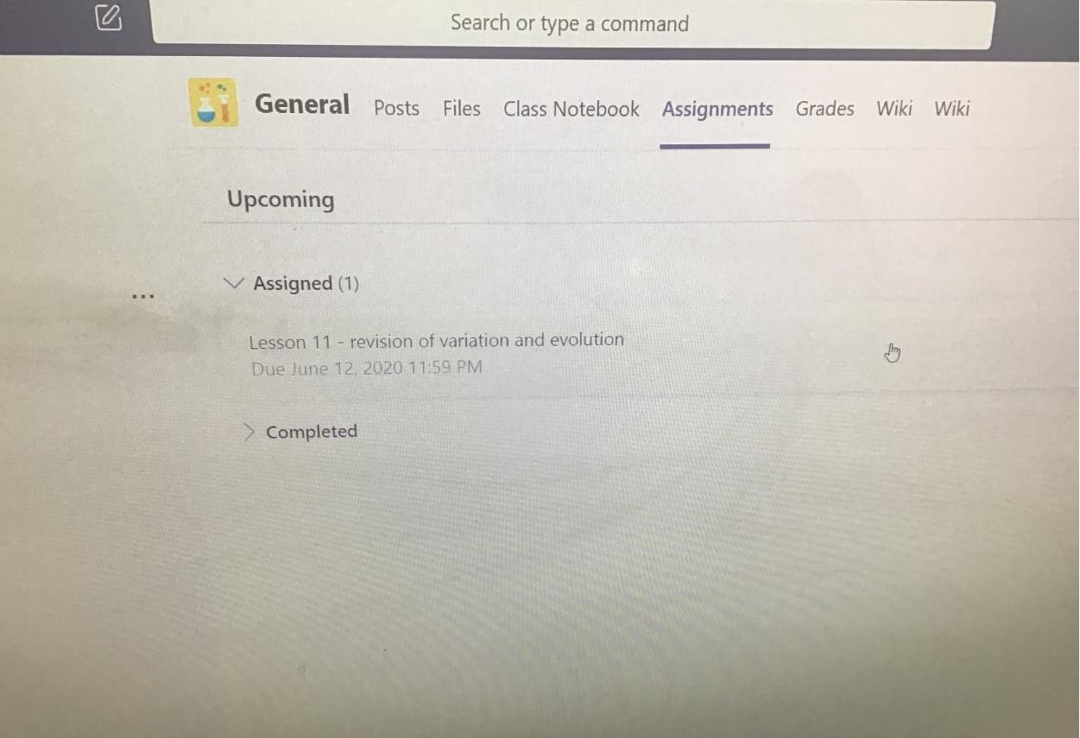

To see all the completed assignments, click on the side arrow and they will drop down –these have been successfully submitted:
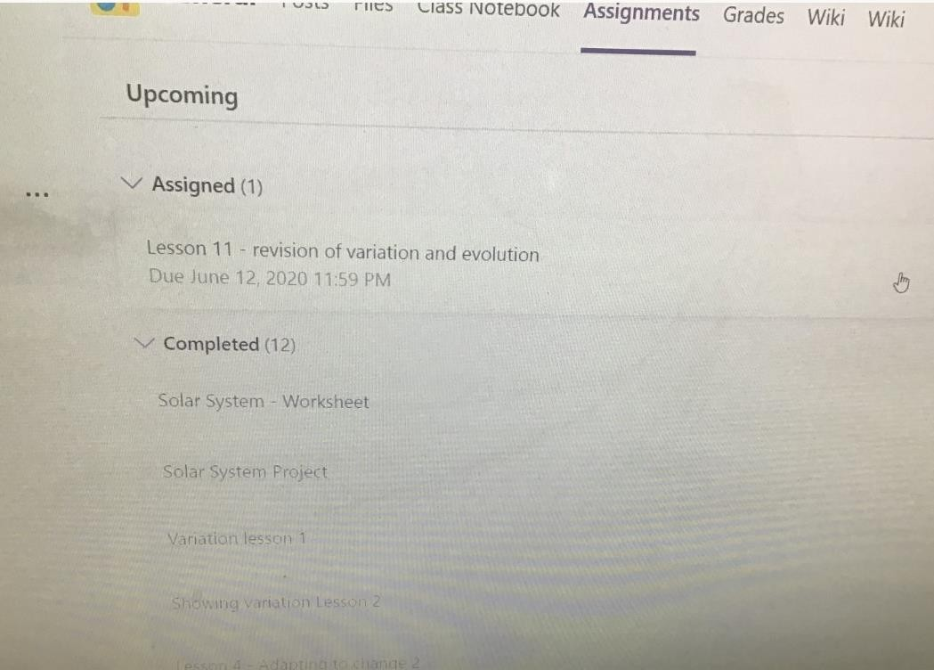
When the student clicks on the “assigned” piece they will see the full instructions. When they have completed the work, at the bottom, underneath any resources is a ‘+’ sign labelled “add work” –they need to click on this to upload work/ photos/ docs etc. –however this is not then handed in! This might be a problem that students are experiencing … (sorry that the picture below is so faint).
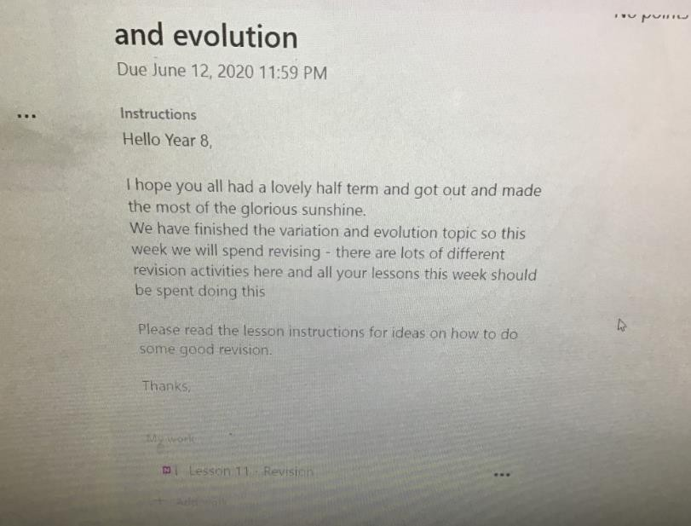
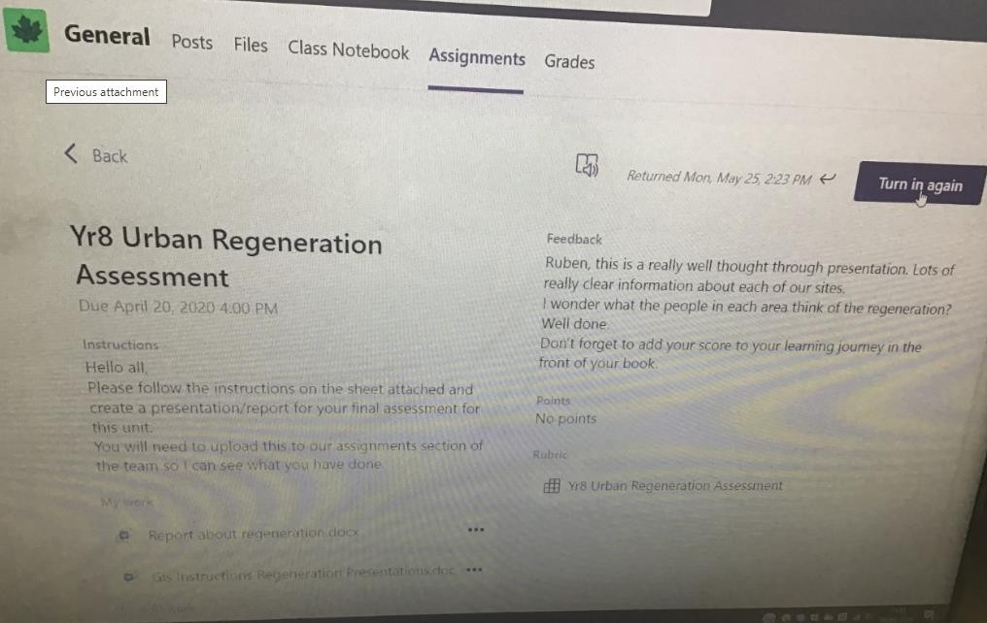
After adding work, students should then press the purple button, top right, “Hand in”. When they do hand in, they will see an icon jump down the page in celebration! If successful, the purple button will change to “Turn in again” so they will know it has been submitted.

