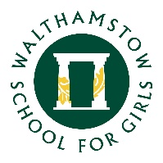
16 July 2021

Dear Year 8 & 9 Parents and Carers

I am writing to inform you that unfortunately, due to extraordinarily high levels of staff absence as a result of COVID symptoms or isolation, as well as religious observance on Tuesday 20th and Wednesday 21st July, we have taken the difficult decision to ask students from Years 8 and 9 to work remotely on both of these days. This will allow us to operate the school safely and ensure effective learning and teaching.

Students should log in to their Teams, following the timetabled day, where the teacher will be available to deliver a live lesson or where work will be posted. If you are concerned about your child's safety working from home, if you are concerned that you are unable to supervise them or if they do not have suitable ICT facilities, students can continue to attend school in our KWV provision. A booking form will be sent out on Monday for you to indicate that you would like to access this provision, but please be aware that we have limited staff and so would appreciate it if you are able to facilitate home learning.

Students will return to school on Thursday, which is the final day of term, and therefore a half day. They will be dismissed at the following times:

Year 8: 12.20 - side gate
Year 9: 12.30 - main gate (MUGA)

We are aware that this will not be the end of term which most of us envisaged and appreciate your support in this matter.

Yours faithfully

Helen Marriott
Headteacher

