8th December 2020

Dear Parents, Carers and Students,

You will be aware, by reading my updates in the Greensheet, that our building works are now coming to an end. This is very good news for our school as our Year 8 students will no longer need to be taught away from the main building, and our Humanities faculty will be able to move back into their former area of the school ready to resume teaching there in January.

However, for this to happen on time, we require the assistance of a removal firm on site from Wednesday next week. The Governing Body of WSfG and the local authority have agreed our plans to phase the end of term for students as you were informed last week.

This means that for KS3 students (Year 7/8/9), their onsite learning will end on the afternoon of Tuesday 15th December, at their normal finishing time, and they will resume remote learning from home from Wednesday 16th December to the end of period three on Thursday 17th December, when they will finish for the winter holidays. Whilst Years 8 and 9 had an opportunity to learn remotely in September, Year 7 have not yet had to do this. This should therefore be viewed as a pilot to see how well they can manage, in the event of the school having to send groups or individuals home to isolate next term

KS4 students (Year 10/11) will continue to be taught onsite as usual until lunchtime on Thursday 17th December, when they will be dismissed for their winter holidays. A ‘grab bag’ lunch option is available to those who pre-order.

All students will be served a Christmas lunch on Tuesday 15th December in their year group bubbles. Students in Years 7, 8 and 9 may wear their own clothes to school on Tuesday, whilst Years 10 and 11 may do so for Thursday morning (not Tuesday). As usual there will be a charity collection for those students who choose to come in non-uniform on their designated day.

We are aware that some parents/carers are keyworkers and so we are looking to offer some limited provision for those students until school closes on Thursday lunchtime. Further details regarding this will follow.

Thank you for your continued support,

Yours faithfully,
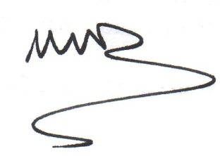
Ms M Davies
Headteacher

Years 7, 8, 9 | Tuesday 15th December: finish on site learning
 | Wednesday 16th December-Thursday 17th Dec. morning: remote lessons from home following normal timetable
Years 10,11 | Normal lessons in school until Thursday 17th December-lunchtime dismissal
 | Year 11 dismissal: 12.30pm, Year 10 dismissal: 12 noon

