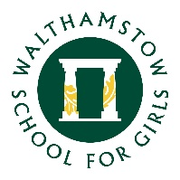
30 April 2021

Dear parents and carers

I hope this email finds you well. I am writing to let you know the details of the end of year assessments for all Year 8 students (as we did not hold any end of year exams last year due to the national lockdown).

The end of year assessment window for Year 8 will take place between 8th and 18th June 2021. These assessments will take place in English, Maths, Science, Humanities and Modern Foreign Languages. The details of the assessments will vary from subject to subject, but they will typically take place in exam style conditions in classrooms during lesson time.

The outcomes from these assessments will help us to measure the progress of all the students in Year 8 and identify where additional support may be needed in the future. It will also be used to help to inform our target setting for the future (teachers will also take into account other work the students have completed this year).

This assessment window is a very important period of the school year as it provides an opportunity for the students to demonstrate how much they have learned and grown since they joined the school in Year 7. It will also be an opportunity to recognise the success and achievement of the many outstanding students we have in Year 8!

The attached booklet gives details of the topics that will be assessed in each subject, as well as some advice on preparing for the various exams. Year 8 Form tutors will discuss the details of the assessments with the students in registration time, and paper copies of these booklets will be given to all Year 8 students.

If you have any questions, then please do get in touch.

Kind regards

Mr Morrow
Student Progress Leader Year 8
Associate Assistant Headteacher

