Please visit: https://wsfg.store.academia.co.uk/shop/year-6-bundle.html
You will need to register here before you can place an order.

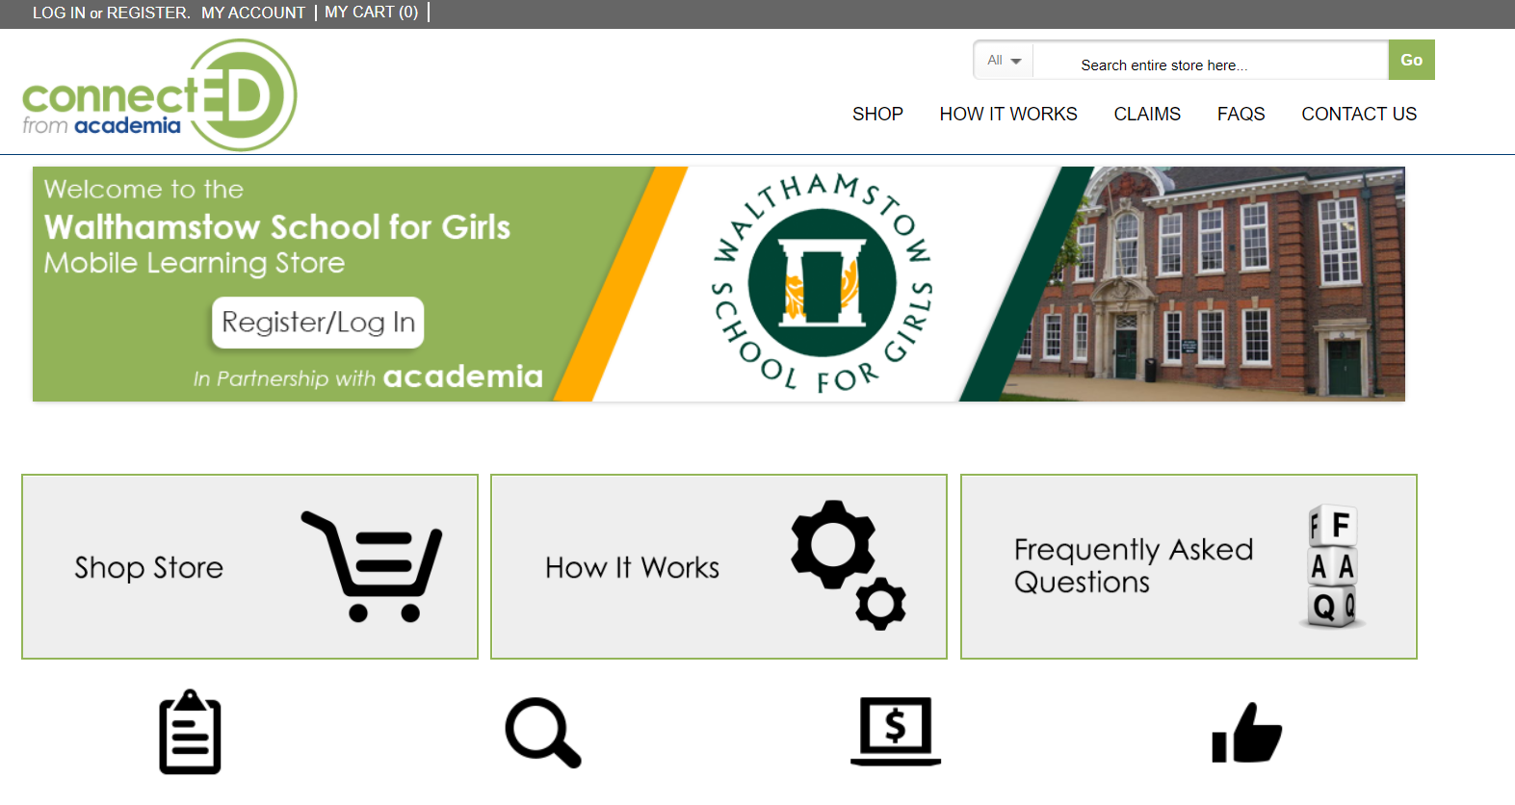

The mandatory fields are required. Once complete, please use the Submit button to proceed.
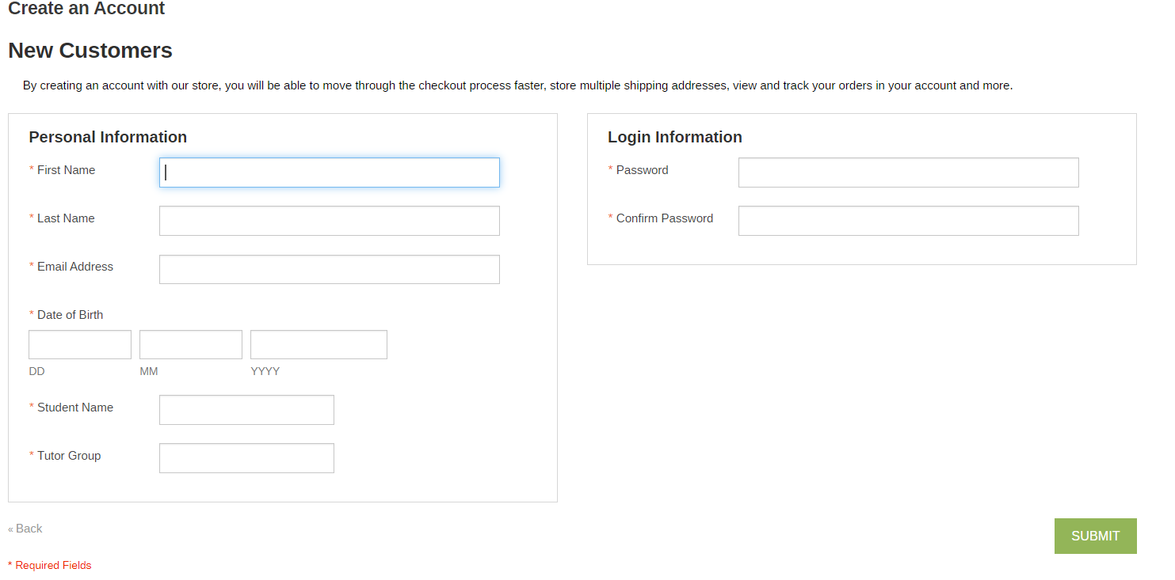

You will now receive an email with a confirmation link. This will validate your account on the portal.
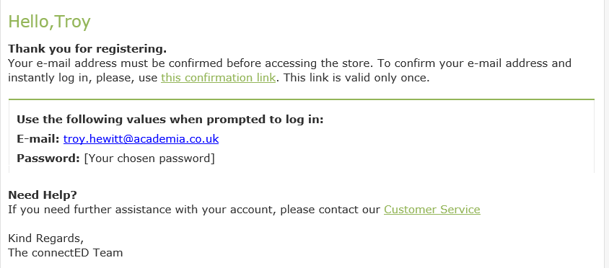
Once you have clicked the confirmation link, you will be taken to your account within the portal. This means your account can now place an order. You can navigate to the products page here.
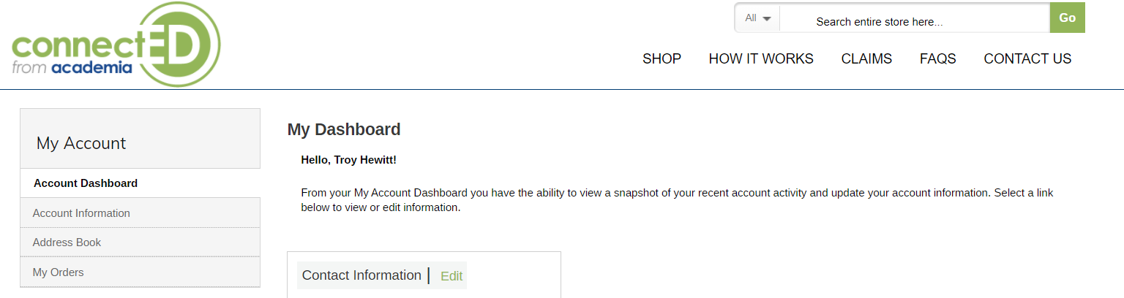

You will now be presented with the below page. You can navigate to the iPad bundle using the “Select Model” button here. You also have the option to purchase additional accessories via this page.
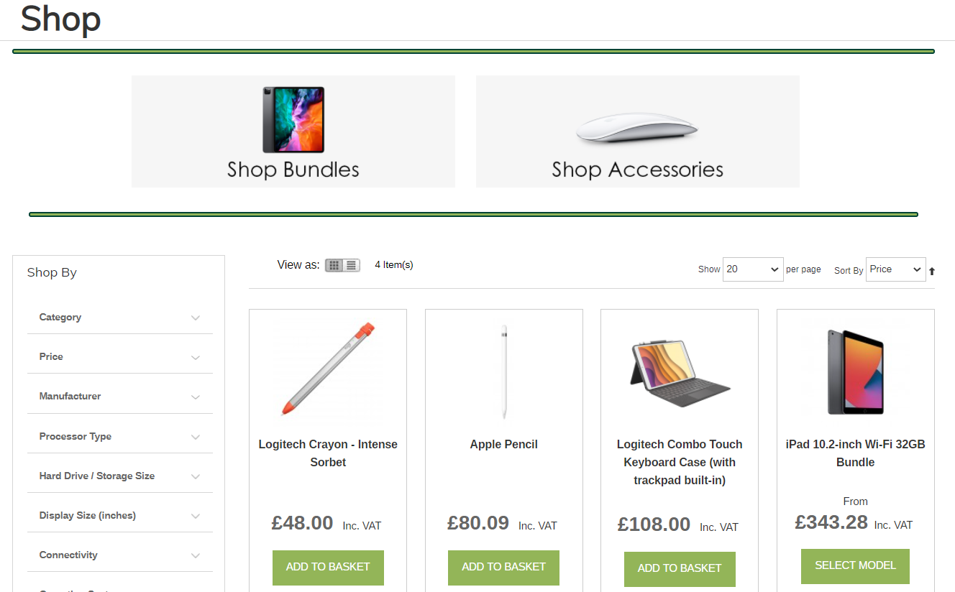
Once you have clicked the Select Model button you will be presented with the bundle page. Items marked with a red * are mandatory and cannot be removed from the bundle. The insurance is optional. When you are ready to place your order, you can click the “Add to Basket” button here
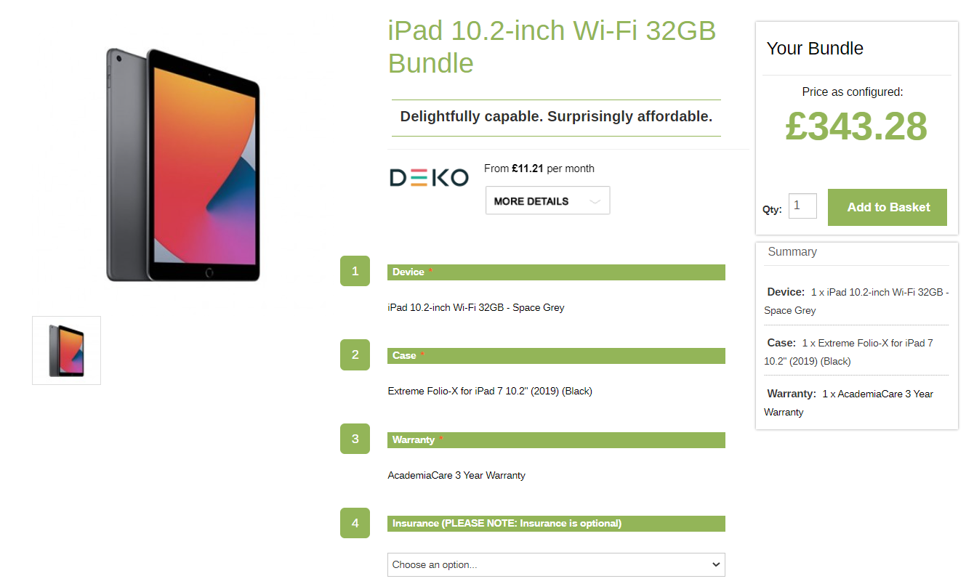

Upon adding the bundle to your basket, you will be taken to your shopping cart as per the below. You can amend your cart from this page and once you are ready to proceed you can use the “Proceed to Checkout” button here.
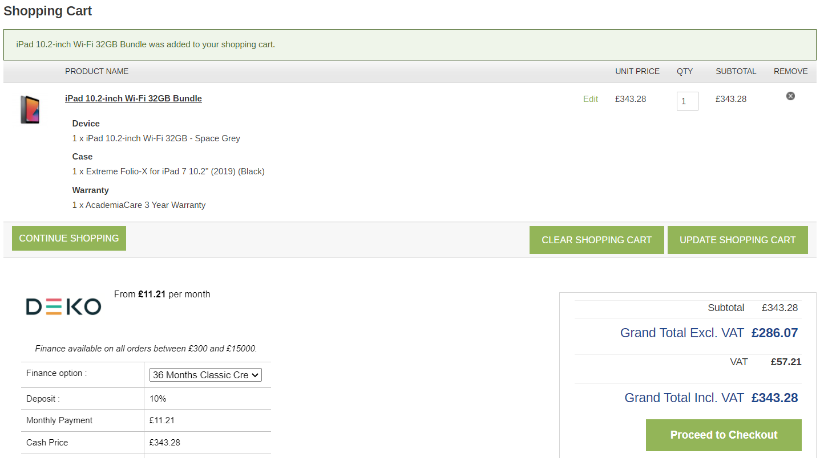

All mandatory fields are required on the billing information page. Once completed, please click the “Continue” button here
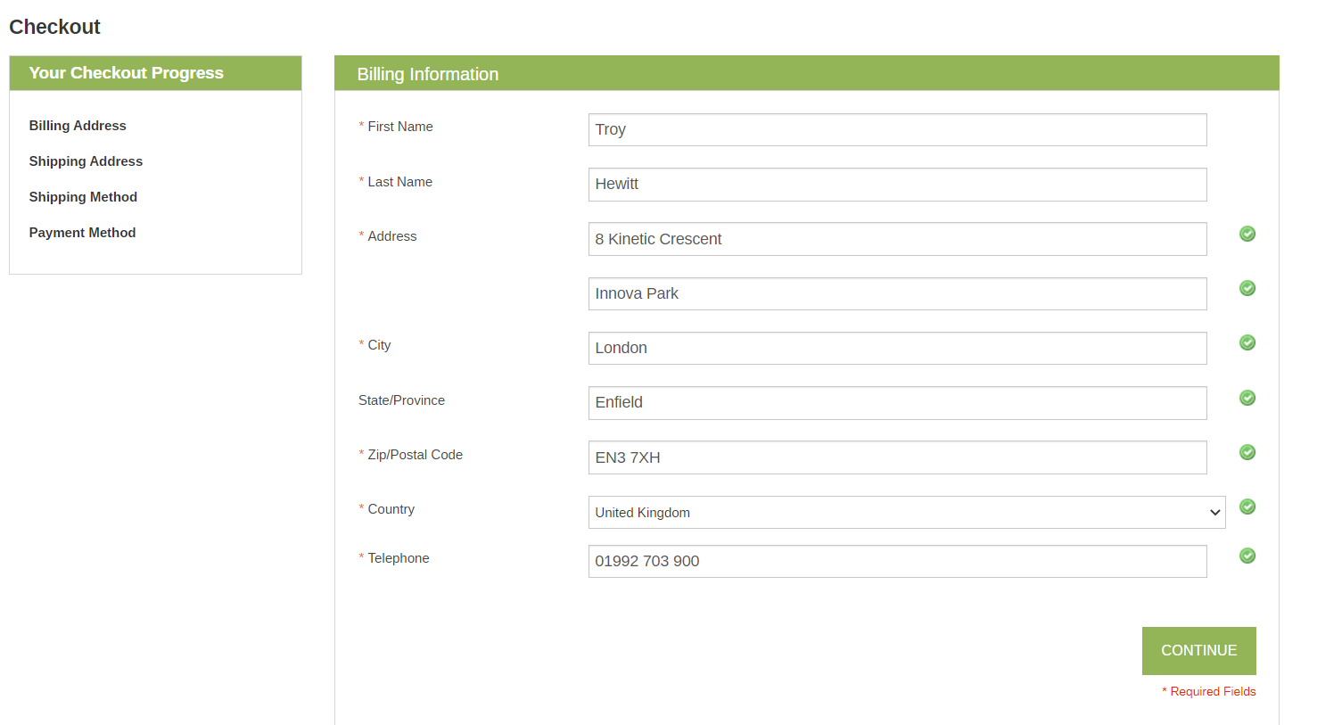

The schools address has been automatically added and must not be changed. If a home address is added, the order will be rejected by our Support Team. This page requires the student name to ensure the devices are allocated correctly once delivered. Once complete, please click continue to proceed
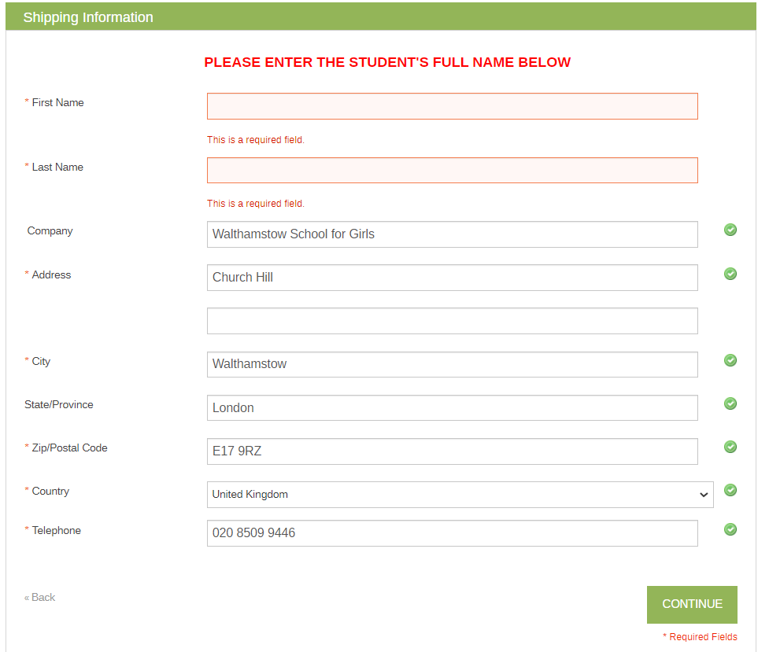
The shipping method page can be bypassed as no action is required. Please click continue to proceed
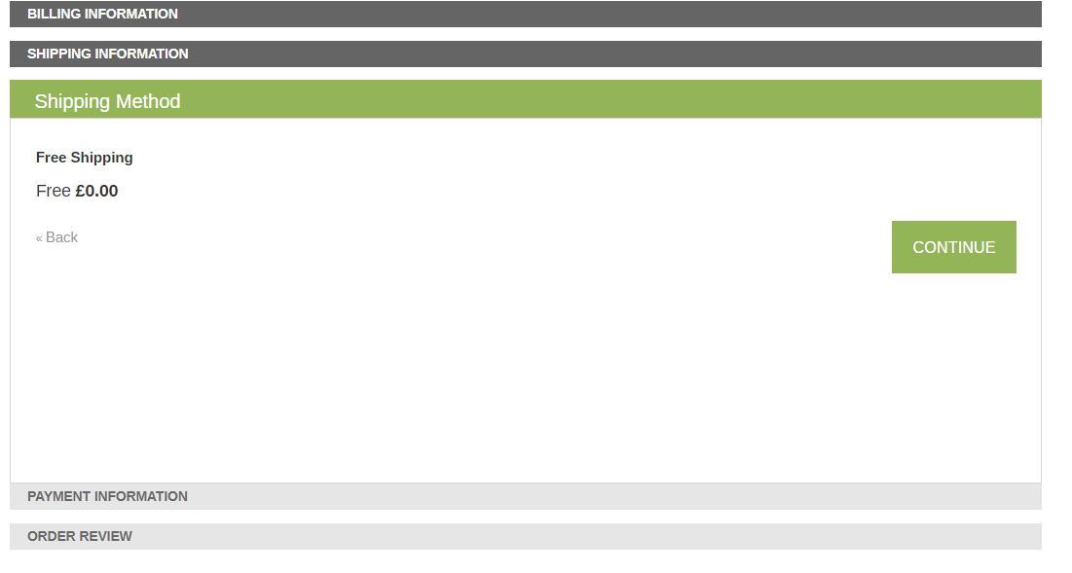
There are now two options available in the Payment Information section. Both options can be viewed below. Once you have chosen your preferred payment method, please click the continue button.
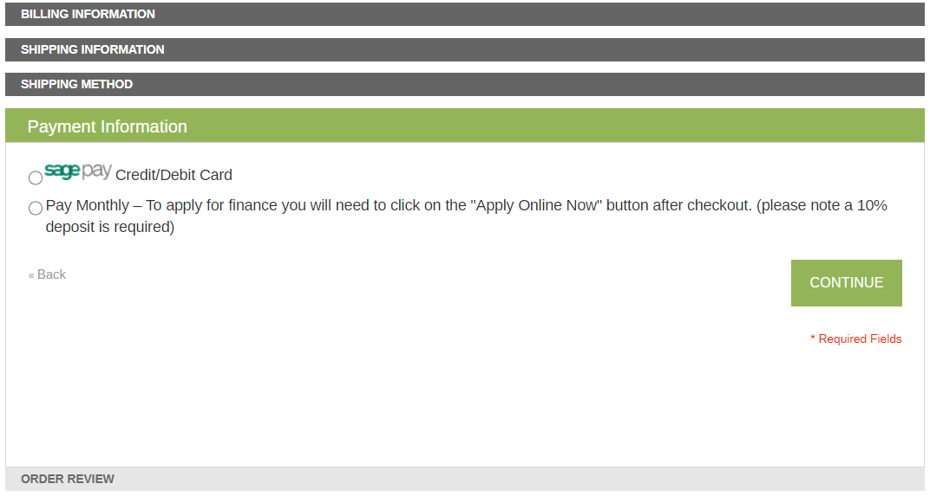

SagePay Credit/Debit Card Option
If you selected the SagePay option, you will be prompted with the below page. You will be required to enter your card details to complete your purchase for the full amount in your basket. This process is safe and secure, and your details will never be shared by Academia.
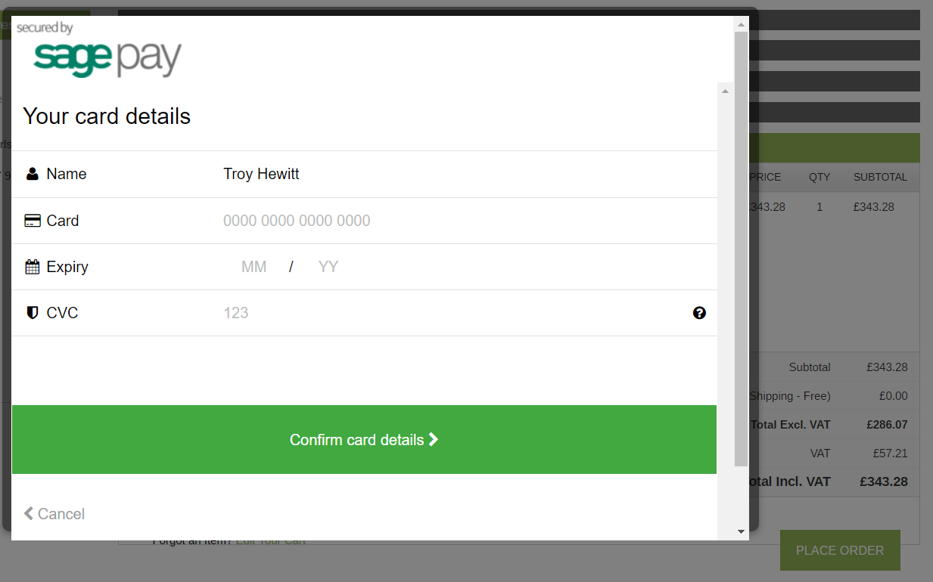
Pay Monthly Option
If you have selected the Pay Monthly option, an order will be created and you will receive an email with confirmation. This does not mean your order has been completed but instead makes our Support Team aware that you are now going to be applying for finance. You will be taken to the below page which will feature your order number and total. Please scroll down to proceed.
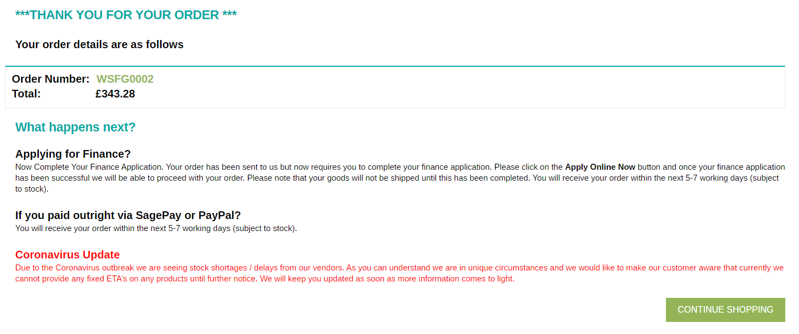
To continue the finance application, please click the button here
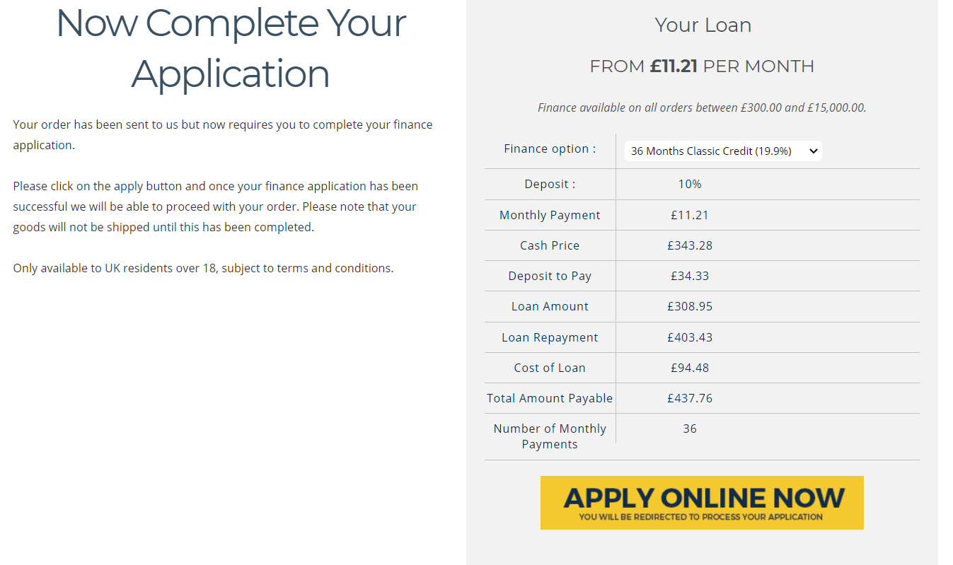

You will be taken to our finance partners page where you can find full details of the finance agreement. It is advised that all details are reviewed before proceeding. Once you are ready, you can start your application here
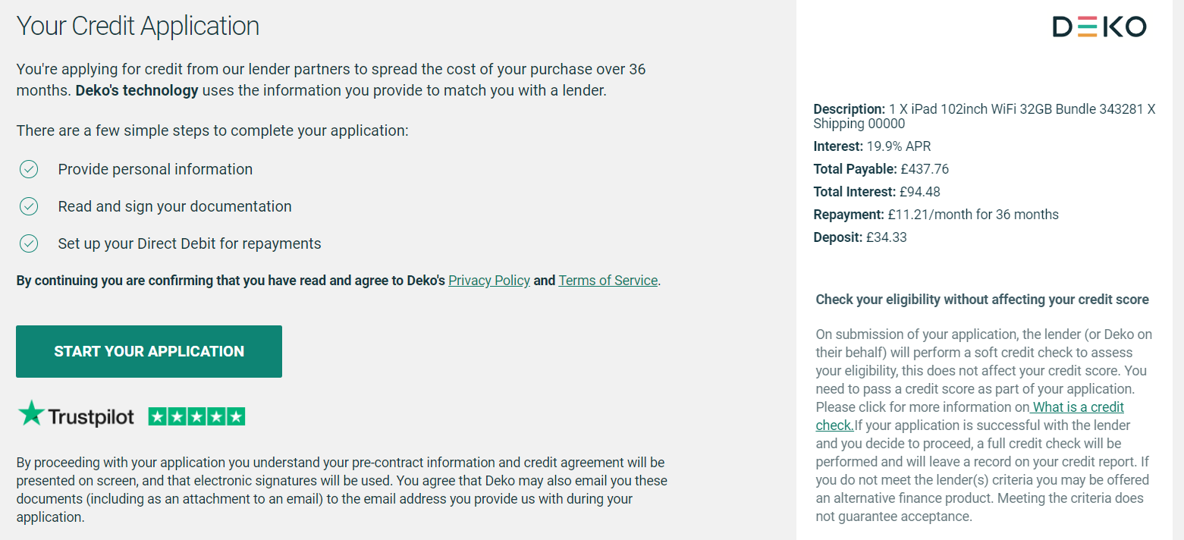
You will be now be taken to the registration page which will require your details be entered. Once completed you will be given a decision on acceptance and notification will be sent to Academia.
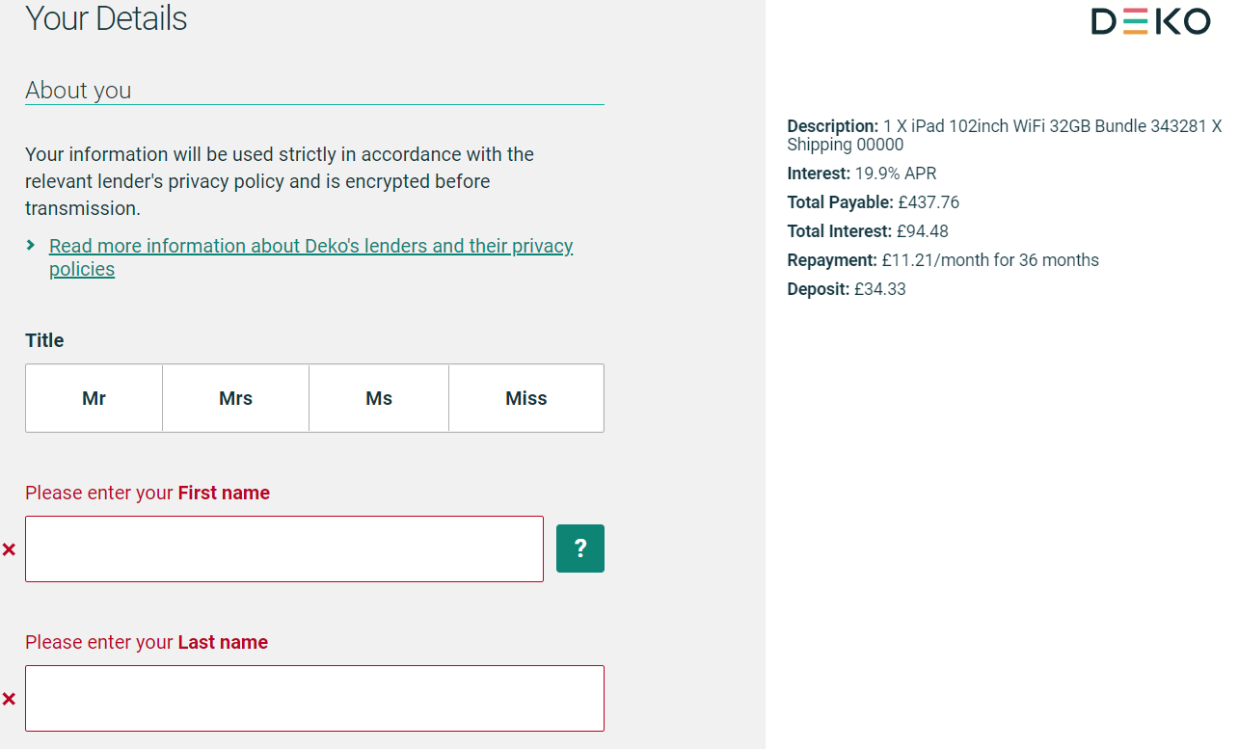
If your finance application has been approved, Academia will update the status of your order. We are unable to proceed with completing your order until the deposit for finance has been paid. Instructions on how to do so are within the finance page mentioned above.
If your finance application is rejected, Academia will close your order and you will be advised to speak with the school. You can begin a new order using your account if you then decide to change payment method.

