Moving On Up
I am ready to join
Walthamstow School for Girls

My name is: My primary school is: My birthday is on:

Welcome to
Walthamstow School for Girls

Don’t stress too much as you will be welcomed and there are many other students
feeling the same as you. Involve yourself with as
many activities, as it really does broaden your knowledge and you get to make new friends.

Come to WSfG with the
knowledge that it is a safe space despite
it being bigger than primary school. You will make some of the best friends you will ever have in your
5 years.

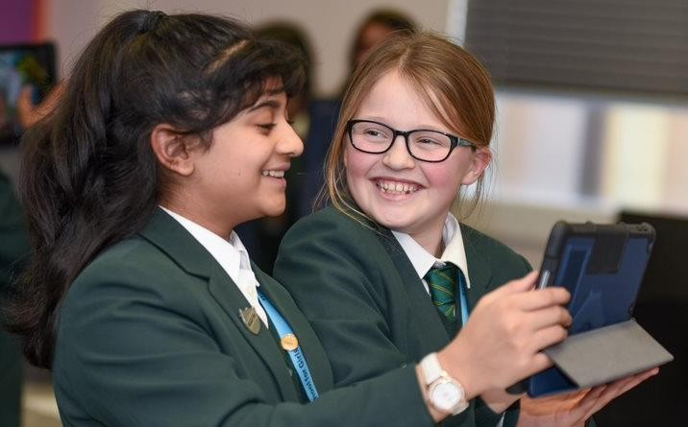

I remember feeling excited but overwhelmed and got lost all the time.
Of course after a few weeks I was settled.

Take advantage of all the incredible opportunities that the
teachers will provide you!
They all want the best for you!

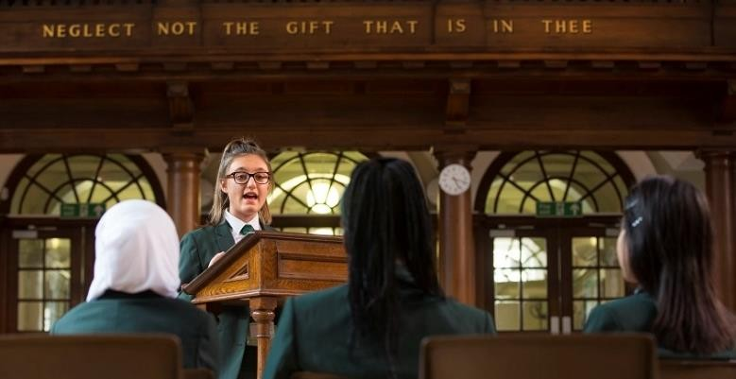
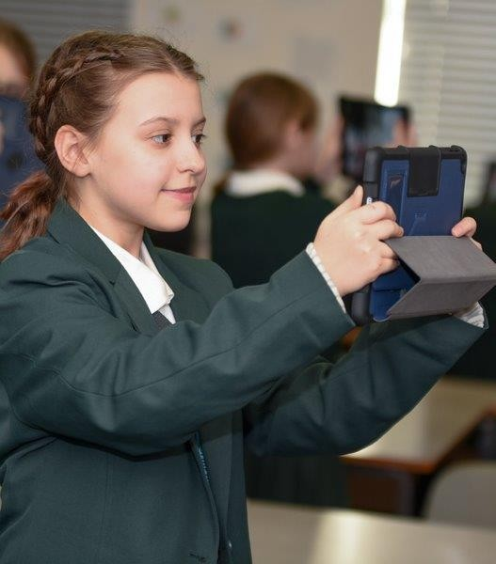
Neglect not the gift that is in thee

Reflections on my time at
The thing that has surprised me most about myself is…
Things I might do differently when I
start at Walthamstow School for Girls:
primary school
My achievements at primary school:
The subjects I enjoy:
I have helped others at school by…

All about me

Here is a picture of me:

The people in my family are:

All about me
My pets are:

My favourite singer/music is:

My family and home
The best place I ever visited was:

Anything funny?
My favourite book is:

The instruments
I play/would like to
play are:

All about me
The clubs I belong
to are:

In my spare
time, I like to…

My hobbies
The sports I enjoy are:

At home, the things I like to do are:

All about me

patient
motivated
sociable
Choose at least
three adjectives to

hard-working conscientious

I am…
1.
2.
3.
dependable
describe your character.

Use the words in the box.

Or you could come up with some of your own words.

New Beginnings

Starting secondary school will help you build on your skills and experiences from primary school and there will be some new opportunities
Things I am looking forward to are…
1.
2.
3.

Don’t forget to say why!

New Beginnings

Whilst starting secondary school is exciting you may be unsure about what to expect
If I am honest, I am a little worried about…

Tell us and we can help!

New Beginnings

This is a map of your new school
It is likely to be a lot bigger than your primary school

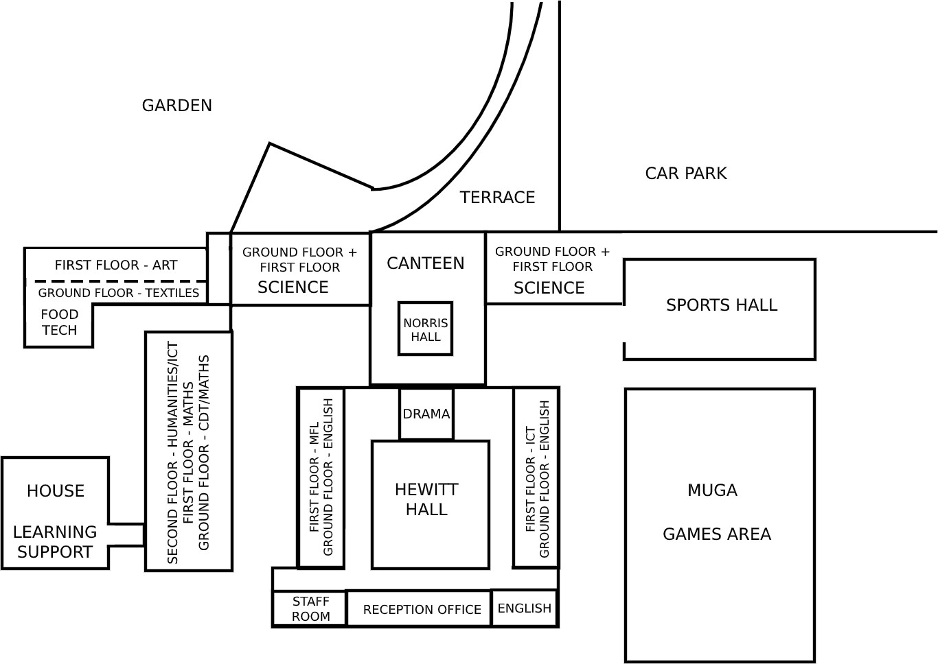
For a virtual tour of
WSfG
click here

Enrichment Activities

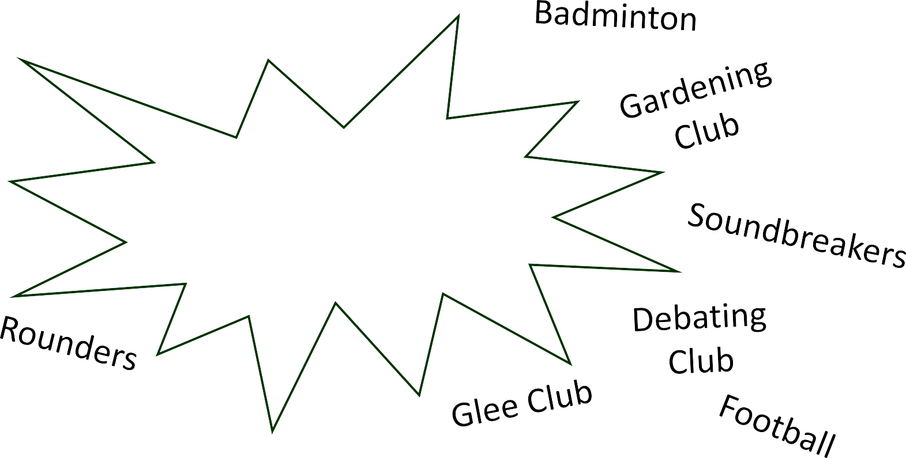
There are a lot of activities for you to get involved in and they are an excellent way for you to make new friends

Trampolining
Steel Pans

Tag rugby

Which activities will you get involved in?
Tennis

Basketball
Handball
Cricket

By the end of Year 7

I would like to have achieved…

1.

2.

3.

4.

Include at least four things.
Neglect not the gift that is in thee

