

**WALTHAMSTOW SCHOOL FOR GIRLS**

***“NEGLECT NOT THE GIFT THAT IS IN THEE”***

**Temporary Youth Worker**

**Required April 2021**

Candidate Information Pack

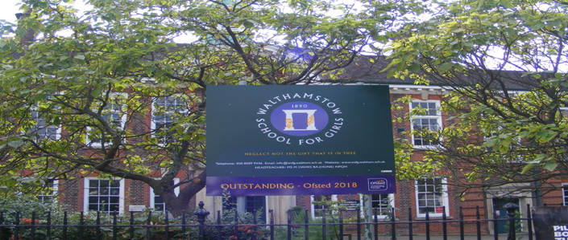

**Hours: 10 hours per week – Monday to Friday over the lunchtime period (term time only)**

**Scale 3**

# 

Welcome letter from Helen Marriott, Headteacher

# January 2021

# Dear Applicant

Thank you for requesting an application pack for the post of Temporary Youth Worker.

Walthamstow School for Girls is a high achieving, oversubscribed, diverse school which is regularly in the top 10% nationally for progress, significantly above the national average in all key indicators, and is at the centre of the vibrant local community of Waltham Forest (the first London Borough of Culture). We have an ambition to become ‘world class’ and a commitment to work with other professionals both locally, nationally and internationally, through our Erasmus links. We won the national High Aspiration Award for the progress made by disadvantaged students and have won SSAT Achievement and Progress awards annually since 2014. We have been awarded the SSAT Exceptional Education standard twice; in 2017, for *Leadership through Moral Purpose*, and, in 2018, for *Systems: use of assessment, data, policies* *and monitoring to support teaching and learning.* We were awarded Teaching School and National Support School Status in September 2017. In June 2018, following a Section 8 inspection, we were awarded an Ofsted ‘outstanding’ judgement in all categories.

Our students are ambitious and hard-working; they embrace the range of opportunities offered to them both during and beyond the school day. This is highlighted not only by our exceptional examination results but also by the maturity of the girls, their sense of responsibility, community and fun. They are a delight to work with.

We offer excellent facilities to both staff and students. Our acclaimed architect designed site is an oasis of green and a pleasure to work in. It is well served by transport connections, being just ten minutes’ walk away from Walthamstow Central tube and overground station and five minutes’ walk from the popular Walthamstow ‘village’, and creative and restaurant quarter. We pride ourselves on working hard to retain our role as an important part of the local community. Examples of this commitment can be seen in our weekly *Greensheets*. Our staff are inclusive and friendly, with regular social and wellbeing events as well as charity fundraising.

We are committed to Safer Recruitment practices and procedures and shortlisted applicants will be questioned about their commitment to the safeguarding of young people. The successful candidate will be subject to an enhanced DBS clearance.

Thank you for taking an interest in this position. I do hope that having read more about the school you will decide to apply for the post. I look forward to receiving your application. Please note that it will not be possible to give feedback to unsuccessful applicants, other than those called for interview. Thank you for your understanding and good luck with your career in education.

Helen Marriott

Headteacher, MA (Cantab), NPQH

About Walthamstow School for Girls

**History**

In January 1890, a circular stated that a “school for girls” was to be opened in Walthamstow. Miss Hewett was appointed as the first Headmistress and remained until she retired in 1924. There were 49 girls, whose ages ranged from 7-16 years. At this time there were only five teachers, two of whom were graduates.

Our original building was in West Avenue Road and when student numbers grew the school moved to Church Hill House, where a church now stands. It was in September 1913 that 243 girls came to the present building with the Greek Amphitheatre being added in the 1920s. In January 2010 our most recent refurbishment and rebuilding work was completed as part of the Building Schools for the Future Programme. This work has given us the unique blend of traditional and state of the art facilities that we currently enjoy at our school.

**Our school in 2020**

Walthamstow School for Girls is a high achieving, oversubscribed, diverse school which is regularly in the top 10% nationally for progress, significantly above the national average in all key indicators at Key Stage 4, and is at the centre of the vibrant local community of Waltham Forest (the 2019 and first London Borough of Culture). Our most recent results can be found on our website.

We have an ambition to become ‘world class’ and a commitment to work with other professionals both locally, nationally and internationally, through our Erasmus links. We won the national High Aspiration Award for the progress made by disadvantaged students in 2015 and have won SSAT Achievement and Progress awards annually since 2014.

We have been awarded the SSAT Exceptional Education standard twice; in 2017, for *Leadership through Moral Purpose*, and, in 2018, for *Systems: use of assessment, data, policies* *and monitoring to support teaching and learning.* We were awarded Teaching School and National Support School Status in July 2017. In June 2018, following a Section 8 inspection, we were awarded an ‘outstanding’ judgement in all categories.

*“Middle Leaders are exceptional and collaborate well to share best practice. They drive their teams with energy and enthusiasm. They share the strong moral purpose of the Headteacher to ensure that no pupil is left behind. As a result, outcomes for pupils are outstanding, giving them essential life chances.” Ofsted 2018.*

**Students and staff**

Every one of our 900 students is valued equally as an individual with different gifts and talents, reflecting our commitment to the school motto “Neglect not the gift that is in thee”. We offer strong pastoral support and regular monitoring, target setting and dialogue with students and parents/carers.

Our students are encouraged to express themselves, to be creative, to have high aspirations and to challenge stereotypes. There is a strongly ethos of equality at this school.

Our students are also ambitious and hard-working; they embrace the range of opportunities offered to them both during and beyond the school day. This is highlighted not only by our exceptional examination results but also by the maturity of the girls, their sense of responsibility, community and fun. They are a delight to work with.

One of the school’s strengths is the quality of the staff we are able to attract and keep. Our teachers ensure lessons are stimulating and challenging. Students work with enthusiasm and interest in classrooms where there is a calm atmosphere suitable for learning. The broad and balanced curriculum ensures that all students are extremely well equipped to continue their education.

**Our environment**

We offer excellent facilities to both staff and students. Our acclaimed architect designed buildings and facilities make a stunning learning and working environment. Our £18 million rebuild project, completed in 2010, dramatically extended and enhanced our accommodation. We have state-of-the-art facilities in science, technology and performing arts, as well as a fantastic dining hall, two assembly halls and social areas.

Situated in beautiful landscaped grounds, the school’s outside space encourages play and creativity as well as quiet reflection and study. Unusually for a London school, our buildings are surrounded by mature trees and lawns, a pond area and our Greek amphitheatre. We have an allotment area which invites students to learn how to grow fruit and vegetables, some of which are then used by our chef.

Our site is an oasis of green and a pleasure to work in. It is well served by transport connections, being just ten minutes’ walk away from Walthamstow Central tube and rail station and five minutes’ walk from the popular Walthamstow ‘village’, creative and restaurant quarter. We pride ourselves on working hard to retain our role as an important part of the local community. Examples of this commitment can be seen in our weekly *Greensheets*. Our staff are inclusive and friendly, with regular social and wellbeing events as well as charity fundraising.

**Educating and empowering young women**

Our role is to educate tomorrow’s women to be confident, articulate and able to discuss and debate intelligently. Through a range of activities and opportunities, students are helped to develop their leadership qualities, their sense of community and global responsibility as citizens of the world in line with our G.R.E.E.N. values.



Our G.R.E.E.N. Vision

**The G.R.E.E.N. values**

| https://www.wsfg.waltham.sch.uk/_site/data/files/images/values/C52FA90503F596A26EE2DC7FE1E19642.png | The value **GROWTH**is based on the work by Carol Dweck on growth mindset.  Having a growth mindset encourages the belief that we can all improve at whatever we put our minds to with practice and perseverance.  It encourages learning, effort and stickability.  It also promotes the importance of reflection and criticism as tools to move us forward. |
| --- | --- |
| https://www.wsfg.waltham.sch.uk/_site/data/files/images/values/3FEE02382FB6B8CCE94E0DF659218767.png | The value **RESILIENCE** represents the notion that, on any learning journey, there will be obstacles.  With **RESILIENCE**and perseverance, these obstacles can be overcome and the final goal more rewarding.  The key is not to be fearful of these obstacles and to accept that mistakes and challenges are an important part of learning.  The learning line is an effective symbol for resilience and for assessment for learning. |
| https://www.wsfg.waltham.sch.uk/_site/data/files/images/values/38C6CD54B28E286D9A8410BF39911E01.png | The value **ENERGY**is the centre of our vision.  It encourages focus and enthusiasm from everyone.  This **ENERGY** could be represented in the attitude of students as well as in staff morale, parent and governor involvement.  It promotes positivity and supports all of the other G.R.E.E.N. values. |
| https://www.wsfg.waltham.sch.uk/_site/data/files/images/values/BC7D9BD0A310876A7B76D38599477A89.png | The value **EMPATHY**promotes community spirit in many dimensions.  It signifies self-awareness as well as respect for each other despite our differences.  In addition to this, it illustrates that none of us are alone on our learning journey and that, through collaboration, success can be greater. |
| https://www.wsfg.waltham.sch.uk/_site/data/files/images/values/AABBE9BC30E8511FD418D7E3A2E90E56.png | The value **NEWNESS** is vital in an ever changing world.  This encourages us to be open to new ideas, techniques, technologies and challenges.  It encourages us all to step out of our comfort zones as this is where the deepest learning and the greatest success can be achieved. |

What staff value about the school

* This school feels safe, kind and caring. We are not driven by results – we seem to be driven to produce fabulous young women
* Ethos of the school, supportive colleagues and strong management with compassion

*“There are very strong working relationships between staff and pupils based on mutual trust and respect.” Ofsted 2018*

* I value the ethos of hard work in the students and how the school promotes kindness, tolerance and maturity amongst the students
* Atmosphere of diversity, respect and inclusion
* Freedom to teach in a range of styles

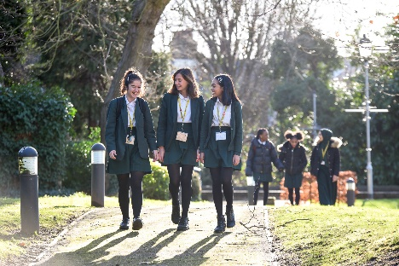

Job Description

**Job title:** Youth Worker

**Reporting to**: Deputy Headteacher KS4

**Line management of:** N/A

**Liaising with:** LT, all Teachers and support staff

**Working time:** 5 days a week - Monday-Friday over the lunchtime period (term time only)

**Salary Grade:**  Scale Point 3

**Disclosure:** Enhanced

|  |  |
| --- | --- |
| **Core Purpose** | * Under the direction of the Deputy Headteacher KS4 to support the management of students outside during the lunch period, providing a continuous presence. To ensure the safety, welfare and conduct of students in accordance with school policies * Youth Workers have a shared role within school in helping to raise the academic and social achievements of students. They are responsible for ensuring that lunchtimes are an enjoyable and safe experience for all the students, so that they are physically and mentally prepared to learn during the afternoon |
| **Main Responsibilities** | * To be responsible for supervising the safety of students outside during the staggered lunch period * To promote the school behaviour policy, assisting with maintaining discipline and supporting children to resolving conflicts in a positive way. To deal with incidents of misbehaviour by appropriate intervention and report serious incidents to the Duty Teacher / Headteacher, as appropriate * To manage a year group of 180 students, to ensure that they line up correctly at the beginning and end of each lunchtime * To organise and give instructions, as necessary, to the students during the lunchtime period * To circulate during the sessions and engage in informal mentoring where appropriate * To deal promptly with minor incidents and manage students who are sick or injured in accordance with the school’s accident/injuries procedures, ensuring that they are seen by a named First Aider * To encourage all students to show respect for others * To ensure that pupils keep out of areas that are out of bounds and don’t leave the school premises. To be aware of security procedures with regard to entrance and exits and to approach visitors and direct them to the appropriate contact person |
| **School Ethos** | * To play a full part in the life of the school community, to support its distinctive aims and ethos and to encourage staff and students to follow this example * To be flexible and work according to needs, which may involve assisting other areas which are commensurate with the grading of the post |
| **Whole School Contribution** | * Be aware and comply with policies and procedures relating to Safeguarding, Equal Opportunities, Behaviour for Learning, Health and Safety, Data Protection and confidentiality, reporting all concerns to an appropriate person * To promote actively the school’s policies * To comply with the school’s Health and Safety policy |

Whilst every effort has been made to explain the main duties and responsibilities of the post, each individual task undertaken may not be identified.

The school will endeavour to make any necessary reasonable adjustments to the job and the working environment to enable access to employment opportunities for disabled job applicants or continued employment for any employee who develops a disabling condition.

This job description is current at the date below but will be reviewed on an annual basis and, following consultation with you, may be changed to reflect or anticipate changes in the job requirements which are commensurate with the job title and grade.

**The Governing Body and the Local Authority are committed to safeguarding and promoting the welfare of children and young people. The Headteacher must ensure that the highest priority is given to following the latest national guidance and regulations on safeguarding and child protection. This role is subject to an enhanced DBS check.**

November 2020

*This school is committed to safeguarding and promoting the welfare of children and young people and expects all staff and volunteers to share this commitment.*

Person Specification

|  |  |  |  |  |  |  |
| --- | --- | --- | --- | --- | --- | --- |
|  | **Criteria** | Essential | Desirable |  | Assessed by application | Assessed by selection process |
|  | **Qualifications** | | | | | |
| 1 | First Aid / Basic First Aid knowledge |  | / |  | / |  |
|  | **Experience** | | | | | |
| 2 | Previous youth mentoring work and/or sports coaching experience involving secondary age students |  | / |  | / |  |
|  | **Special abilities and aptitudes** | | | | | |
| 3 | Ability to build good working relationships and rapport with pupils and adults | / |  |  | / | / |
| 4 | Willingness and ability to work as a team for the benefit of the students | / |  |  | / | / |
| 5 | To be flexible | / |  |  | / | / |
| 6 | Ability to work using own initiative | / |  |  | / | / |
| 7 | Understand the behaviour expected of the students and manage in line with the school policies | / |  |  |  | / |
| 8 | The ability to listen patiently and communicate with students and other staff | / |  |  |  | / |
| 9 | A positive outlook and can-do mentality | / |  |  | / | / |
| 10 | Observant and alert to potential dangers to students | / |  |  |  | / |
| 11 | Honesty and integrity. | / |  |  | / | / |
|  | **Special abilities and aptitudes** | | | | | |
| 12 | Commitment to the LA’s Equal Opportunities Policy and acceptance of their responsibility for its practical application | / |  |  | / | / |

Staff Benefits

Outlined below are some of the additional benefits available to staff working at Walthamstow School for Girls.

**Cycle 2 work scheme**

This benefit offers staff the opportunity to make tax and national insurance savings whilst keeping fit at the same time.

**Commitment to CPD**

We actively encourage CPD to all staff. We regularly provide whole school CPD as part of the school calendar, as well as opportunities for individual CPD requests.

“*I have been given some fantastic CPD opportunities with an amazing amount of training. My personal knowledge and confidence has increased immensely.”*

**Eye Tests**

All staff using computer equipment should have eye and eyesight checks at regular intervals. Eyesight testing should also happen where staff experience visual difficulties, which may reasonably be considered to be caused by computer work. Staff working within schools in the London Borough of

Waltham Forest may be entitled to reimbursement of some costs associated with vision testing and the frames and lenses needed to enable them to work safely on display screen equipment.

**Staff Wellbeing**

As part of our CPD for staff we include session related to staff wellbeing. There are also opportunities for staff to participate in various activities as individuals.

At Walthamstow School for Girls we also offer a staff running club, Badminton club, Boxfit exercise sessions, yoga and the London Club (historical walks around London).

“Since joining WSFG *I have felt totally reinvigorated and I am excited to teach again. This is undoubtedly because the atmosphere in school is a very positive one.”*

**Workplace Options - Employee Assistance Provider**

A confidential counselling, help and information service is provided for all those employed by Waltham Forest and is available free of charge 24 hours a day, every day of the year. This service can help with a range of problems from practical everyday matters to sensitive and emotional issues. For further information please call 0800 328 1437 or contact: **www**.**employeeassistance.org.uk**

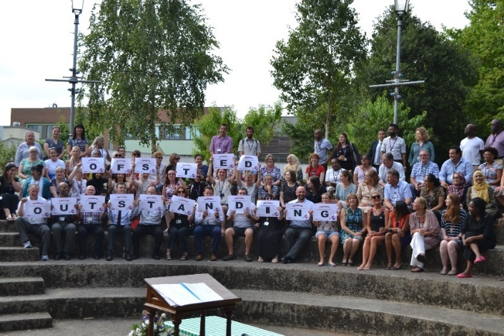



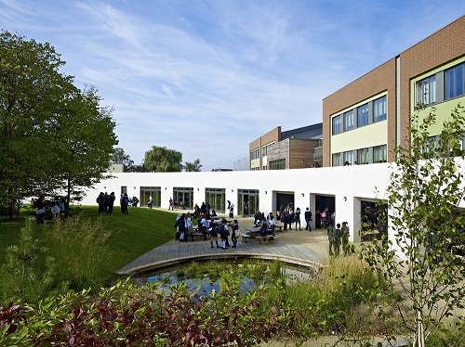

For further information about our school please visit our website: **www.wsfg.waltham.sch.uk**