WALTHAMSTOW SCHOOL FOR GIRLS
“NEGLECT NOT THE GIFT THAT IS IN THEE”

Data Manager
Candidate Information Pack

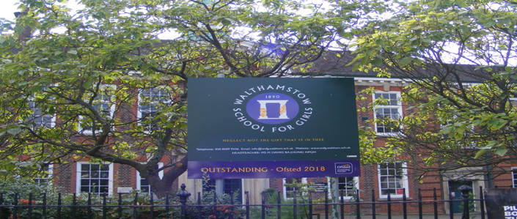

SO1 (£30,585.00-£31,557.00 per annum)
36 hours per week, 52 weeks per year
Required as soon as possible

Welcome letter from Helen Marriott, Headteacher

June 2021

Dear Applicant

Thank you for requesting an application pack for the post of Data Manager.

Walthamstow School for Girls is a high achieving, oversubscribed, diverse school which is regularly in the top 10% nationally for progress, significantly above the national average in all key indicators, and is at the centre of the vibrant local community of Waltham Forest (the first London Borough of Culture). We have an ambition to become ‘world class’ and a commitment to work with other professionals both locally, nationally and internationally, through our Erasmus links. We won the national High Aspiration Award for the progress made by disadvantaged students and have won SSAT Achievement and Progress awards annually since 2014. We have been awarded the SSAT Exceptional Education standard twice; in 2017, for Leadership through Moral Purpose, and, in 2018, for Systems: use of assessment, data, policies and monitoring to support teaching and learning. We were awarded Teaching School and National Support School Status in September 2017. In June 2018, following a Section 8 inspection, we were awarded an Ofsted ‘outstanding’ judgement in all categories.

Our students are ambitious and hard-working; they embrace the range of opportunities offered to them both during and beyond the school day. This is highlighted not only by our exceptional examination results but also by the maturity of the girls, their sense of responsibility, community and fun. They are a delight to work with.

We offer excellent facilities to both staff and students. Our acclaimed architect designed site is an oasis of green and a pleasure to work in. It is well served by transport connections, being just ten minutes’ walk away from Walthamstow Central tube and overground station and five minutes’ walk from the popular Walthamstow ‘village’, and creative and restaurant quarter. We pride ourselves on working hard to retain our role as an important part of the local community. Examples of this commitment can be seen in our weekly Greensheets. Our staff are inclusive and friendly, with regular social and wellbeing events as well as charity fundraising.

We are committed to Safer Recruitment practices and procedures and shortlisted applicants will be questioned about their commitment to the safeguarding of young people. The successful candidate will be subject to an enhanced DBS clearance.

Thank you for taking an interest in this position. I do hope that having read more about the school you will decide to apply for the post. I look forward to receiving your application. Please note that it will not be possible to give feedback to unsuccessful applicants, other than those called for interview. Thank you for your understanding and good luck with your career in education.

Helen Marriott

Headteacher, MA (Cantab), NPQH
About Walthamstow School for Girls

History
In January 1890, a circular stated that a “school for girls” was to be opened in Walthamstow. Miss Hewett was appointed as the first Headmistress and remained until she retired in 1924. There were 49 girls, whose ages ranged from 7-16 years. At this time there were only five teachers, two of whom were graduates.
Our original building was in West Avenue Road and when student numbers grew the school moved to Church Hill House, where a church now stands. It was in September 1913 that 243 girls came to the present building with the Greek Amphitheatre being added in the 1920s. In January 2010 our most recent refurbishment and rebuilding work was completed as part of the Building Schools for the Future Programme. This work has given us the unique blend of traditional and state of the art facilities that we currently enjoy at our school.
Our school in 2020
Walthamstow School for Girls is a high achieving, oversubscribed, diverse school which is regularly in the top 10% nationally for progress, significantly above the national average in all key indicators at Key Stage 4, and is at the centre of the vibrant local community of Waltham Forest (the 2019 and first London Borough of Culture). Our most recent results can be found on our website.
We have an ambition to become ‘world class’ and a commitment to work with other professionals both locally, nationally and internationally, through our Erasmus links. We won the national High Aspiration Award for the progress made by disadvantaged students in 2015 and have won SSAT Achievement and Progress awards annually since 2014.
We have been awarded the SSAT Exceptional Education standard twice; in 2017, for Leadership through Moral Purpose, and, in 2018, for Systems: use of assessment, data, policies and monitoring to support teaching and learning. We were awarded Teaching School and National Support School Status in July 2017. In June 2018, following a Section 8 inspection, we were awarded an ‘outstanding’ judgement in all categories.
“Middle Leaders are exceptional and collaborate well to share best practice. They drive their teams with energy and enthusiasm. They share the strong moral purpose of the Headteacher to ensure that no pupil is left behind. As a result, outcomes for pupils are outstanding, giving them essential life chances.” Ofsted 2018.
Students and staff
Every one of our 900 students is valued equally as an individual with different gifts and talents, reflecting our commitment to the school motto “Neglect not the gift that is in thee”. We offer strong pastoral support and regular monitoring, target setting and dialogue with students and parents/carers.
Our students are encouraged to express themselves, to be creative, to have high aspirations and to challenge stereotypes. There is a strongly ethos of equality at this school.
Our students are also ambitious and hard-working; they embrace the range of opportunities offered to them both during and beyond the school day. This is highlighted not only by our exceptional examination results but also by the maturity of the girls, their sense of responsibility, community and fun. They are a delight to work with.
One of the school’s strengths is the quality of the staff we are able to attract and keep. Our teachers ensure lessons are stimulating and challenging. Students work with enthusiasm and interest in classrooms where there is a calm atmosphere suitable for learning. The broad and balanced curriculum ensures that all students are extremely well equipped to continue their education.
Our environment
We offer excellent facilities to both staff and students. Our acclaimed architect designed buildings and facilities make a stunning learning and working environment. Our £18 million rebuild project, completed in 2010, dramatically extended and enhanced our accommodation. We have state-of-the-art facilities in science, technology and performing arts, as well as a fantastic dining hall, two assembly halls and social areas.
Situated in beautiful landscaped grounds, the school’s outside space encourages play and creativity as well as quiet reflection and study. Unusually for a London school, our buildings are surrounded by mature trees and lawns, a pond area and our Greek amphitheatre. We have an allotment area which invites students to learn how to grow fruit and vegetables, some of which are then used by our chef.
Our site is an oasis of green and a pleasure to work in. It is well served by transport connections, being just ten minutes’ walk away from Walthamstow Central tube and rail station and five minutes’ walk from the popular Walthamstow ‘village’, creative and restaurant quarter. We pride ourselves on working hard to retain our role as an important part of the local community. Examples of this commitment can be seen in our weekly Greensheets. Our staff are inclusive and friendly, with regular social and wellbeing events as well as charity fundraising.
Educating and empowering young women
Our role is to educate tomorrow’s women to be confident, articulate and able to discuss and debate intelligently. Through a range of activities and opportunities, students are helped to develop their leadership qualities, their sense of community and global responsibility as citizens of the world in line with our G.R.E.E.N. values.

Our G.R.E.E.N. Vision

The G.R.E.E.N. values
The value GROWTH is based on the work by Carol Dweck on growth mindset. Having a growth mindset encourages the belief that we can all improve at whatever we put our minds to with practice and perseverance. It encourages learning, effort and stickability. It also promotes the importance of reflection and criticism as tools to move us forward.
The value RESILIENCE represents the notion that, on any learning journey, there will be obstacles. With RESILIENCE and perseverance, these obstacles can be overcome and the final goal more rewarding. The key is not to be fearful of these obstacles and to accept that mistakes and challenges are an important part of learning. The learning line is an effective symbol for resilience and for assessment for learning.
The value ENERGY is the centre of our vision. It encourages focus and enthusiasm from everyone. This ENERGY could be represented in the attitude of students as well as in staff morale, parent and governor involvement. It promotes positivity and supports all of the other G.R.E.E.N. values.
The value EMPATHY promotes community spirit in many dimensions. It signifies self-awareness as well as respect for each other despite our differences. In addition to this, it illustrates that none of us are alone on our learning journey and that, through collaboration, success can be greater.
The value NEWNESS is vital in an ever changing world. This encourages us to be open to new ideas, techniques, technologies and challenges. It encourages us all to step out of our comfort zones as this is where the deepest learning and the greatest success can be achieved.

What staff value about the school

- This school feels safe, kind and caring. We are not driven by results – we seem to be driven to produce fabulous young women
- Ethos of the school, supportive colleagues and strong management with compassion
“There are very strong working relationships between staff and pupils based on mutual trust and respect.” Ofsted 2018
- I value the ethos of hard work in the students and how the school promotes kindness, tolerance and maturity amongst the students
- Atmosphere of diversity, respect and inclusion
- Freedom to teach in a range of styles

Job Description

Job title: Data Manager

Reporting to: Assistant Headteacher (AHT)
Line management of: Data Officer/Administrative Assistant
Liaising with: Leadership Team (LT), all Teachers and support staff, governors, LEA representatives, external agencies and parents/carers.
Working time: 36 hours per week (8.00am-4.00pm) 52 weeks per year, with an expectation to be available during crucial exam periods
Salary: S01
Disclosure: Enhanced

Core Purpose | - Update records and provide students, parents, teachers, Governors, DfE, Ofsted and the LA with information about students at our school, particularly in respect of their attainment and progress  - Support teachers and learners in “smartly” using data in order to raise student attainment  - Work closely with Assistant Headteacher responsible for Assessment to develop the school’s assessment recording and reporting systems so that they support the needs of the teachers and learners  - Oversee the management of the school’s MIS system, SIMS
Data | - To be responsible for the oversight and collection, organisation, input, analysis, presentation and distribution of data relating to student attainment and progress using the school's ICT based management information system (currently SIMS)  - To line manage the Data Officer / Administrative Assistant  - To manage the data transfer of students at Year 6 and to oversee the regular updating of student data in order to ensure data held is accurately maintained and timely. Obtain KS2 data from LA, primary schools and DfE, calculate sub-levels from the threshold information and calculate KS3 targets  - To keep under regular review, the School's Management Information System in order to make the most effective use of relevant academic and administrative information  - To train staff in the effective and SMART use of the MIS system  - To test new and updated modules, transfer data as necessary and ensure end users are trained in the updated / new modules  - Analyse the annual student reports to highlight areas of strength and under performance to allow Student Progress Leader (SPL) intervention. Work with the SPL to determine how this data can be analysed to meet their requirements  - To be responsible for the analysis of data (examinations, attendance, timetabling, options), producing easily accessible information for teachers and learners  - Manage a database of user information to enable student and staff ID cards to be produced in liaison with the ICT Systems Manager and Media Resources Officer  - To effectively manage data and targets in order to ensure easy accessibility by all staff.  - To collate, develop and disseminate information that tracks students' progress from KS2 to KS4  - To train and support colleagues in the effective use of the schools’ management information system  - To ensure that all statutory DfE and LA data returns such as the Census are completed accurately and on time  - Perform System Administrator duties for Sims, adding new users, maintaining access rights and security levels and performing system backups on an ad hoc basis and ensuring the annual rollover of SIMS takes place at the start of each new academic year
Examinations and Assessment | - To work in partnership with the Examinations Manager to ensure internal and external assessment data is accurately processed and analysed  - To support the work of faculties and year teams in developing and maintaining their own ICT based assessment and recording systems. This may include setting up spreadsheets or Sims mark sheets for recording data, in addition to using advanced formulas, look up tables, conditional formatting and calculated fields to interpret the data, predict grades and highlight student performance  - Manage the analysis of exam results. Convert non GCSE data to equivalent GCSE grades and points, calculate class and subject residuals where these are not available in Exams Organiser. Calculate the school percentage of 1-9 grades and make this available to the Headteacher, LA and other official bodies
ICT | - To co-ordinate the school's ICT based systems of reporting, target setting and review, producing reports for a range of audiences and informing tutors, subject teachers and parents/carers about each student's progress, liaising with the ICT Systems Manager as required  - To support colleagues in the use of spreadsheets, word processing and database packages  - To liaise with members of Senior Leadership Team (SLT) and be responsible for the organisation and development of computerised recording and reporting systems in order to support the needs of teachers and learners. Advise SLT about findings from data analysis and its implications  - To work with the ICT core group to support the MIS aspects of the school’s in-house ICT service  - To liaise with the ICT Systems Manager and/or any third- party support providers to ensure the smooth updating of all MIS software  - To coordinate patches and upgrades to the SIMS/FMS databases in partnership with our SIMS Support provider and ICT Systems Manager
Other administrative duties | - To work with the AHT in order to take on specific areas of responsibility in the production of the school timetable. Maintain class changes and produce timetables for new students as directed by SLT  - To have day-to -day overview and administration of timetabling including preparing the timetable model in the MIS system for SLT to use to plan and supporting SLT in the transition from plan to practice  - In the absence of the Cover Officer and Examinations Manager, to cover aspects of the cover administration role in liaison with the Cover Supervisors and the member of SLT in charge of cover  - To ensure availability during term-time holidays in critical weeks when examination results are released and analysed  - To support and oversee the work of the Data Officer in responding to any Data Protection /GDPR investigations or Freedom of Information requests as required  - Be aware and comply with policies and procedures relating to Safeguarding, Equal Opportunities, Behaviour for Learning, Health and Safety, security, confidentiality and Data Protection, reporting all concerns to an appropriate person  - There is an expectation to attend all key school events out of hours as detailed in the school calendar e.g. Open Evenings, all faculty and staff meetings and the relevant twilight inset sessions
School Ethos | - To support the school ethos, aims and policies  - To be flexible and work according to needs, which may involve assisting other areas which are commensurate with the grading of the post
Whole School Contribution | - To play a full part in the life of the school community, to support its distinctive aims and ethos and to encourage staff and students to follow this example  - To promote actively the school’s policies  - To continue professional development  - To comply with the school’s Health and Safety policy

Whilst every effort has been made to explain the main duties and responsibilities of the post, each individual task undertaken may not be identified.
The school will endeavour to make any necessary reasonable adjustments to the job and the working environment to enable access to employment opportunities for disabled job applicants or continued employment for any employee who develops a disabling condition.
This job description is current at the date below but will be reviewed on an annual basis and, following consultation with you, may be changed to reflect or anticipate changes in the job requirements which are commensurate with the job title and grade.
June 2021

This school is committed to safeguarding and promoting the welfare of children and young people and expects all staff and volunteers to share this commitment

Person Specification

.
 | Criteria | Essential | Desirable |  | Assessed by application | Assessed by selection process
 | Qualifications
1 | Good general standard of education | / |  |  | /
 | Experience
2 | Relevant work experience | / |  |  | / | /
3 | Experience of the use of a wide range of computer software including spreadsheets and data bases, including SIMS | / |  |  | / | /
4 | Experience of administering school examinations |  | / |  | /
5 | Knowledge \ experience of working in the education sector and/or schools |  | / |  | /
 | Special abilities and aptitudes
6 | Excellent communication skills, at all levels, both verbally and in writing | / |  |  | / | /
7 | The ability to interrogate, analyse and present data | / |  |  | / | /
8 | The ability to work systematically and logically, ensuring attention to detail | / |  |  | / | /
9 | The ability to deal sensitively and in confidence with a wide range of issues relating to working practices | / |  |  |  | /
10 | The ability to work under your own initiative and as a member of a team writing | / |  |  | / | /
11 | The ability to enthuse staff | / |  |  |  | /
12 | Proven ability to meet targets and deadlines in a pressurised work environment | / |  |  | / | /
 | Other
13 | Commitment to the LA’s Equal Opportunities Policy and acceptance of their responsibility for it practical application | / |  |  | / | /
14 | A willingness to undertake training as required both on and off site | / |  |  | /

Disqualifying Factors
Indication of sexist, racist. Or anti-disability attitudes or any other inconsistent with the LA s Equal Opportunities Policy

Staff Benefits

Outlined below are some of the additional benefits available to staff working at Walthamstow School for Girls.

Cycle 2 work scheme
This benefit offers staff the opportunity to make tax and national insurance savings whilst keeping fit at the same time.
Commitment to CPD
We actively encourage CPD to all staff. We regularly provide whole school CPD as part of the school calendar, as well as opportunities for individual CPD requests.
“I have been given some fantastic CPD opportunities with an amazing amount of training. My personal knowledge and confidence has increased immensely.”

Eye Tests
All staff using computer equipment should have eye and eyesight checks at regular intervals. Eyesight testing should also happen where staff experience visual difficulties, which may reasonably be considered to be caused by computer work. Staff working within schools in the London Borough of
Waltham Forest may be entitled to reimbursement of some costs associated with vision testing and the frames and lenses needed to enable them to work safely on display screen equipment.

Staff Wellbeing
As part of our CPD for staff we include session related to staff wellbeing. There are also opportunities for staff to participate in various activities as individuals.

At Walthamstow School for Girls we also offer a staff running club, Badminton club, Boxfit exercise sessions, yoga and the London Club (historical walks around London).
“Since joining WSFG I have felt totally reinvigorated and I am excited to teach again. This is undoubtedly because the atmosphere in school is a very positive one.”

Workplace Options - Employee Assistance Provider
A confidential counselling, help and information service is provided for all those employed by Waltham Forest and is available free of charge 24 hours a day, every day of the year. This service can help with a range of problems from practical everyday matters to sensitive and emotional issues. For further information please call 0800 328 1437 or contact: www.employeeassistance.org.uk

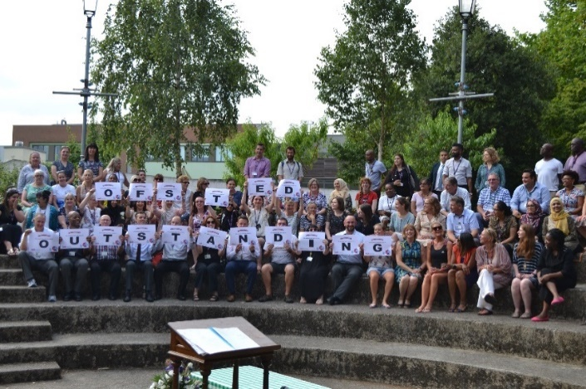

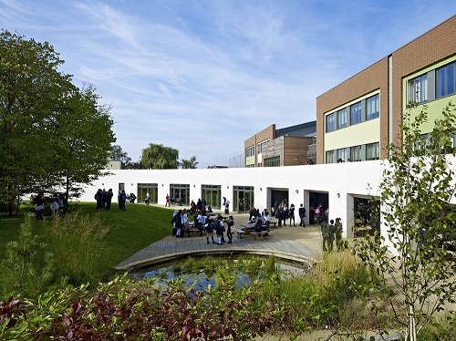

For further information about our school please visit our website: www.wsfg.waltham.sch.uk

