

**WALTHAMSTOW SCHOOL FOR GIRLS**

***“NEGLECT NOT THE GIFT THAT IS IN THEE”***

Candidate Information Pack

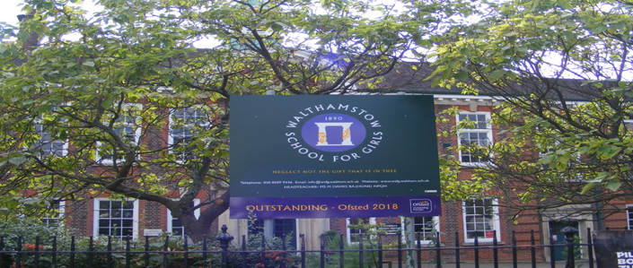

**Information for applicants for the post of**

**Teacher of PE**

**Full time**

**Required September 2022**

Contents of Applicant Pack

* Welcome letter from Helen Marriott – Headteacher
* Brief history of Walthamstow School for Girls
* Walthamstow School for Girls G.R.E.E.N. vision
* School Improvement Plan Summary
* What staff value about our school
* Applying for a job at Walthamstow School for Girls
* Pre-employment checks
* Job description and Person Specification
* Faculty Information (where applicable)
* Staff Benefits

**Candidates are encouraged to visit the school website for additional information:**

[www.wsfg.waltham.sch.uk](http://www.wsfg.waltham.sch.uk)

**Additional Information and Key Policies:**

Safeguarding: <https://www.wsfg.waltham.sch.uk/attachments/download.asp?file=2921&type=doc>

Keeping Children Safe in Education: <https://www.wsfg.waltham.sch.uk/attachments/download.asp?file=2756&type=pdf>

Policy statement on Recruiting Ex-Offenders and Safekeeping of Disclosure:

<https://www.wsfg.waltham.sch.uk/attachments/download.asp?file=2527&type=pdf>

Applicants Guide to Prevention of Illegal Working:

<https://www.wsfg.waltham.sch.uk/attachments/download.asp?file=2528&type=pdf>

LBWF Safer Recruitment Guidance

[**https://www.wsfg.waltham.sch.uk/attachments/download.asp?file=2730&type=doc**](https://www.wsfg.waltham.sch.uk/attachments/download.asp?file=2730&type=doc)

LBWF Equal Opportunities Policy Statement

[**https://www.wsfg.waltham.sch.uk/attachments/download.asp?file=2731&type=doc**](https://www.wsfg.waltham.sch.uk/attachments/download.asp?file=2731&type=doc)

# 

Welcome letter from Helen Marriott, Headteacher

# April 2022

Dear Applicant

I am delighted that you are considering applying for the role of **Teacher of PE** at Walthamstow School for Girls. I consider it a privilege to lead staff and students in this exceptional school where we are passionate about education being a vehicle for promoting equality for all and where our mission is to empower young women to become leaders of the future. We are a truly comprehensive school, proud of our diversity and committed to social justice. Although we are an Outstanding School (Ofsted, 2018), achieve exceptional outcomes and have consistently been in the top 20% of schools nationally for progress, our focus is on developing exceptional young women, not just on academic achievement. Our designation as a Teaching School Hub in February has given us the opportunity to work collaboratively with leaders and practitioners throughout Haringey, Redbridge and Waltham Forest to improve the life chances of young people in 239 schools across our area. There could not be a more exciting time to join the students and staff at WSfG!

We actively value staff and students: we are committed to their development and the contribution they make to shaping the future direction of the school. The new school SIP, created initially with middle leaders and then with a wider range of stakeholders, demonstrates our commitment to staff and student wellbeing, distributed leadership and creating robust systems, founded on evidence-informed practice. I have included a summary in this pack so that you have a ‘flavour’ of how our key priorities will be developed over the next few years.

We are committed to Safer Recruitment practices and procedures and shortlisted applicants will be questioned about their commitment to the safeguarding of young people. The successful candidate will be subject to an enhanced DBS clearance.

Having read the candidate information, I hope that you feel excited by both the role itself and the chance to be part of WSfG at a pivotal moment in its development. We welcome visits from prospective candidates and would be proud to show you round our wonderful school.

I look forward to hearing from you.

Helen Marriott

Headteacher MA NPQH



**History**

In January 1890, a circular stated that a “school for girls” was to be opened in Walthamstow. Miss Hewett was appointed as the first Headmistress and remained until she retired in 1924. There were 49 girls, whose ages ranged from 7-16 years. At this time there were only five teachers, two of whom were graduates.

Our original building was in West Avenue Road and when student numbers grew the school moved to Church Hill House, where a church now stands. It was in September 1913 that 243 girls came to the present building with the Greek Amphitheatre being added in the 1920s. In January 2010 our most recent refurbishment and rebuilding work was completed as part of the Building Schools for the Future Programme. This work has given us the unique blend of traditional and state of the art facilities that we currently enjoy at our school.

**Our school in 2022**

Walthamstow School for Girls is a high achieving, oversubscribed, diverse and inclusive school which is regularly in the top 20% nationally for progress, and is at the centre of the vibrant local community of Waltham Forest (the 2019 and first London Borough of Culture). Our most recent results can be found on our website. We are consistently among the top-performing non-selective schools in the country and the pupils take great pride in their school. In June 2018 we were awarded an ‘outstanding’ judgement in all categories.

Every one of our 900 students is valued equally as an individual with different gifts and talents, reflecting our commitment to the school motto “Neglect not the gift that is in thee”. We offer strong pastoral support and regular monitoring, target setting and dialogue with students and parents/carers.

Walthamstow School for Girls is proud be the lead school of the North East London Teaching School Hub. Working collaboratively across Haringey, Redbridge and Waltham Forest our aim is to ensure that every child has a great teacher who inspires and unlocks their potential. We aim to achieve this by providing exemplary training and development, for leaders and practitioners which meets the needs of all the schools in our area, so that every child has access to the highest quality education and develops a desire for lifelong learning..

*“Middle Leaders are exceptional and collaborate well to share best practice. They drive their teams with energy and enthusiasm. They share the strong moral purpose of the Headteacher to ensure that no pupil is left behind. As a result, outcomes for pupils are outstanding, giving them essential life chances.” Ofsted 2018.*

**Students and staff**

Our school is characterised by its sense of community and ‘family’, the commitment of staff to the welfare and progress of students and its inclusive and diverse nature. Our students are a delight: ambitious and hard-working, they embrace the full range of opportunities offered to them both during and beyond the school day. This is highlighted not only by our exceptional examination results but also by the maturity of the girls, their sense of responsibility, community and fun.

One of the school’s strengths is the quality of the staff we are able to attract and retain. Our teachers ensure lessons are stimulating and challenging. Students work with enthusiasm and interest in classrooms where there is a calm atmosphere suitable for learning. The broad and balanced curriculum ensures that all students are extremely well equipped to continue their education.

**Our environment**

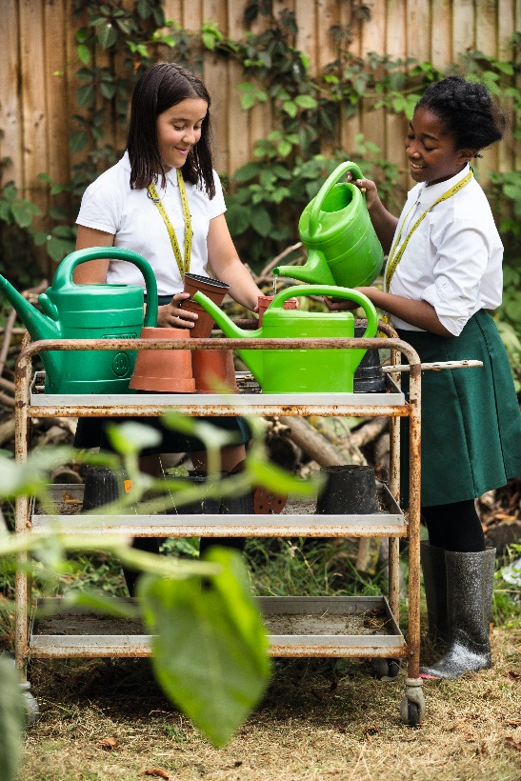We offer excellent facilities to both staff and students. Our acclaimed architect designed buildings and facilities make a stunning learning and working environment. Our £18 million rebuild project, completed in 2010, dramatically extended and enhanced our accommodation. We have state-of-the-art facilities in science, technology and performing arts, as well as a fantastic dining hall, two assembly halls and social areas.

Visitors often comment on the beautiful school grounds and are surprised to find them in an East London comprehensive school! We are fortunate to benefit from both a listed building and an architect designed site, surrounded by lawns and trees. We also have a Greek amphitheatre and an allotment where students to learn how to grow fruit and vegetables, some of which are then used by our chef.

The school is well-served by transport connections, being just ten minutes’ walk away from Walthamstow Central tube and rail station and five minutes’ walk from the popular Walthamstow ‘village’, creative and restaurant quarter. We pride ourselves on working hard to retain our role as an important part of the local community. Examples of this commitment can be seen in our weekly *Greensheets*. Our staff are inclusive and friendly, with regular social and wellbeing events as well as charity fundraising.

**Educating and empowering young women**

Our role is to empower young women become leaders of the future: confident and articulate, but also critical thinkers. Through a range of activities and opportunities, students are helped to develop their leadership qualities, their sense of community and global responsibility as citizens of the world in line with our G.R.E.E.N. values.



Our G.R.E.E.N. Vision

**The G.R.E.E.N. values**

| https://www.wsfg.waltham.sch.uk/_site/data/files/images/values/C52FA90503F596A26EE2DC7FE1E19642.png | The value **GROWTH**is based on the work by Carol Dweck on growth mindset.  Having a growth mindset encourages the belief that we can all improve at whatever we put our minds to with practice and perseverance.  It encourages learning, effort and stickability.  It also promotes the importance of reflection and criticism as tools to move us forward. |
| --- | --- |
| https://www.wsfg.waltham.sch.uk/_site/data/files/images/values/3FEE02382FB6B8CCE94E0DF659218767.png | The value **RESILIENCE** represents the notion that, on any learning journey, there will be obstacles.  With **RESILIENCE**and perseverance, these obstacles can be overcome and the final goal more rewarding.  The key is not to be fearful of these obstacles and to accept that mistakes and challenges are an important part of learning.  The learning line is an effective symbol for resilience and for assessment for learning. |
| https://www.wsfg.waltham.sch.uk/_site/data/files/images/values/38C6CD54B28E286D9A8410BF39911E01.png | The value **ENERGY**is the centre of our vision.  It encourages focus and enthusiasm from everyone.  This **ENERGY** could be represented in the attitude of students as well as in staff morale, parent and governor involvement.  It promotes positivity and supports all of the other G.R.E.E.N. values. |
| https://www.wsfg.waltham.sch.uk/_site/data/files/images/values/BC7D9BD0A310876A7B76D38599477A89.png | The value **EMPATHY**promotes community spirit in many dimensions.  It signifies self-awareness as well as respect for each other despite our differences.  In addition to this, it illustrates that none of us are alone on our learning journey and that, through collaboration, success can be greater. |
| https://www.wsfg.waltham.sch.uk/_site/data/files/images/values/AABBE9BC30E8511FD418D7E3A2E90E56.png | The value **NEWNESS** is vital in an ever changing world.  This encourages us to be open to new ideas, techniques, technologies and challenges.  It encourages us all to step out of our comfort zones as this is where the deepest learning and the greatest success can be achieved. |



Our vision: Where are we heading and what are we trying to achieve?

Our vision for WSFG is...

• A school where we value great learning and great teaching because we know that this is the key to unlock our students’ potential and inspire them on a journey of lifelong learning

• A school where all staff understand their role as agents of social change so that we focus on improving the life chances of all students, particularly the most vulnerable and disadvantaged

• A school where all of our girls feel safe and nurtured because of our robust support and safeguarding systems, where students understand how to improve their wellbeing, and where there is a culture of empathy and kindness

• A school where every student feels known, valued and listened to; students are empowered to become decision makers and have the confidence to undertake any role or profession, regardless of gender, sexual-orientation, race or ethnicity, knowing that in doing so, they are making the world a better and more equal place

• A school where there is distributed leadership; systems ensure that staff feel listened to and valued and effective communication enhances staff wellbeing

• A school which produces great leaders, both in its students and staff, and where there is a culture of female leaders being ‘10% braver’

• A school where students have broad horizons: physically, intellectually, culturally and emotionally

• An outstanding school where its evidence-based practice is shared, both nationally and internationally

• A school where the curriculum is broad and balanced, is used as a tool to develop critical thinking, where leaders understand its impact and where students feel the curriculum is both relevant and meets their needs

• A school which is enhanced by its leadership of the Teaching School Hub, seeing it as a mechanism for sharing and learning from the best teacher training and development practice in North East London and across the country.

**What is the purpose of the SIP?**

• The SIP acts as an ambitious medium and long-term plan for the school

• It creates an accurate baseline from which we can plan so that we have a clear idea of ‘where we are’ as a school, in terms of our priorities

• We need to ensure that we have a clear evidence base for any actions we take and our SIP actively encourages this process

• The ‘impact’ section allows us to see the journey we need to make, with clearly-defined, measurable outcomes

• The ‘actions’ should be what enables us to make that journey and should be carefully reviewed in order to ensure that they will have the desired impact, rather than actions for their own sake

• Since it is impact-driven, the SIP allows us to plan backwards and understand the actions we need to take from our current position.

**Who is it for?**

• The SIP has been created by a range of stakeholders: staff, governors and senior leaders. In June and July, students and parents will be consulted on these priorities and plans.

• The SIP is for the whole school community but will be used by governors to hold the school to account

**How will it be used?**

• This is an ‘organic’ document which will be constantly updated and reviewed by leaders and governors

• In the Autumn term, additional information for the baseline will necessitate changes in actions and intended outcomes

• The SLT will review the SIP actions and measure their impact against the intended outcomes at least every half-term

• Middle leaders will create their own faculty versions of the SIP so that their actions reflect those of the whole school and, in turn, feed into the process, forming part of the cycle of evaluation and review

**What are our priorities and why?**

• Our SIP priorities were proposed by a working group of middle leaders, led by the Headteacher, in February and March 2021. SLT at the SLT conference interrogated quantitative and qualitative information to ensure that these were the right priorities for the school. Staff and governors at our SIP day in April then explored the priorities further through a more detailed planning exercise and made decisions about which should be our most important priorities.

• There are four priorities so that we can focus on fewer priorities and more impact. These are our key priorities, which are all of equal importance: student wellbeing; staff wellbeing; pedagogy for achievement and progress; leadership and coaching development.

https://educationendowmentfoundation.org.uk/public/files/Publications/Implementation/EEF-Implementation-Recommendations-Poster.pdf

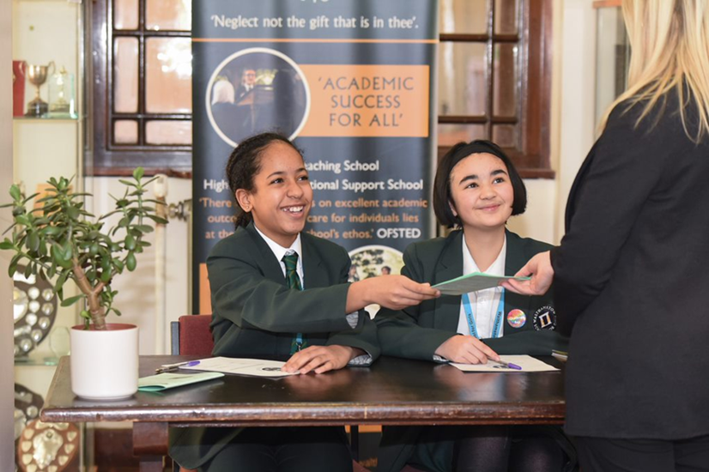

What staff value about the school

*“The school’s values of Growth, Resilience, Energy, Empathy and Newness (GREEN) are lived by staff and pupils in all aspects of the school’s work.” Ofsted 2018.*

* This school feels safe, kind and caring. We are not driven by results – we seem to be driven to produce fabulous young women
* Ethos of the school, supportive colleagues and strong management with compassion

*“There are very strong working relationships between staff and pupils based on mutual trust and respect.” Ofsted 2018*

* I value the ethos of hard work in the students and how the school promotes kindness, tolerance and maturity amongst the students
* Atmosphere of diversity, respect and inclusion
* Freedom to teach in a range of styles

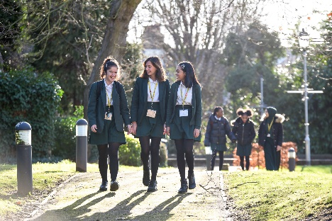



**What makes a good application?**

You need to make sure your application does you justice and provides you with the best possible chance of getting an interview. This means reading the job description and person specification and taking time over your application to demonstrate your skills and experience.

**The Application Form**

We do not accept CVs for any post in school, any CVs submitted will not be used for short listing purposes. It is essential that you complete all the sections on the application form. The “monitoring information” section will not be used for short-listing; it is used for administrative purposes only. You must provide full details in respect of two referees, one must be your current or last employer. If you are looking to join us from another school one of your referees must be your current Headteacher.

**Do you meet the requirements of the Person Specification?**

During the short-listing process we look at the information that you have provided and compare this against the person specification for the position that you are applying for. It is important, therefore, that you provide as much information as possible about how you meet the requirements of the post. You need to be able to demonstrate how you match the criteria, giving examples where possible. This will give you the best chance of being invited for an interview.

**Supporting Information**

The “general experience and information” section is your opportunity to sell yourself and demonstrate your suitability for the post, be concise but informative and highlight your skills and knowledge. Please include all your relevant experience whether gained at work or outside of the work place environment.

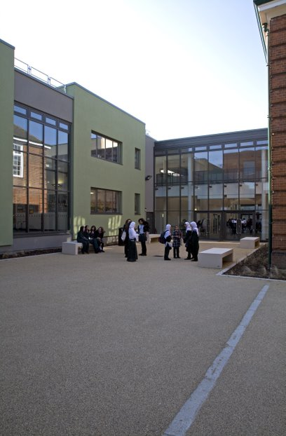



If you are successful at interview and are offered a post at Walthamstow School for Girls we will be required to carry out a number of pre-employment checks. All offers of employment are conditional on these checks being satisfactorily completed.

The checks completed are:

**Identification documents**

All staff are required to provide proof of their identity and that they have the right to work in the UK.

**Criminal Record Checks (DBS)**

All offers of employment are subject to a satisfactory Enhanced Disclosure from the Disclosure and Barring Service DBS (formerly the Criminal Records Bureau CRB). Full information relating to this check and the Rehabilitation of Offenders Act 1974 is included in our New Starter Information Pack, issued with offer letters. Before completing the online DBS application you are advised to read the guidance information received with the email link.

Please note any information provided on your application form in the Disclosure and Criminal Background section will only be viewed by those who need to see it as part of the recruitment process. Any information disclosed will be treated in strictest confidence.

**Employment history and references**

On your application form it is important that you provide your full employment history including information regarding any gaps in your employment. References will be requested, prior to interview, from the information provided on your application form. We reserve the right to seek further references deemed appropriate and all references are verified on receipt.

We may ask you to help us to chase your referees to make sure that we receive your references as quickly as possible.

If you are currently employed in a school we will request a reference from your current Headteacher.

**Qualifications**

If your role requires you to hold a professional qualification you will be asked to provide evidence in the form of original certificates. Copies of these will be held on your Personnel file.

**NCTL Checks (Teaching staff only)**

All teachers are checked against the NCTL central register, this includes a Prohibition check.

**Pre-Employment Health Check**

All staff will be asked to complete a pre-employment health questionnaire. Any information that is disclosed as part of the health check will only be shared with relevant key members of staff and will be treated in the strictest of confidence.

**WALTHAMSTOW SCHOOL FOR GIRLS**

***“NEGLECT NOT THE GIFT THAT IS IN THEE”***

Job Description

**Job title: Classroom Teacher**

**Reporting to: Head of Faculty (HOF)**

**Responsible for: The provision of a full learning experience and support for students.**

**Safeguarding and promoting the welfare of all students.**

**Liaising with: Teachers and support staff, LEA representatives, external agencies and parents/carers.**

**Working time: 32.5 hours per week**

**Salary: Classroom Teachers’ Pay Scale**

**Disclosure: Enhanced**

|  |  |
| --- | --- |
| **Core Purpose** | * Under the reasonable direction of the Headteacher, carry out the professional duties of a school teacher as set out in the current School Teachers’ Pay and Conditions Document (STPCD) * To implement and deliver an appropriately broad, balanced relevant and differentiated curriculum for students and to support a designated area as appropriate * To monitor and support the overall progress and development of students as a Teacher/Form Tutor * To facilitate and encourage a learning experience which provides students with the opportunity to achieve their individual potential * To contribute to raising standards of student attainment * To share and support the school’s responsibility to provide and monitor opportunities for personal and academic growth. |
| **Teaching** | * To teach students according to their individual educational needs, including the setting and marking of work according to the school’s policies * To assess, record and report on the attendance, progress, development and attainment of students and to keep such records as are required * To provide, or contribute to, oral and written assessments, reports and references relating to individual students and groups of students * To ensure that ICT, Literacy, Numeracy and school subject specialism(s) are reflected in the teaching/learning experience of students * To undertake a designated programme of teaching on a ratio of 40/50 periods * To ensure a high quality of learning experience for students which meets internal and external quality standards * To prepare and update subject materials * To use a variety of delivery methods which will stimulate learning appropriate to student needs and demands of the syllabus * To maintain discipline in accordance with the school’s procedures, and to encourage and model good practice with regard to punctuality, behaviour, standards of work and homework * To undertake assessment of students as requested by external examination bodies, departmental and school procedures * To mark, grade and give written/verbal and diagnostic feedback as required |
| **Operational / Strategic Planning** | * To assist in the development of appropriate syllabi, resources, schemes of work, marking policies and teaching strategies in the faculty * To contribute to the faculty’s development plan and its implementation * To plan and prepare courses and lessons * To contribute to the whole school’s planning activities |
| **Curriculum Provision and Development** | * To assist the HOF in ensuring that the curriculum area provides a range of teaching which complements the school’s strategic objectives and continues to be relevant to the needs of students, examining and awarding bodies and the school’s aims |
| **Staffing** | * To take part in the school’s staff development programme by participating in arrangements for further training and professional development * To continue personal development in the relevant areas including subject knowledge and teaching periods * To engage actively in the Performance Management Review process * To ensure the effective/efficient development of classroom support * To work as a member of a designated team and to contribute positively to effective working relationships within school |
| **Quality Assurance** | * To help implement school quality procedures and to adhere to those * To contribute to the process of monitoring and evaluation of the curriculum area in line with agreed school procedures, including evaluation against quality standards and performance criteria. To seek/implement modification and improvement where required * To review, from time, to time methods of teaching and programmes of work * To take part, as may be required, in the review, development and management of activities relating to the curriculum, organisation and pastoral functions of the school |
| **Management Information** | * To maintain appropriate records and to provide relevant accurate and up to date information for MIS, registers etc * To complete the relevant documentation to assist in the tracking of students * To track student progress and use information to inform teaching and learning |
| **Communications and Liaison** | * To communicate effectively with the parents/carers of students as appropriate * Where appropriate, to communicate and co-operate with persons or bodies outside the school * To follow agreed policies for communications in the school * To take part in liaison activities such as parents’ evenings, review days and liaison events with partner schools * To contribute to the development of effective subject links with external agencies |
| **Resources** | * To assist the HOF in identifying resource needs and to contribute to the efficient/effective use of physical resources * To co-operate with other staff to ensure a sharing and effective usage of resources to benefit the school, faculty and the students |
| **Pastoral System** | * To be a Form Tutor to an assigned group of students * To promote the general progress and well-being of individual students and of the form tutor group as a whole * To liaise with a Curriculum Leader to ensure the implementation of the school’s Pastoral System * To register students, accompany them to assemblies, encourage their full attendance at all lessons and their participation in other aspects of school life * To evaluate and monitor the progress of students and keep up-to-date student records as may be required * To contribute to the preparation of action plans and progress files and other reports * To alert the appropriate staff to problems experienced by students and to make recommendations as to how these may be resolved * To communicate as appropriate, with the parents of students and with persons or bodies outside the school concerned with the welfare of individual students, after consultation with the appropriate staff. * To apply the Behaviour Management systems so that effective learning can take place * To deliver a tutorial programme of activities relevant to the tutor group as advised by line manager * To attend annual reviews for assigned students who are on the SEN register |
| **School Ethos** | * To support the school ethos, aims and policies |
| **Whole School Contribution** | * To play a full part in the life of the school community, to support its distinctive aims and ethos and to encourage staff and students to follow this example * To promote actively the school’s policies * To continue professional development * To comply with the school’s Health and Safety policy and undertake risk assessments as appropriate |

Whilst every effort has been made to explain the main duties and responsibilities of the post, each individual task undertaken may not be identified.

This job description is carried out in accordance with provisions of the School Teachers’ Pay and Conditions document and within the range of teachers’ duties set out in that document. This job description is current at the date shown but, in consultation with you, may be changed by the Headteacher to reflect or anticipate changes in the job commensurate with the grade and job title.

The school will endeavour to make any necessary reasonable adjustments to the job and the working environment to enable access to employment opportunity for disabled job applicants or continued employment for any employee who develops a disabling condition.

September 2021

*This school is committed to safeguarding and promoting the welfare of children and young people and expects all staff and volunteers to share this commitment.*

Person Specification

|  |  |  |  |  |  |  |
| --- | --- | --- | --- | --- | --- | --- |
|  | **Criteria** | Essential | Desirable |  | Assessed by application | Assessed by selection process |
|  | **Qualifications** | | | | | |
| 1 | A good honours degree or equivalent | / |  |  | / |  |
| 2 | Qualified Teacher Status (QTS) | / |  |  | / |  |
|  | **Professional experience and knowledge** | | | | | |
| 3 | A willingness to develop and deliver PE |  | / |  | / | / |
| 4 | An ability to plan, deliver and evaluate sequences of work and individual lessons | / |  |  | / | / |
| 5 | An ability to constantly monitor students’ achievements and adapt teaching to the needs of the class with the support of the Head of Faculty of teaching/working in a single sex educational environment | / |  |  | / | / |
| 6 | Understanding and knowledge of the appropriate use of a range of differentiation techniques | / |  |  | / | / |
| 7 | The ability to contribute to the work within the faculties, both as a member of a team and individually | / |  |  | / | / |
| 8 | A commitment to the promotion of anti-sexism, anti-racism and equality of opportunity in all aspects of their work within the school | / |  |  | / | / |
|  | **Professional aptitudes, qualities and skills** | | | | | |
| 9 | A willingness to contribute to the extra-curricular activities within the faculty and support ongoing projects | / |  |  | / |  |
| 10 | A willingness to learn new skills and develop existing skills as a part of a program of professional development, with the aim of using this development to further their career | / |  |  | / | / |
| 11 | Personal qualities and skills that can contribute to the school’s pastoral system | / |  |  | / | / |
| 12 | An ability to effectively organise their workload, be energetic and have a sense of humour | / |  |  |  | / |

*This school is committed to safeguarding and promoting the welfare of children and young people and expects all staff and volunteers to share this commitment.*



**Performing Arts Faculty**

The Performing Arts Faculty is made up of a committed, passionate and energetic team of teachers. Music, Drama and Physical Education are taught as discrete subjects at KS3, but we adopt a unified approach and a shared philosophy across the three curriculum areas. At KS4 the academic results are very good and many students go on to study the subjects at ‘A’ level and beyond.

The Faculty enjoys a high profile within the school and the local community, and the extra-curricular programme on offer is a permanent and regular feature of school life, with a high percentage of the student body participating at a number of different levels. Every two years, in addition to the individual departmental activities, we work together on a fully staged Musical. The last few years have seen highly successful productions of ‘Bugsy Malone’, ‘The Wizard of Oz’, ‘Annie’ and ‘Mary Poppins’.

In Music at Key Stage Three all students follow a Scheme of Work designed to develop and extend their skills in the key areas of Performing, Composing and Listening and Appraising. This includes whole class vocal work, performing as part of a steel band and composing using Garageband.

At KS4 students follow the AQA GCSE Music Specification, further developing their Performing and Composing skills and deepening their understanding of music through the study of set works by Haydn, Copland, Santana and The Beatles.

The work of the Music Department is supported by 11 peripatetic instrumental teachers. They are an integral and indispensable part of the team. The department runs a choir, Glee Club, wind band, flute group, five steel bands and an orchestra, performing at numerous annual events throughout the school year. We are regular participants in the Festival of Music for Youth, having performed in the National Festival for the last two years running. In 2019 our Year 11 Steel Band was invited to perform as part of the Music for Youth Prom at the Royal Albert Hall. Our Glee Club was selected for the regional finals of the Jack Petchey Glee Club Challenge in 2019, and in 2020 progressed to the A Cappella Grand Final at Cadogan Hall.

In Drama lessons at KS3, pupils explore the development of theatre, from ancient Greece to Shakespeare to contemporary theatre. Students develop drama skills through the study of practitioners and genres, including Boal, Stanislavski and physical theatre and use these skills to explore topics such as the transition from primary to secondary school. Students are given the opportunity to devise their own drama and work on text throughout Key Stage 3, and log books are used to record and support their learning. Within lessons, there is also a strong emphasis on the development of oracy.

At KS4, students follow the Eduqas GCSE Drama course. This involves the in-depth study of practitioners and genres, including Berkoff, Complicite and Frantic Assembly. Devising and text-work are given equal weighting, and experiencing live theatre is an important element of the course.

The provision of cultural enrichment through extra-curricular opportunities is a key element of the Drama Department’s philosophy. In recent years, we have forged partnerships with the Unicorn, Almeida, Donmar Warehouse and Old Vic theatres, giving students in Key Stages 3 and 4 numerous opportunities to experience live performance. Our students have participated in the Donmar’s Take the Stage project, Barbican Box, National Theatre Connections and Shakespeare Schools Festival, performing at the Donmar Warehouse, Barbican, Soho Theatre and Stratford Circus.

The P.E. Department aims to emphasise the importance of leading a healthy lifestyle and encourages participation in all forms of sporting activities. To this end, the core curriculum at KS4 has a more recreational basis and we offer activities such as boxing, badminton, trampolining and self-defence; many Year 11 students opt into offsite activities such as swimming and use of a local gym.

At KS3, the students follow a broad curriculum which includes dance, gymnastics, netball, football, basketball, trampolining, handball, tag rugby, fitness and athletics and are assessed at the end of each activity.

In addition to the 3 members of the P.E. department, the school is fortunate in having a number of specialist coaches, who come into the school to offer extra-curricular activities. The department organises an annual Sports Day in the summer term and Inter-Form competitions spread throughout the year, where every student in the school participates in a sporting activity. A range of extra-curricular clubs and events are run throughout the year, and the school has a reputation for high levels of participation in borough fixtures.

The Faculty firmly believes that education through aesthetic and physical subjects is of vital importance to the development of each individual and that cultural capital is a key element in academic and personal fulfilment. We strive to promote our work as a microcosm of the wider artistic and sporting world.

**February 2022**

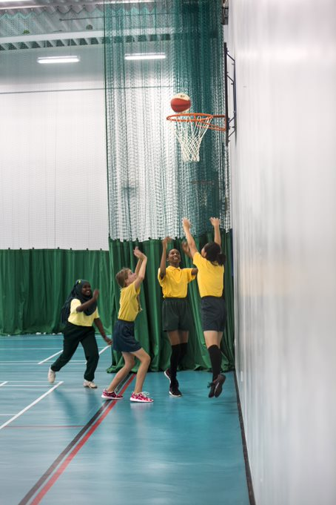

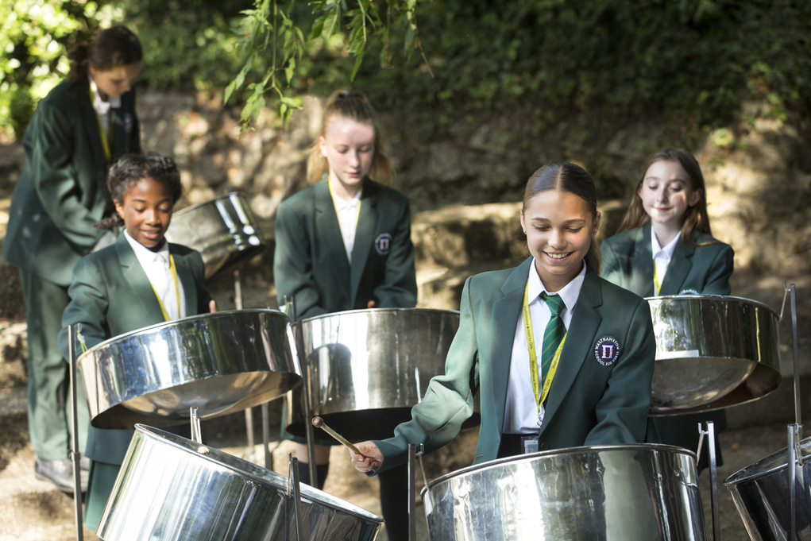

Staff Benefits

Outlined below are some of the additional benefits available to staff working at Walthamstow School for Girls.

**Commitment to CPD**

The best CPD has a measurable impact on the progress of students. For this reason, we believe in giving our staff dedicated training time, delivered during twilights. We are developing a comprehensive CPD programme, where all staff follow long-term courses, including training as coaches by John Kane, an external provider. Staff then work in triads to coach each other, developing their practice through bespoke feedback training.



**Cycle 2 work scheme**

This benefit offers staff the opportunity to purchase a bike (from a range of providers) making a tax saving, whilst keeping fit at the same time.

**Eye Tests**

All staff using computer equipment should have eye and eyesight checks at regular intervals. Eyesight testing should also happen where staff experience visual difficulties, which may reasonably be considered to be caused by computer work. Staff working within schools in the London Borough of

Waltham Forest may be entitled to reimbursement of some costs associated with vision testing and the frames and lenses needed to enable them to work safely on display screen equipment.

**Staff Wellbeing**

Staff Wellbeing is one of our school SIP priorities. There is a staff wellbeing development group which examines both strategic and operational approaches to improving the wellbeing of all groups of staff in our school.

At Walthamstow School for Girls there are also a number of staff organised activities including a running club, Keep Fit and Boxfit exercise sessions and staff football matches.

**Workplace Options - Employee Assistance Provider**A confidential counselling, help and information service is provided for all those employed by Waltham Forest and is available free of charge 24 hours a day, every day of the year. This service can help with a range of problems from practical everyday matters to sensitive and emotional issues. For further information please call 0800 328 1437 or contact: [**www**.**employeeassistance.org.uk**](http://www.employeeassistance.org.uk)

**Non-meeting weeks**

There are designated Home and Family non-meeting weeks throughout the year to support with reduced workload and staff wellbeing.

**Staff Car Park**

There is parking available on site for all staff.





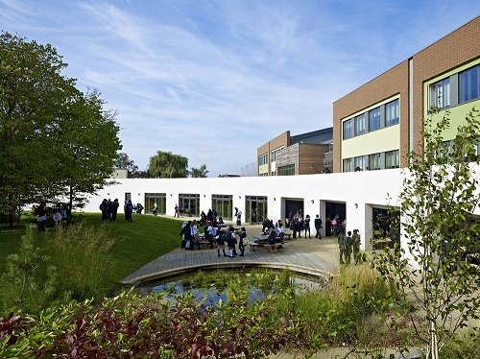

For further information about our school please visit our website: [**www.wsfg.waltham.sch.uk**](http://www.wsfg.waltham.sch.uk)