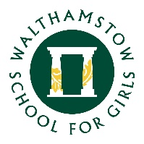
13 September 2022

College Roadshow
Tuesday 18th October 2022

Students to attend in allocated cohorts as follows:
WSF: 5.30 - 6.15
FCH: 6.15 - 7.00
During this term, students in Year 11 will be receiving information about continuing their education after they leave this school. Over the last few years more and more students have chosen to go to colleges/sixth form schools to extend their skills and qualifications. At the present time the number of job vacancies for school leavers is small. Employers increasingly prefer applicants with a good variety of skills, abilities and interests. Continuing in education is one way of increasing these.

Our College Roadshow is an excellent opportunity to meet and discuss options with
established providers of A Levels, BTECs and Apprenticeships. At least 25 stall holders will offer guidance and information about courses, University options, required GCSEs and job opportunities for Post-16 year olds.

We hope as many students as possible, accompanied by their parents/carers, will be able to attend this event.

Mr Shackson
Assistant Headteacher

