Dear Parents and Carers
I hope this email finds you all safe and well. Thank you for your support this week and for helping to make the return to school as smooth as possible. Your daughters are so incredibly resilient and have coped extremely well with testing, year 11 non-core mock examinations, as well as the return to school routines. We are all very proud of them.
I wanted to clarify the current arrangements relating to COVID regulations, as well as to highlight some further adjustments we are making in order to keep everyone safe.
GOVERNMENT PLAN B
Please be aware that the government has stressed that the current measures will be temporary. Plan B regulations are currently scheduled to expire on 26th January, at which point things will be reviewed. As ever, the school will carefully follow government guidance and Public Health advice and all our procedures will be kept under review. If the number of cases falls significantly, we anticipate being able to relax some of our current measures.
FACE COVERINGS
All students are required to wear face coverings in classrooms, as well as in communal areas, unless they are exempt. Students should also wear a face covering when travelling on public transport. Face coverings do not need to be worn by students when outdoors.
We ask families to ensure that their child comes to school with a face covering and to encourage them to wear these when required. Face coverings help protect the wearer and others against the spread of infection because they cover the nose and mouth, which are the main confirmed sources of transmission of COVID-19
Please be aware that the government guidance does not ordinarily expect teachers to wear a face covering in the classroom if they are at the front of the class, to support education delivery, but decisions around this need to be made by the individual teacher.
PE KIT
From next week, students will be asked to wear their PE kit to school on the days that they have a PE lesson. This will remove the need for them to change into their kit during the day. It is important that students are aware that this only applies to the days when they have PE on their timetable and that it must be the official school PE kit. On their PE days students should also wear the school blazers over their PE kit.
VENTILATION AND WEARING COATS
The government has recognised the importance of good ventilation and has supplied schools with some CO2 meters and also allowed schools to apply for a small number of air purifiers. WSFG has already made use of CO2 meters to determine the air flows within classrooms and access the ventilation available. If the teacher considers it appropriate, students will be allowed to wear their outdoor coats in the classroom, should that be necessary to maintain good ventilation by opening windows, depending on the room temperature. The usual uniform rules will continue to apply, however, and it is the teacher rather than the student who will determine whether it is appropriate to allow the wearing of coats.
As the cold weather is now here, please ensure your daughter wears additional layers in order to keep as warm as possible.
COVID TESTING
Students continue to be encouraged to test twice weekly at home, with lateral flow device (LFD) test kits, 3 to 4 days apart. LFD test kits are available from the school, but can also be ordered online or obtained from a chemist. They should also report their result online.
POSITIVE LFD TEST RESULTS OR COVID SYMPTOMS
If a student has a positive test result, or if they have any of the Covid-19 symptoms, they should not come to school. If a student has received a positive LFD test result they should self-isolate, follow the stay at home guidance and order a PCR test. Similarly, if a student has developed Covid-19 symptoms they should order a PCR test. If the student’s PCR test is negative then they may return to school. Otherwise they must self-isolate
POSITIVE TEST RESULT AND SELF-ISOLATION
New self-isolation guidance for people testing positive. Any child or adult who tests positive or develops symptoms (a new continuous cough, a temperature, or a loss of taste/smell) is still required to isolate for 10 full days, from the day on which their symptoms started (or on which they took the test, if they don’t have any symptoms). However, there is new guidance on ending self-isolation early using lateral flow device (LFD) tests. If the child or adult is negative on 2 lateral flow tests taken at least 24 hours apart, beginning on day 6, and they do not have a high temperature, then they can end isolation after the second negative lateral flow test result and return to their school on the next day. This is from Department for Education guidance – even if the test result is taken early on the morning of day 7, the earliest a child can return would be day 8. If the child or adult is positive on day 6, they will need to retest daily until they get 2 negative lateral flow tests taken at least 24 hours apart, or reach their 10 day self-isolation, whichever is sooner.
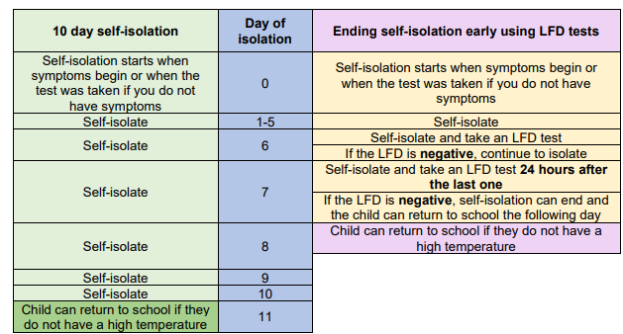
ISOLATION RULES FOR CLOSE CONTACTS
Young people between 5 and 18 and a half, or adults who have been fully vaccinated, no longer need to self-isolate if they have been identified as a close contact of someone with Covid-19. Instead they should take a lateral flow test every day for seven days and, unless they have a positive test result or develop symptoms at any time, they should continue to attend school as normal. However, whilst the number of cases remains high, as advised by the local authority, we may advise students to self-isolate where siblings or another person living in the same household has tested positive in order to reduce infection rates.
REMOTE WORK FOR STUDENTS SELF-ISOLATING
Staff will always set work on Teams for their lessons in order to support students who are self-isolating. Please contact your child’s SPL if you have any queries.
Wishing you a restful weekend.
Yours faithfully
Helen Marriott

