PRIMARY LINK ACTIVITIES
Textiles Primary Link Activity with Henry Maynard School

This term we engaged in an exciting textiles enrichment workshop for our Year 10 students in collaboration with Year 6 students from Henry Maynard Primary School. This opportunity allowed us to establish further links with Ms Smith, Year 6 Creative Development Leader. The workshop had been organised within our Year 10 Textiles lessons, so our students could show off both their leadership and specialist skills. After a four day marathon with success after success on each day, we were amazed with final products.

Ms Powell

Here are some comments from members of staff and the Year 6 primary students:

After talking to the pupils this afternoon, they all said they really enjoyed the project and they were extremely happy with the finished products. They were looking forward to doing more textile work when they get to secondary school in the autumn and hoped they might get to use some of the other machinery! It has been a great transition activity so they can see the opportunity available to them in KS3. Thank you so much for all your hard work in organising the project, and also for the help of your students and your teaching assistant, who made us feel very welcome. I'd love to work together again in the future.
Ms Smith, Year 6
Creative Development Leader
Henry Maynard Primary School

I went into Ms Powell’s Primary Links lessons on Monday and Thursday. It was amazing to see the Year 6 students so engaged and focused on the tasks. Clearly, the requirements of the lesson had been well explained as, not only were the Year 6s on task, the Year 10s were supporting them diligently. On Thursday, many students were nearing completion of their items and they were thrilled at the outcome. I know the teachers and teaching assistants who brought the children for this project and the feedback was excellent. Ms Smith, the project co-ordinator, cannot wait to undertake another project with Ms Powell. It was fantastic to watch our Year 10 girls confidently passing on the skills and knowledge they have acquired from their textiles classes to the Year 6 visitors from Henry Maynard primary school. All the children were welcomed with open arms and listened attentively as they were shown how to use the sewing machines and their joy was obvious as their iPod covers quickly developed before their eyes. There was a definite buzz around the room, and you could quite clearly hear the excitement in the younger girls’ voices as they talked about joining our school in September.
Ms Jolliffe
Student Welfare Officer

10 out of 10!
Kubran and Eloise Year 6

Our teamwork went really well. Jade and Aisha were very helpful and kind. I hope I’ll see them when I’m in secondary. It would have been better if we could stay here for at least three hours because I had so much fun!
IIgin Year 6

I like the part when I get to sew the fabric because I learned a new thing. I would have liked to do more sewing!
Tamjid Year 6

Everything went well! The ideas that I had went with the colours that I chose. I wish I had more time to glue on my squares!
Siwan Year 6
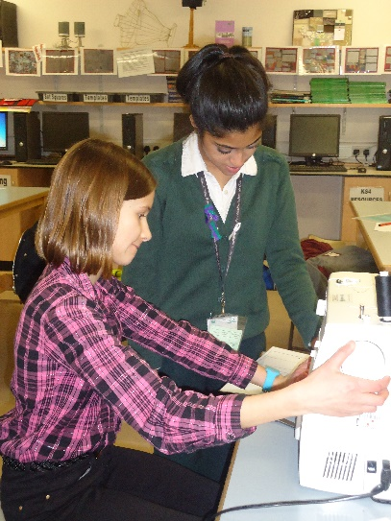
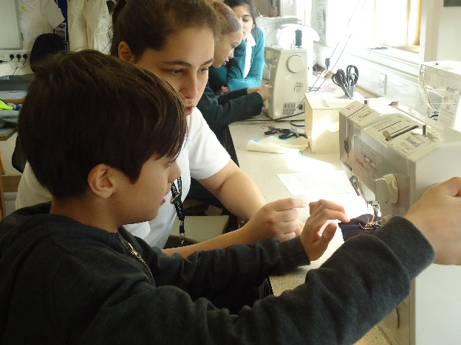
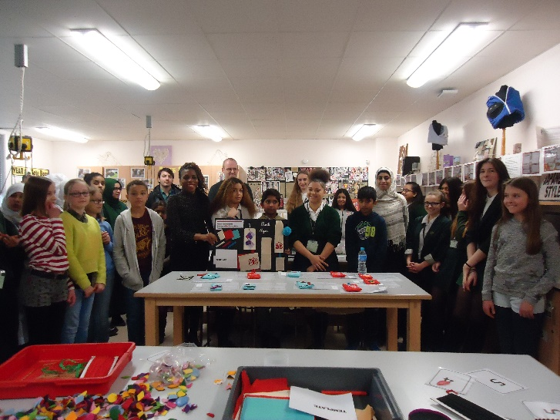

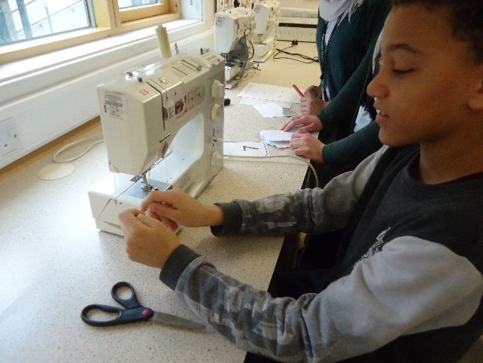
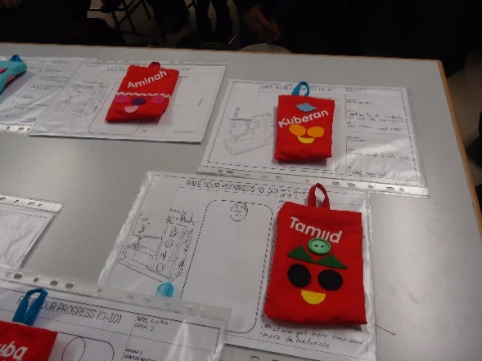

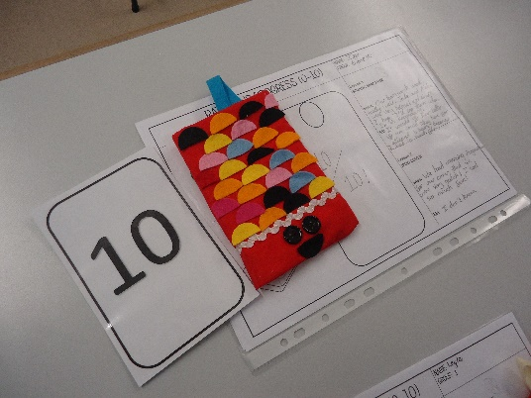

Steel Band Workshop with Henry Maynard Primary School
Walthamstow School for Girls hosted a morning of steel band workshops led by the Head of Performing Arts, Mr Burstow. Year 3 students from Henry Maynard came to WSFG throughout the morning to learn a piece on the steel pans. Each workshop lasted approximately 45 minutes with students playing pretty much non-stop throughout. It was lovely to see how enthusiastic and focused the students were and everyone left energised and uplifted by their steel pan experience.

Drama Primary Link Activity with Edinburgh Primary School
Our Year 7 Drama Club visited Edinburgh Primary School to perform their devised play on the Boudicca Warrior Story. Walthamstow School for Girls commissioned a thrilling performance based on the topic of The Romans, which Edinburgh students had recently enjoyed studying.
In groups, students were given different sections of the Warrior Queen’s tale to develop into a scene. These were then fused together to create a stunning piece featuring scenes of battle, death, loyalty and bravery. Each act was interwoven with quality ensemble sequences, featuring mime, movement and still images. The girls worked tirelessly for three months, spending Wednesdays after school and Thursday lunchtimes crafting a show that was thoroughly enjoyed by their Year 4 audience.
Feedback from the audience showed that they really enjoyed the different scenes and found the play realistic. One young boy said he particularly enjoyed the battle scene and the way techniques, such as slow motion, were used to present it.
Destiny from WSFG says that being involved in the project really helped bring different Year 7 students together. Students were able to work with different groups and make new friends. Zainab says that it was an amazing experience and something really different. Khara says she feels that she has learnt a lot of performance techniques and many of the girls agreed that the overall experience helped develop their confidence.
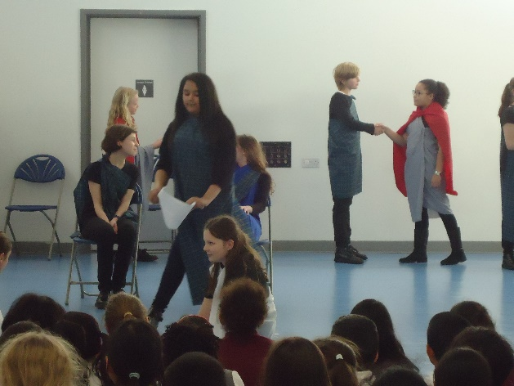
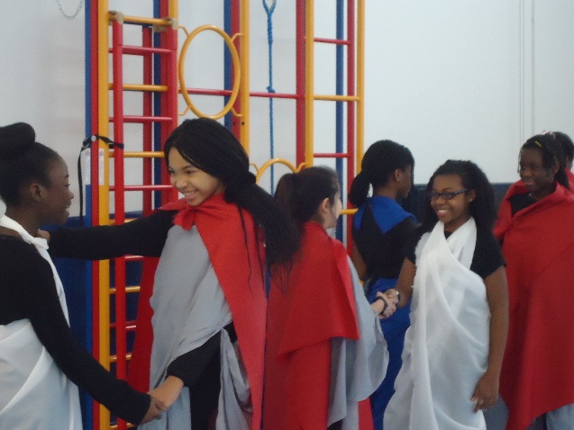

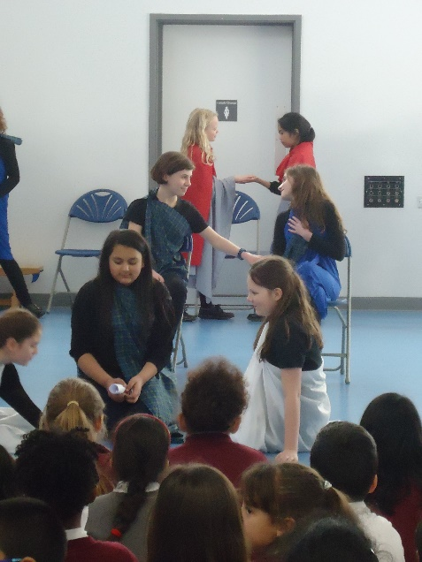
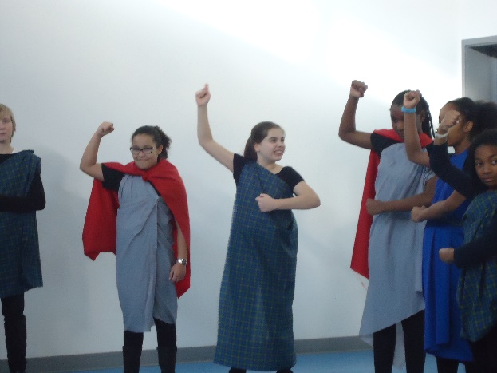

ICT Scratch Workshop with Woodside Primary School.

A group of girls from Woodside Primary School attended our school to take part in a Scratch programming workshop run by Ms Shafiq. The group eagerly arrived in the afternoon to learn how to code using a software called Scratch.

Once the group settled, they were introduced to Scratch and were shown a video which was made entirely from Scratch explaining how this block editing tool worked. The girls were introduced to different components of Scratch and were made familiar with the basic tools. They were told that basic animations could be created on Scratch as well as complex multi-level games. They were then sent off to the computers to get started.

The girls were given a challenge card each to try to replicate using the Scratch program. The challenge cards included tasks such as changing the colour of a butterfly, dancing cat, gliding ghost, cat follows the mouse, keystroke movement of cat etc. There was a slow start as the girls familiarised themselves with the system, but soon they all got the hang of it and were excited to create their next Scratch animations. Even one of the staff members accompanying them got involved with creating!

Once the challenge cards were completed, Ms Shafiq displayed three other animations on the board, which the girls had to try and program by themselves. The Princess and Frog conversation and the Disco Dancing animation were quite straight forward. The girls did however find it difficult to animate a Fish Tank which had several fish swimming in different directions at the same time. Some were able to use the skills learnt to complete the Fish Tank task and were definitely showing signs of being great problem solvers and computer programmers.

Soon it was time to leave, and the girls were shown how to access the free Scratch versions to continue coding in their own time. They were given a Shark Game instruction pack to take away and try at home. They were also awarded with a Computing Star pen. Overall, the workshop was a great success and the Year 6 students were able to take away valuable skills to develop their coding.
