Waltham Forest GREEN Teaching School Alliance
Partner Schools
Buxton School - http://buxtonschool.org.uk/

Chingford Foundation School - https://www.chingfordfoundation.org/

Connaught School For Girls - http://www.connaught-school.co.uk/
Frederick Bremer School - https://www.bremer.org.uk/
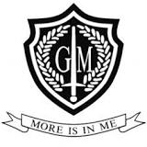
George Mitchell - http://www.georgemitchellschool.co.uk/
Heathcote School - https://www.heathcoteschool.com/

Highams Park School - http://highamsparkschool.co.uk/

Holy Family - http://www.holyfamily.waltham.sch.uk/
Kelmscott School - https://www.kelmscottschool.co.uk/

Leytonstone School - http://www.leytonstoneschool.org/

Norlington School - http://www.norlington.net/
Rushcroft School - http://rushcroftfoundation.org.uk/
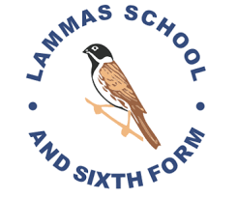
The Lammas School - http://www.lammas.waltham.sch.uk/
Walthamstow Academy - https://www.walthamstow-academy.org/

Willowfield School - http://www.willowfield-school.co.uk/

Eden Girls - http://www.edengirlswalthamforest.com/

Burnside Secondary PRU - Chingford

